Report Evaluation Form:
EE 365 Advanced Digital Design, Fall 2025

Total Grade _______/50

Project Title ______Take Home Exam 2, LCD Display_______________ Project Grade _______/

Report Writers _______Owen Wild_______________________________ Report Grade _______/

I. Report Content (20 points): If any area below is entirely missing, 0 points are given.

A. Summary (Executive summary or abstract) ____/2
It should summarize the design problem, the overall approach, and the results regarding how well the specifications were met.
____Excellent _____Good _____Average _____Fair _____None

B. Design Problem Statement (Interpretation of the Specification) ____/2
Explain what was to be designed, what assumptions were made, and what constraints were placed on your design.
____Excellent _____Good _____Average _____Fair _____None

C. Problem Decomposition ____/4
It should describe the overall design in terms of functional blocks needed to meet the specifications, explain what each functional block is intended to do, and include a block diagram showing the inputs and outputs of each functional block.
____Excellent _____Good _____Average _____Fair _____None

D. Detailed Design ____/6
It should describe how the design works in sufficient detail so that a knowledgeable person can understand and verify that the design is technically sound. There should be adequate documentation to allow a knowledgeable person to duplicate your design. It would be best to have schematics for all hardware and source code for all programmable logic, VHDL, etc.
____Excellent _____Good _____Average _____Fair _____None

E. Module and Specifications Testing ____/4
It should also describe how the design was tested at the module level and corrections made. It should also describe how the completed design was tested to verify that it meets specifications or identifies any deviations from the specifications.
____Excellent _____Good _____Average _____Fair _____None

F. Results and Analysis ____/2
Describe how well your design met the specifications and discuss any deviations from those specifications. Give an analysis of any deviations from the specification and explain what should be done to correct these.
____Excellent _____Good _____Average _____Fair _____None

II. Report form. (5 points) The report should be produced professionally. Basis of Evaluation:
1 - no deficiencies, 1/2- no more than two minor deficiencies, 0-1, major or multiple minor deficiencies

The report is well organized, with explanatory text for each section. | ____/1
The written language is clear and grammatically correct. | ____/1
All figures and tables are referenced in the text and appear shortly after the reference or are located in an appendix with appropriate text to refer the reader to. All figures and tables have a caption | ____/1
All diagrams and schematics are drawn using CAD-type software with no hand drawing or lettering | ____/1
The report includes a list of references used in completing the design and documenting your results | ____/1
Owen Wild 11/14/2025
EE 365 Advanced Digital Design Take Home Exam 2
LCD Display Exam

- Summary/Abstract
The goal of this take-home exam was to design and implement a digital system on the Cora z7 FPGA board, that would output to a 16x2 character 8-bit LCD display, to display a specific message. Using the 125MHz on-board clock, the design generates the required LCD initialization sequence as specified in the project (the 6 0x38 set commands, followed by 01, 0C, 06, 80, and then “SYSTEM READY” [new line] “==>DEAD”.
In my final design, I used four main functional blocks. The first, ‘Reset_delay’, produces a short active-high power on reset pulse, so that every functional block starts in its designated base state. The next, ‘btn_debounce_toggle’ takes the raw input from BTN0, and generates a clean, debounced signal, that I used as a manual reset. The ‘StateMachine’ block is a synchronous finite state machine that goes through the hexademical commands/data, holds each value for 5ms, generates the proper LCD_EN pulses, and switches LCD_RS between command mode and data mode, distinguishing between command and character bytes. The first two files were provided, however the state machine code and the top level were written by me. This top_level file instantiated all of the other components, and handled the reset logic. While the top_level file brought everything together, the main logic file was the StateMachine file, as that was what drove everything.
I first verified the design in a simulation, using a testbench that instantiated the top_level design, and runs for long enough to capture the complete initialization and message sequence. The simulated waveforms for LCD_data, LCD_RS, and LCD_EN matched the waveforms in the takehome exam specification document, and met specifications exactly. The EN pulse width that I chose matched the one in the diagram, the 5ms update interval worked correctly, and the correct hex values appeared in the right order. After synthesis and implementation, I uploaded the bitstream to the Cora z7 and used the Integrated Logic Analyzer (ILA) to capture the signals on the live hardware.
Overall, I was able to meet all of the design specifications for this exam. The LCD reliably initializes on power-up, responds to the debounced reset button, and continuously displays the required message with the correct timing on the LCD board. The state machine functioned correctly, such that it would initialize on x”38” and continue until reaching the end of the message, when it would then loop back to C0, the red-coloured sequence that was specified to repeat indefinitely.
- Design Problem Statement
The objective of this take home exam was to design and implement a sequential digital system on the Cora z7 FPGA board. The board had to generate the exact hexadecimal command/data sequence given in the exam (38, 38, 38, 38, 38, 38, 01, 0C, 06, 80, 53, 79, 73, 74, 65, 6D, FE, 52, 65, 61, 64, 79, C0, 3D, 3D, 3E, 44, 45, 41, 44) and apply it to the LCD_Data bus while controlling LCD_RS and LCD_EN so that the display would initialize and display properly. After the initialization sequence, the first row of the LCD displays “System Ready”, and the second row displays “==>DEAD”, with the portion of the sequence corresponding to the bottom row repeating indefinitely as specified in the exam.
Looking closer at the data given, and the RS simulation waveform examples shown in the exam statement, we can see when RS was meant to be on, and when it was meant to be off. From the waveforms provided we can see that RS should only be off on initialization, so LOW for: 38, 38, 38, 38, 38, 38, 01, 0C, 06, 80, and then go high, for 53, 79, 73, 74, 65, 6D, FE, 52, 65, 61, 64, 79, and then go low again for C0, and then high again when continuing the infinite state machine loop. Per directions, each of these would be sent every 5 ms, which would allow for ample time for the LCD display to accept the new data, and display it. As specified in the lecture, the display can have much tighter timings, however for our use case of simply displaying the data, there was no need to have anything faster.
For this project, there were a couple of assumptions made. First, that the LCD display’s RW pin would be grounded, as there was no need to read from the LCD display, only write to it to tell it what to display. The biggest assumption made, however, was the timings of the Enable. It was not specified in the exam documentation how long we should have enable high for. For each byte of data (every 5 ms), LCD_EN needed to go from 0 -> 1 -> 0, so that the LCD display would understand “this is a new byte, look at RS to see if it’s a new command or a new character, and then display it”. I assumed that using 2ms after the new byte is sent, then 2ms of EN being high, and then 1ms of EN being low, would suffice. Another assumption was that the reset button on the board would be synchronous to the clock. Lastly, I assumed that the data did not need to be shown as initialized until AFTER the reset button had been let go.
There were several constraints placed on this project. Firstly, the design had to include a power-on reset, and a manual reset button from BTN0 on the Cora z7 board, to restart the sequence. The LCD_Data and RS outputs also were specified to change every 5ms, and EN toggle 0 -> 1 -> 0 while LCD_Data and LCD_RS remained fixed. Figure 1. Shows the layout and physical connections of the Cora z7 board to the LCD display and shows correct specified functionality. The data ports are connected to the Arduino/ChipKIT connectors, all labeled LCD.
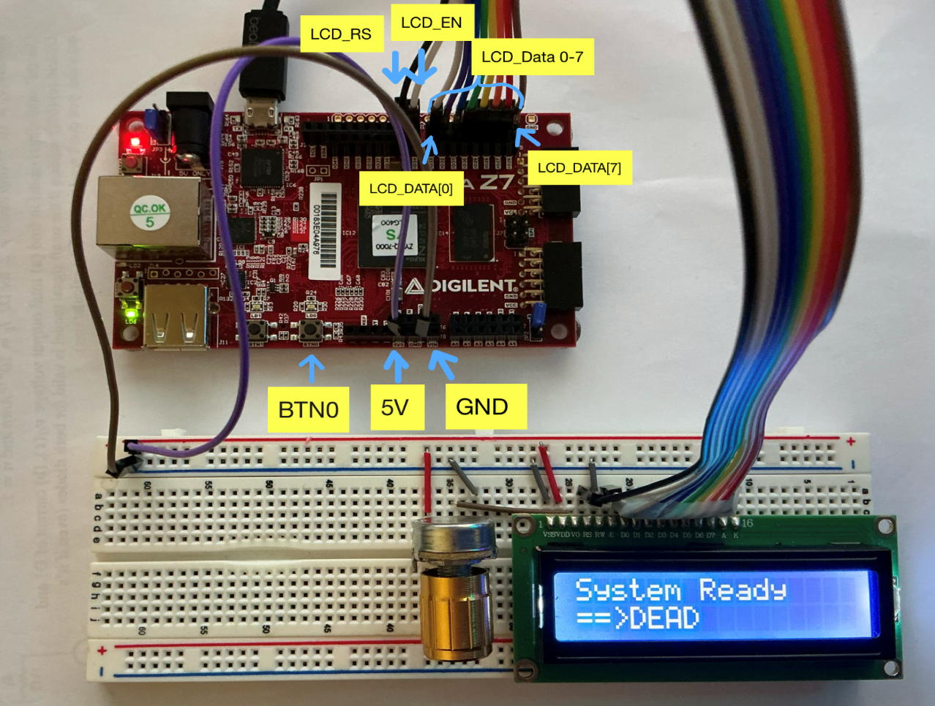

Figure 1. Shows the Cora z7 Board connected to the LCD display functioning
- Problem Decomposition
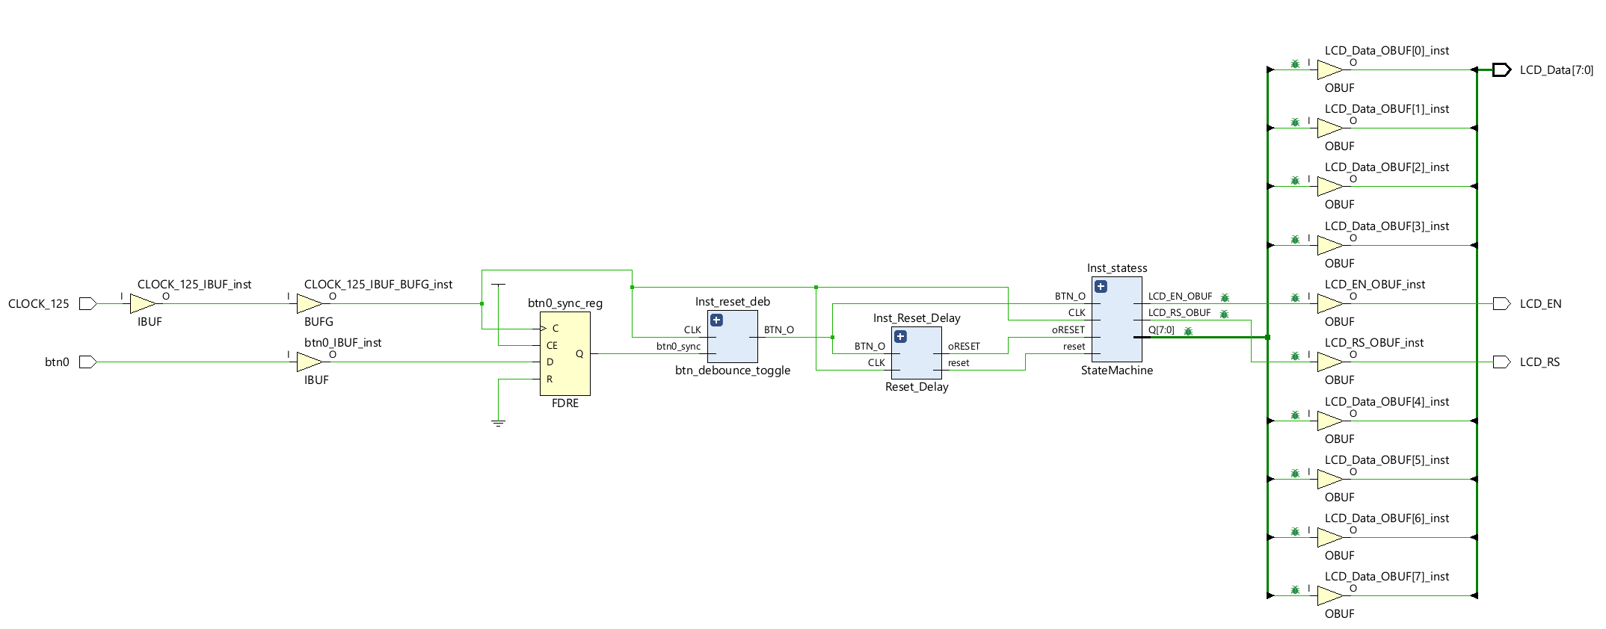
This design was divided into several functional blocks, which were then connected together in the top_level file. The blocks were the power on reset, the button debouncer for the reset button, the statemachine, and the logic from the top level code.
Figure 2. Vivado Generated Schematic for the program design
As seen in Figure 2. the schematic uses 4 functional blocks. The external input is only btn0 which is the button labeled in Figure 1. There is also in internal 125MHz clock that synchronizes the whole system.
The first block, the btn0_sync_reg is a register created by the top_level that synchronizes the btn0 input with the clock. This was done per the assumption that the btn0 input should be synchronized.
The next block is the btn_debounce block, which instantiates the btn_debouncer code, and makes sure that any button presses go high after enough time to show that the button is properly pressed. This is to account for any mechanical bouncing that occurs whenever the button is pressed or released on the board. It uses an internal counter synchronized to the clock to enough cycles to filter out any unwanted signals from the button.
The reset delay block was given, and just sets everything to its initial values on startup, so that whenever the board is initialized or plugged in, it starts at the same default values set for the state machine, for the button, and for the LCD data, rs, and en ports.
The StateMachine block is the core of the design. It takes the btn0 input as a reset button, it takes the 125MHz clock as its clock, oReset and reset from the block. This block is what calculates the states, whether RS should be on or off, when EN should be on and off, and what the LCD_data stream should be.
As you can see in the schematic, debug nets are set on LCD_EN_OBUF, LCD_RS_OBUF, and LCD_DATA [0 -> 7], to view in the logic analyzer in testing.

- Detailed Design
The Reset_Delay code was provided for this exam. Its purpose is to generate a clean power-on reset so that the LCD controller always starts from a known state after the FPGA is configured. This is done by using a synchronized counter, and sends a RESET signal for the first x0FFFF cycles (65,535 cycles, which is 0.54ms at 125MHz) which is enough time to ensure that the reset signal has correctly reset all of the states. The code for this can be found in APPENDIX 1.
The debouncer code, btn_debounce_toggle was also provided for this exam. The purpose of this code is to remove the mechanical bouncing from BTN0 and produce a stable, debounced signal that can be used as a manual reset. The design uses a synchronized counter that is set with max count of xFFFF which is also 65,535 cycles, 0.54ms at 125MHz. The module confirms that the button is being held for the entire 65535, half a ms, which is enough time to be sure that any mechanical bounce is filtered out of the signal sent to the rest of the program. The code for this can be found in APPENDIX 2.
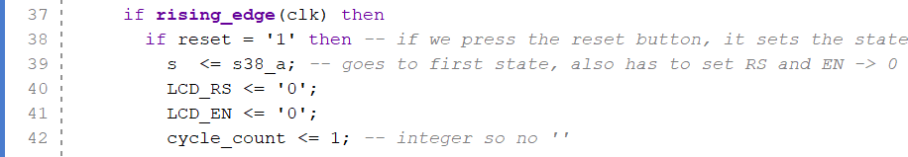
The StateMachine block is the main driver of the LCD. The entity has inputs for clk, reset, and clk_en, and outputs for LCD_Data(7 downto 0), LCD_RS, and LCD_EN. Inside the program, there are 30 states, each corresponding to an LCD display output.

Figure 3. State machine code showing RESET logic
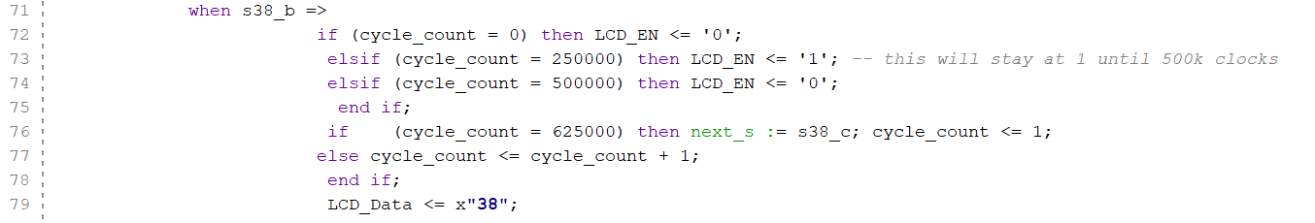
In Figure 3. We can see the logic for the reset functionality in the state machine code. If it receives an input signal saying reset is high, then it will set the state immediately to the initial state (the first x’38’ output), sets LCD_RS, and LCD_EN, and cycle_count to 0.
Cycle count is an integer used to keep track of how long has passed during a specific state. Looking at the code for each state, we can get a better understanding of my implementation of a state machine for this project.
Figure 4. State machine code, showing the code for a sample state.
In the code above, in Figure 4. We can see what happens inside each particular state. On the rising edge of each clock cycle sent from the 125MHz internal clock from the Cora z7 Board, the state machine checks if reset is pressed, and if not it continues to the cases. Once it reaches the case that the state machine is currently in, it goes through these next logical steps. In this code, assume that the state machine has reached state s38_b. This is the second x’38’ hexadecimal signal outlined in the exam description, and will output and hold the LCD_Data at x’38’. The following checks now occur:
Keeping track of the cycle count is important in these states, such that when the cycle count = 0, which happens on the first clock cycle of the new state, it sets LCD_EN to ‘0’. If it is not the first cycle count, it checks whether it is cycle count 250,000. These numbers are chosen because there are 250,000 clock cycles in 2 ms. Here it turns enable on. Then it checks at 500,000 after 2ms, and turns enable off. Finally, it checks for 625,000, which is when 1 full clock cycle has been reached. Note that 250,000 and 500,000 were chosen as clean values, and the delay for EN is still exactly 2ms (assuming a perfect 125MHz clock) as the clock_cycles starts at 1. If it reaches its full 5ms window, it then indicates that the next state will be whatever the next state is supposed to be, in this case it will move from s38_b => s38_c. If it doesn’t reach its full clock cycle, it will add 1 to the cycle count, continue to keep the LCD_Data at its designated output, and set RS if needed.
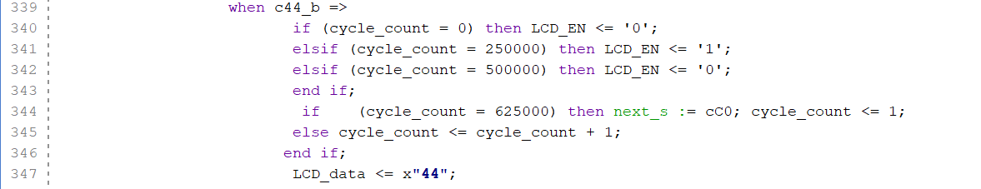
At the end of the 30 states, we reach c44_b, which is then designated to continuously loop back to cC0 unless interrupted. As seen in Figure 5. The next state is set to cC0 which continually loops through the sequence correctly.

Figure 5. State machine code showing looping mechanism
All the code for the StateMachine can be found in APPENDIX 3.
The final reset signal for the StateMachine, called restart in the Top_Level code, is defined as the logical OR of pwrReset and btn0_deb. This means that the LCD state machine will be reset automatically at power on by the reset_delay module, and will also be reset whenever BTN0 is pressed long enough to be recognized by the debouncer (0.54ms). the state machine is instantiated in the top_level with clk tied directly to CLOCK_125, reset tied to restart, clk_en hard wired to 1, and the 3 LCD outputs (LCD_DATA, LCD_RS, and LCD_EN), mapped to the corresponding top level ports. Then, in the constraints file, these ports are correctly mapped on to the Cora z7 board. The code for the top level can be found in APPENDIX 4. The code for the constraints can be found in APPENDIX 6.

- Module and Specifications Testing
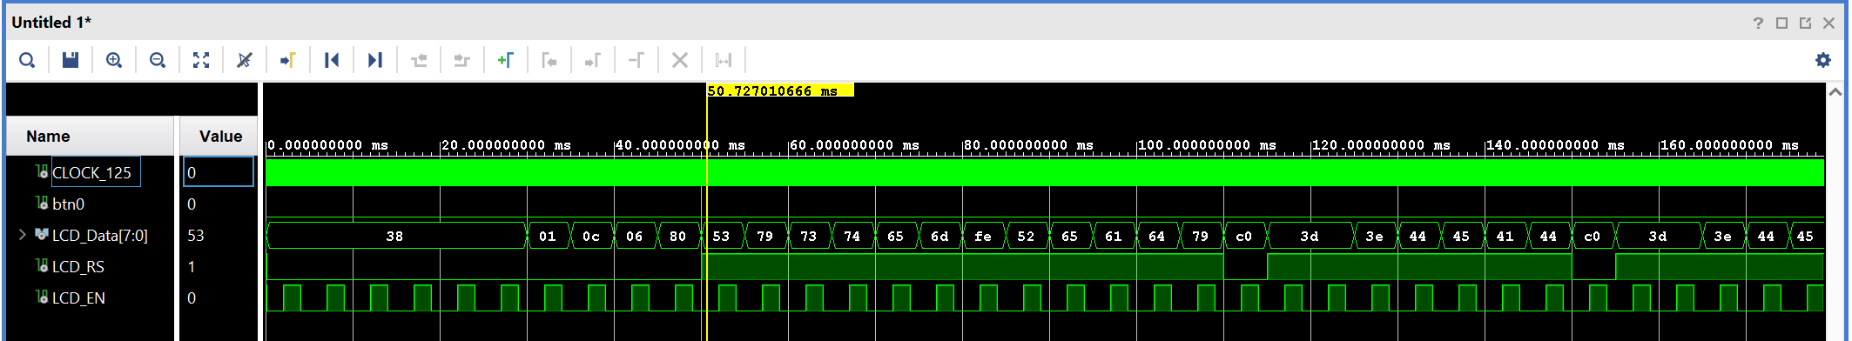
To test this design, I first used Vivado’s built in behavioral simulation on the full top_level entity. I wrote a testbench that simulated the inputs of the 125MHz clock, and the simulated press of a reset button. To match the take home exam’s description, I first wrote the simulation to match perfectly with the waveforms given in the exam description. In Figure 6. We can see the simulation waveform matching up exactly with the waveforms in the exam.
Figure 6. Vivado Simulation, testing uninterrupted waveforms.

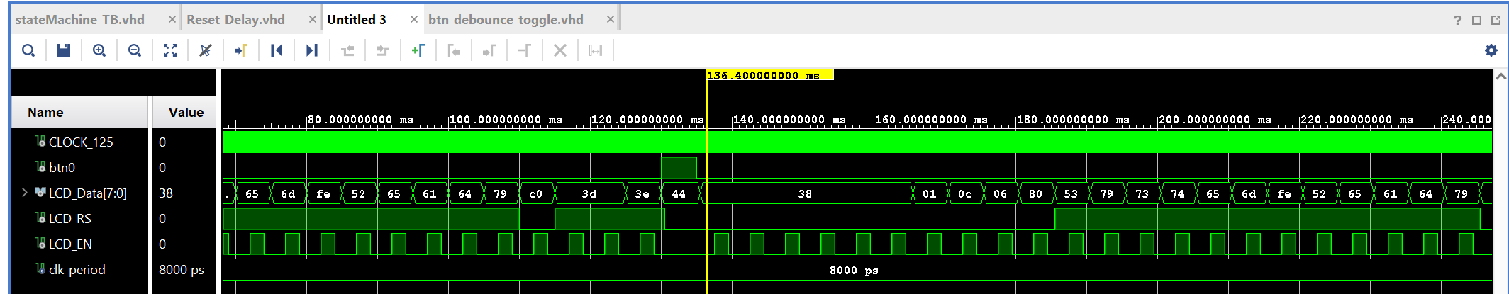
To further test this design, I wrote some code in the testbench that would test a BTN0 press. It simulated waiting 130ms (until the sequence was looping) and then held down the reset button for 5ms, ample time to get past the debouncer, and then let it go again. In Figure 7. We can see the effect. The button being pressed immediately sets RS to 0 and holds it there, sets EN to 0 and holds it there, however it isn’t until the clock cycle after the button is let go, when the data goes back to the initial data. The code for the testbench can be found in APPENDIX 5.
Figure 7. Vivado Simulation, testing interrupted waveform with reset button press.

After confirming that the finite state machine functioned correctly, I moved on to using the Integrated Logic Analyzer for testing. After setting up the debug nets seen in Figure 2. I ran implementation, and generated the bitstream.
I set up the logic analyzer to use Capture Setup, with LCD_EN_OBUF using the == in binary watching both transitions (rising and falling of EN), to generate the matching waveform in the exam description. By pressing the reset button, and then immediately pressing the ‘capture waveform’ I was able to replicate the waveforms shown in the exam description. This also showed full functionality, which meant that it was time to move on to testing with the board directly! In Figure 8. we can see the correct waveforms from the logic analyzer, showing full functionality of the statemachine, top level, reset button, and the project as a whole.

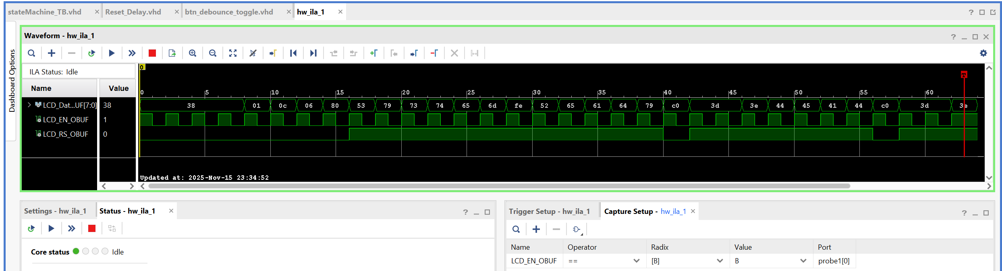
Figure 8. Integrated Logic Analyzer for board.

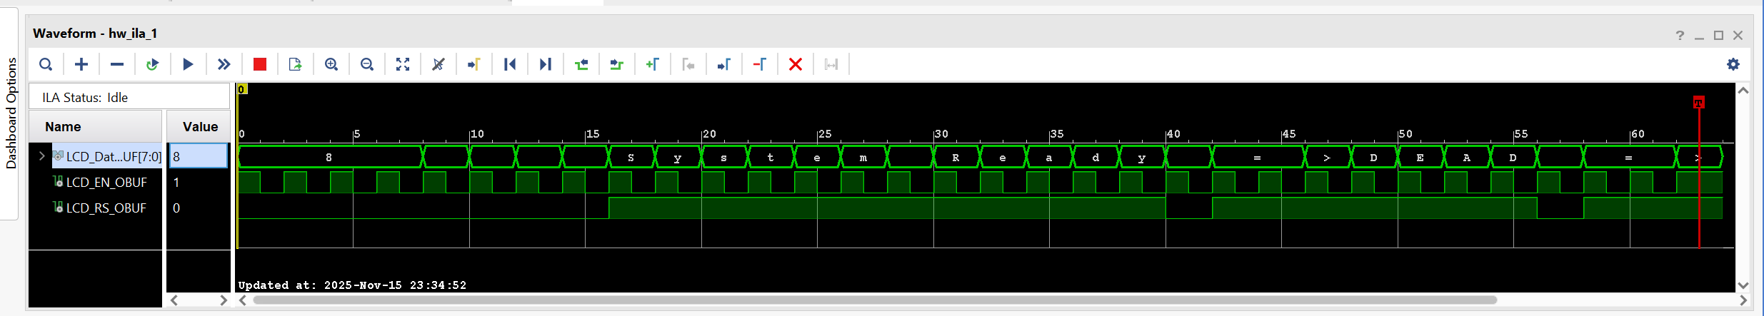
Using the logic analyzer, and setting the values of the LCD data to ASCII, we can view the data that is actually being sent to the LCD display. This functionality can be seen in Figure 9. Whenever RS is low, it is not sending the characters shown above, as those are commands, however when RS is high, we can see “System Ready ==> DEAD” shown. Note that because the = is sent and 2 EN pulses are sent, it will display it twice. The command sent at 40ms is a newline command.
Figure 9. Integrated Logic Analyzer, showing ASCII values.
Finally, this functionality was tested with the LCD board directly. Using a board, with the set up provided, making sure to correctly wire the right pins on the board (using IO0 -> IO9 set in the constraints file), I connected the board, and successfully displayed the required sequence to the board! Figure 10. And Figure 1. Both show this success, and full 100% functionality of the project!
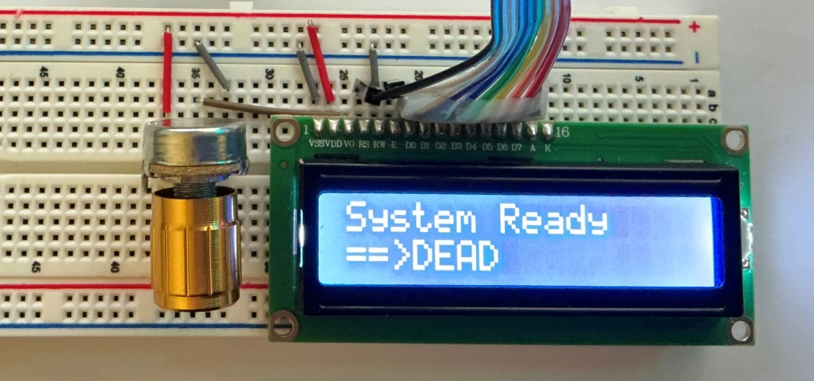

Figure 10. LCD display displaying full functionality!

F) Results and Analysis
The LCD controller design for this take-home exam worked completely as intended in both the Vivado behavioral simulation and on the Cora z7 board with the external LCD display. In the simulation, the finite state machine stepped through the entire required hexadecimal command/character sequence in the correct order, starting with the six 0x38 initialization commands, followed by 01, 0C, 06, 80, and then the ASCII bytes “System Ready” the new line command C0, and then the remaining ASCII bytes “==>DEAD”. The final test with the physical hardware confirmed that the LCD controller was distinguishing correctly between instruction and data mode.
To explain exactly what the display is displaying, the LCD display displays the data stored in the state machine as hexadecimal values, sent via 8 binary data input lanes onto the LCD board, and then read back and displayed by the LCD display as ASCII characters from a lookup table inside the LCD’s own circuit board. Any time that RS was low however, it meant that the data was being received in command receiving mode, and so the LCD controller would take those commands and control other things, not display characters (ie initialization, cursor on/off).
The 5ms timing requirement was also met. In Vivado’s waveform viewer, LCD_Data and LCD_RS stayed constant for the duration of each state, while LCD_EN produced a single pulse in the middle of that window. By measuring the time between two consecutive changes in LCD_Data, the effective update period was 5ms based on the 125MHz input clock, and the cycle_count divider.
The reset behavior also matched the intended design. In the Vivado simulation, pwrReset from the Reset_Delay block produced a single, clean power on reset pulse at the initialization of the board. While pwrReset was high, the state machine was held in its state, going to its first state on the first click after the Reset signal was removed.
On the physical hardware, the LCD behaved the same way that was expected because of the simulation. After programming the bitstream to the Cora Z7 and powering up the board, the LCD ran through its initialization sequence and then displayed the correct two-line message. This behavior was repeatable and worked perfectly.
One interesting function that could be changed is reset button function. Currently, due to how the state machine is set up, while the reset button is held, the LCD_Data will never change. I chose to implement it this way because it seemed most logical, I wouldn’t want a clear empty display while I press the button. However, this could easily be updated, by adding one line of code in the state machine in the ‘if reset = ‘1’’ block, and saying if reset is high, then set LCD_Data to ‘0’, or to the data from the initial state, x38.
There were no deviations from the specifications. All the design goals were met: the LCD initializes reliably at power-on, responds correctly to the debounced reset button, and continuously displays the specified two-line message with the correct command/data sequence, timing, and control signal behavior in both simulation and hardware.

REFERENCES
[1] OneNote provided on Moodle, information on LCD displays. No up to date links on the LCD page.
[2] LCD Module datasheet and timing diagram on Moodle
[3] Cora Z7 Board Reference Manual/Documentation https://digilent.com/reference/programmable-logic/cora-z7/reference-manual?redirect=1
[4] Reset_Delay.vhd, and btn_debounce.vhd, and the Cora z7 constraints file, with changes made to constraints file to support the boards designs.
[5] A portion of the layout and wording of this report came from my previously written reports. Only the work that I produced was used towards this exam.

APPENDIX
This is where all of the code for this take home exam can be found.

APPENDIX 1. This is the RESET_DELAY code provided
library IEEE;
use IEEE.STD_LOGIC_1164.ALL;

--use IEEE.numeric_std.ALL;
use IEEE.STD_LOGIC_ARITH;
use IEEE.STD_LOGIC_UNSIGNED.ALL;

ENTITY Reset_Delay IS
PORT (
SIGNAL iCLK : IN std_logic;
SIGNAL oRESET : OUT std_logic
);
END Reset_Delay;

ARCHITECTURE Arch OF Reset_Delay IS

SIGNAL Cont : std_logic_vector(19 DOWNTO 0):=X"00000";

BEGIN

PROCESS
BEGIN

WAIT UNTIL rising_edge (iCLK);
-- IF Cont /= X"FFFFF" THEN
IF Cont /= X"0FFFF" THEN
Cont <= Cont + '1';
oRESET <= '1';
ELSE
oRESET <= '0';
END IF;
END PROCESS;

END Arch;

APPENDIX 2. This file is the DEBOUNCER code provided
----------------------------------------------------------------------------
-- btn_debounce.vhd -- Button Debouncer
----------------------------------------------------------------------------
-- Author: Sam Bobrowicz
-- Copyright 2011 Digilent, Inc.
-- Modified: Added toggle output
----------------------------------------------------------------------------
--
----------------------------------------------------------------------------
-- This component is used to debounce signals generated by external push
-- buttons. It is designed to independently debounce a Push button signal.
-- Debouncing is done by only registering a change in a button state if
-- it remains constant for 2^16 clock cycles.
--
-- Port Descriptions:
--
-- BTN_I - The input button signals
-- CLK - Behavior is optimized for a 100 MHz clock
-- BTN_O - The debounced button signals
-- TOGGLE_O - Debounced toggle output
----------------------------------------------------------------------------
--
----------------------------------------------------------------------------
-- Revision History:
-- 08/08/2011(SamB): Created using Xilinx Tools 13.2
-- 10/06/2013 (CU): Converted to one button and added toggle output
----------------------------------------------------------------------------
library IEEE;
use IEEE.STD_LOGIC_1164.ALL;
use IEEE.std_logic_unsigned.all;

entity btn_debounce_toggle is
GENERIC (
CONSTANT CNTR_MAX : std_logic_vector(15 downto 0) := X"FFFF");
Port ( BTN_I : in STD_LOGIC;
CLK : in STD_LOGIC;
BTN_O : out STD_LOGIC;
TOGGLE_O : out STD_LOGIC;
PULSE_O : out STD_LOGIC);
end btn_debounce_toggle;

architecture Behavioral of btn_debounce_toggle is

--constant CNTR_MAX : std_logic_vector(15 downto 0) := X"FFFF";
signal btn_cntr : std_logic_vector(15 downto 0) := (others => '0');
signal btn_reg : std_logic := '0';
signal btn_toggle : std_logic := '1';
signal btn_sync : std_logic_vector(1 downto 0) := (others => '0');
signal btn_pulse : std_logic := '0';

begin

btn_debounce_process : process (CLK)
begin
if (rising_edge(CLK)) then
if (btn_cntr = CNTR_MAX) then
btn_reg <= not(btn_reg);
end if;
end if;
end process;

btn_counter_process : process (CLK)
begin
if (rising_edge(CLK)) then
if ((btn_reg = '1') xor (BTN_I = '1')) then
if (btn_cntr = CNTR_MAX) then
btn_cntr <= (others => '0');
else
btn_cntr <= btn_cntr + 1;
end if;
else
btn_cntr <= (others => '0');
end if;
end if;
end process;

btn_toggle_process : process(CLK)
begin
if (rising_edge(CLK)) then
btn_sync(0) <= btn_reg;
btn_sync(1) <= btn_sync(0);
btn_pulse <= not btn_sync(1) and btn_sync(0);
if btn_pulse = '1' then
btn_toggle <= not btn_toggle;
end if;
end if;
end process;

BTN_O <= btn_reg;
TOGGLE_O <= btn_toggle;
PULSE_O <= btn_pulse;
end Behavioral;

APPENDIX 3. This file is the StateMachine code I wrote
library ieee;
use ieee.std_logic_1164.all;

entity StateMachine is
port (
clk : in std_logic;
reset : in std_logic; -- synchronous, active high
clk_en : in std_logic;
LCD_data : out std_logic_vector(7 downto 0);
LCD_RS : out std_logic;
LCD_EN : out std_logic
);

end StateMachine;

architecture Behavioral of StateMachine is

type State_type is (
s38_a, s38_b, s38_c, s38_d, s38_e, s38_f,
s01, s0C, s06, s80, s53, s79_a, s73, s74, s65_a, s6D, sFE, s52,
s65_b, s61, s64, s79_b,
cC0, c3D_a, c3D_b, c3E, c44_a, c45, c41, c44_b -- these are the continuous values/looping
) ;
signal s : State_type := s38_a;
-- like said in class, 5ms for each one, so we need a count that it will go through each clock cycle
-- for eacch state
signal cycle_count : integer range 0 to 625000 := 0; -- this integer counts 0 -> max number of clock cycles for 5ms
-- at 125mhz which is the boards clkspee.d

begin
process(clk)
variable next_s : State_type;
begin

if rising_edge(clk) then
if reset = '1' then -- if we press the reset button, it sets the state machine into the idle state, and doesn't send a count signal
s <= s38_a; -- goes to first state, also has to set RS and EN -> 0 and cycle count
LCD_RS <= '0';
LCD_EN <= '0';
cycle_count <= 1; -- integer so no ''

else
next_s := s;-- this means that each clock, it will go to what is stored in next state, which will be current state until updated
-- at max clock cylce. / base state. Don't change unless s tells you to (and clock cycle tells you too)

case s is
when s38_a => -- -- base state

-- now that its checked that it isn't moving to the next state, we'll do the EN -> 0 -> 1 -> 0
-- not specified INCLUDE IN ASSUMPTIONS PART OF REPORT that its going to be 2ms 0 -> 1ms 1 -> 2ms 0
if (cycle_count = 0) then LCD_EN <= '0'; -- on first clock this puts enable. In reality this isn't needed
-- ** MOVE ABOVE OTHER PARTS
elsif (cycle_count = 250000) then LCD_EN <= '1'; -- this will stay at 1 until 500k clocks
elsif (cycle_count = 500000) then LCD_EN <= '0';
end if;

if (cycle_count = 625000) then next_s := s38_b; cycle_count <= 1;
else cycle_count <= cycle_count + 1;
-- don't need to tell it, it automatically stays in this state
end if;
-- I'm also going to send the data over here, using EN with the cycle count
-- each time this will run, say its in s38_a, it will check, is this the 5ms do I move to next state?
-- If it is, moves to next state next clock cycle, sets cycle_count -> 0, and next cycle will
-- go to the next version of the data.
LCD_RS <= '0'; -- just to make sure nothing weird happened not neccesary NVM needed, bc of initialization
-- NOW send the data over the LCD:
LCD_Data <= x"38";

when s38_b =>
if (cycle_count = 0) then LCD_EN <= '0';
elsif (cycle_count = 250000) then LCD_EN <= '1'; -- this will stay at 1 until 500k clocks
elsif (cycle_count = 500000) then LCD_EN <= '0';
end if;
if (cycle_count = 625000) then next_s := s38_c; cycle_count <= 1;
else cycle_count <= cycle_count + 1;
end if;
LCD_Data <= x"38";

when s38_c =>
if (cycle_count = 0) then LCD_EN <= '0';
elsif (cycle_count = 250000) then LCD_EN <= '1'; -- this will stay at 1 until 500k clocks
elsif (cycle_count = 500000) then LCD_EN <= '0';
end if;
if (cycle_count = 625000) then next_s := s38_d; cycle_count <= 1;
else cycle_count <= cycle_count + 1;
end if;
LCD_data <= x"38";
when s38_d =>
if (cycle_count = 0) then LCD_EN <= '0';
elsif (cycle_count = 250000) then LCD_EN <= '1'; -- this will stay at 1 until 500k clocks
elsif (cycle_count = 500000) then LCD_EN <= '0';
end if;
if (cycle_count = 625000) then next_s := s38_e; cycle_count <= 1;
else cycle_count <= cycle_count + 1;
end if;
LCD_data <= x"38";
when s38_e =>
if (cycle_count = 0) then LCD_EN <= '0';
elsif (cycle_count = 250000) then LCD_EN <= '1'; -- this will stay at 1 until 500k clocks
elsif (cycle_count = 500000) then LCD_EN <= '0';
end if;
if (cycle_count = 625000) then next_s := s38_f; cycle_count <= 1;
else cycle_count <= cycle_count + 1;
end if;
LCD_data <= x"38";
when s38_f =>
if (cycle_count = 0) then LCD_EN <= '0';
elsif (cycle_count = 250000) then LCD_EN <= '1'; -- this will stay at 1 until 500k clocks
elsif (cycle_count = 500000) then LCD_EN <= '0';
end if;
if (cycle_count = 625000) then next_s := s01; cycle_count <= 1;
else cycle_count <= cycle_count + 1;
end if;
LCD_data <= x"38";
when s01 =>
if (cycle_count = 0) then LCD_EN <= '0';
elsif (cycle_count = 250000) then LCD_EN <= '1'; -- this will stay at 1 until 500k clocks
elsif (cycle_count = 500000) then LCD_EN <= '0';
end if;
if (cycle_count = 625000) then next_s := s0C; cycle_count <= 1;
else cycle_count <= cycle_count + 1;
end if;
LCD_data <= x"01";
when s0C =>
if (cycle_count = 0) then LCD_EN <= '0';
elsif (cycle_count = 250000) then LCD_EN <= '1'; -- this will stay at 1 until 500k clocks
elsif (cycle_count = 500000) then LCD_EN <= '0';
end if;
if (cycle_count = 625000) then next_s := s06; cycle_count <= 1;
else cycle_count <= cycle_count + 1;
end if;
LCD_data <= x"0C";

when s06 =>
if (cycle_count = 0) then LCD_EN <= '0';
elsif (cycle_count = 250000) then LCD_EN <= '1'; -- this will stay at 1 until 500k clocks
elsif (cycle_count = 500000) then LCD_EN <= '0';
end if;
if (cycle_count = 625000) then next_s := s80; cycle_count <= 1;
else cycle_count <= cycle_count + 1;
end if;
LCD_data <= x"06";
when s80 =>
if (cycle_count = 0) then LCD_EN <= '0';
elsif (cycle_count = 250000) then LCD_EN <= '1'; -- this will stay at 1 until 500k clocks
elsif (cycle_count = 500000) then LCD_EN <= '0';
end if;
if (cycle_count = 625000) then next_s := s53; cycle_count <= 1;
else cycle_count <= cycle_count + 1;
end if;
LCD_data <= x"80";

----------------------------------------------------- (RS ON) --------------------------

when s53 =>
if (cycle_count = 0) then LCD_EN <= '0';
elsif (cycle_count = 250000) then LCD_EN <= '1'; -- this will stay at 1 until 500k clocks
elsif (cycle_count = 500000) then LCD_EN <= '0';
end if;
if (cycle_count = 625000) then next_s := s79_a; cycle_count <= 1;
else cycle_count <= cycle_count + 1;
end if;
LCD_data <= x"53";
LCD_RS <= '1'; -- this is the only time this is needed, it MUST go through this state
when s79_a =>
if (cycle_count = 0) then LCD_EN <= '0';
elsif (cycle_count = 250000) then LCD_EN <= '1';
elsif (cycle_count = 500000) then LCD_EN <= '0';
end if;
if (cycle_count = 625000) then next_s := s73; cycle_count <= 1;
else cycle_count <= cycle_count + 1;
end if;
LCD_data <= x"79";
when s73 =>
if (cycle_count = 0) then LCD_EN <= '0';
elsif (cycle_count = 250000) then LCD_EN <= '1';
elsif (cycle_count = 500000) then LCD_EN <= '0';
end if;
if (cycle_count = 625000) then next_s := s74; cycle_count <= 1;
else cycle_count <= cycle_count + 1;
end if;
LCD_data <= x"73";
when s74 =>
if (cycle_count = 0) then LCD_EN <= '0';
elsif (cycle_count = 250000) then LCD_EN <= '1';
elsif (cycle_count = 500000) then LCD_EN <= '0';
end if;
if (cycle_count = 625000) then next_s := s65_a; cycle_count <= 1;
else cycle_count <= cycle_count + 1;
end if;
LCD_data <= x"74";
when s65_a =>
if (cycle_count = 0) then LCD_EN <= '0';
elsif (cycle_count = 250000) then LCD_EN <= '1';
elsif (cycle_count = 500000) then LCD_EN <= '0';
end if;
if (cycle_count = 625000) then next_s := s6D; cycle_count <= 1;
else cycle_count <= cycle_count + 1;
end if;
LCD_data <= x"65";
when s6D =>
if (cycle_count = 0) then LCD_EN <= '0';
elsif (cycle_count = 250000) then LCD_EN <= '1';
elsif (cycle_count = 500000) then LCD_EN <= '0';
end if;
if (cycle_count = 625000) then next_s := sFE; cycle_count <= 1;
else cycle_count <= cycle_count + 1;
end if;
LCD_data <= x"6D";
when sFE =>
if (cycle_count = 0) then LCD_EN <= '0';
elsif (cycle_count = 250000) then LCD_EN <= '1';
elsif (cycle_count = 500000) then LCD_EN <= '0';
end if;
if (cycle_count = 625000) then next_s := s52; cycle_count <= 1;
else cycle_count <= cycle_count + 1;
end if;
LCD_data <= x"FE";
when s52 =>
if (cycle_count = 0) then LCD_EN <= '0';
elsif (cycle_count = 250000) then LCD_EN <= '1';
elsif (cycle_count = 500000) then LCD_EN <= '0';
end if;
if (cycle_count = 625000) then next_s := s65_b; cycle_count <= 1;
else cycle_count <= cycle_count + 1;
end if;
LCD_data <= x"52";
when s65_b =>
if (cycle_count = 0) then LCD_EN <= '0';
elsif (cycle_count = 250000) then LCD_EN <= '1';
elsif (cycle_count = 500000) then LCD_EN <= '0';
end if;
if (cycle_count = 625000) then next_s := s61; cycle_count <= 1;
else cycle_count <= cycle_count + 1;
end if;
LCD_data <= x"65";
when s61 =>
if (cycle_count = 0) then LCD_EN <= '0';
elsif (cycle_count = 250000) then LCD_EN <= '1';
elsif (cycle_count = 500000) then LCD_EN <= '0';
end if;
if (cycle_count = 625000) then next_s := s64; cycle_count <= 1;
else cycle_count <= cycle_count + 1;
end if;
LCD_data <= x"61";
when s64 =>
if (cycle_count = 0) then LCD_EN <= '0';
elsif (cycle_count = 250000) then LCD_EN <= '1';
elsif (cycle_count = 500000) then LCD_EN <= '0';
end if;
if (cycle_count = 625000) then next_s := s79_b; cycle_count <= 1;
else cycle_count <= cycle_count + 1;
end if;
LCD_data <= x"64";
when s79_b =>
if (cycle_count = 0) then LCD_EN <= '0';
elsif (cycle_count = 250000) then LCD_EN <= '1';
elsif (cycle_count = 500000) then LCD_EN <= '0';
end if;
if (cycle_count = 625000) then next_s := cC0; cycle_count <= 1;
else cycle_count <= cycle_count + 1;
end if;
LCD_data <= x"79";

---- HERE IT STARTS LOOPING WITH cC0 AND KEEPS DOING IT
when cC0 =>
if (cycle_count = 0) then LCD_EN <= '0';
elsif (cycle_count = 250000) then LCD_EN <= '1';
elsif (cycle_count = 500000) then LCD_EN <= '0';
end if;
if (cycle_count = 625000) then next_s := c3D_a; cycle_count <= 1;
else cycle_count <= cycle_count + 1;
end if;
LCD_data <= x"C0";
LCD_RS <= '0'; -- rs is just low for this one, and then high
when c3D_a =>
if (cycle_count = 0) then LCD_EN <= '0';
elsif (cycle_count = 250000) then LCD_EN <= '1';
elsif (cycle_count = 500000) then LCD_EN <= '0';
end if;
if (cycle_count = 625000) then next_s := c3D_b; cycle_count <= 1;
else cycle_count <= cycle_count + 1;
end if;
LCD_data <= x"3D";
LCD_RS <= '1';
when c3D_b =>
if (cycle_count = 0) then LCD_EN <= '0';
elsif (cycle_count = 250000) then LCD_EN <= '1';
elsif (cycle_count = 500000) then LCD_EN <= '0';
end if;
if (cycle_count = 625000) then next_s := c3E; cycle_count <= 1;
else cycle_count <= cycle_count + 1;
end if;
LCD_data <= x"3D";
when c3E =>
if (cycle_count = 0) then LCD_EN <= '0';
elsif (cycle_count = 250000) then LCD_EN <= '1';
elsif (cycle_count = 500000) then LCD_EN <= '0';
end if;
if (cycle_count = 625000) then next_s := c44_a; cycle_count <= 1;
else cycle_count <= cycle_count + 1;
end if;
LCD_data <= x"3E";
when c44_a =>
if (cycle_count = 0) then LCD_EN <= '0';
elsif (cycle_count = 250000) then LCD_EN <= '1';
elsif (cycle_count = 500000) then LCD_EN <= '0';
end if;
if (cycle_count = 625000) then next_s := c45; cycle_count <= 1;
else cycle_count <= cycle_count + 1;
end if;
LCD_data <= x"44";
when c45 =>
if (cycle_count = 0) then LCD_EN <= '0';
elsif (cycle_count = 250000) then LCD_EN <= '1';
elsif (cycle_count = 500000) then LCD_EN <= '0';
end if;
if (cycle_count = 625000) then next_s := c41; cycle_count <= 1;
else cycle_count <= cycle_count + 1;
end if;
LCD_data <= x"45";
when c41 =>
if (cycle_count = 0) then LCD_EN <= '0';
elsif (cycle_count = 250000) then LCD_EN <= '1';
elsif (cycle_count = 500000) then LCD_EN <= '0';
end if;
if (cycle_count = 625000) then next_s := c44_b; cycle_count <= 1;
else cycle_count <= cycle_count + 1;
end if;
LCD_data <= x"41";
when c44_b =>
if (cycle_count = 0) then LCD_EN <= '0';
elsif (cycle_count = 250000) then LCD_EN <= '1';
elsif (cycle_count = 500000) then LCD_EN <= '0';
end if;
if (cycle_count = 625000) then next_s := cC0; cycle_count <= 1;
else cycle_count <= cycle_count + 1;
end if;
LCD_data <= x"44";

when others =>
next_s := s38_a;
cycle_count <= 0;
-- LCD RS will be reset and so will LCD data, and so will LCD enable.
end case;

s <= next_s;
end if;
end if;
end process;
end Behavioral;

APPENDIX 4. This is the TopLevel code I wrote for this exam

library IEEE;
use IEEE.STD_LOGIC_1164.ALL;

entity top_level is
port (
CLOCK_125 : in std_logic; -- 125mhz internal clock
btn0 : in std_logic; -- this is the reset delay button that we'll also debounce
LCD_Data : out std_logic_vector(7 downto 0); -- data stream
LCD_RS : out std_logic; -- tells if cmnd or char to display
LCD_EN : out std_logic
);
end top_level;

architecture Behavioral of top_level is
signal btn0_sync : std_logic;
signal btn0_deb : std_logic; -- debounced reset button
signal restart : std_logic; -- for reset button and reset_delay on start up
signal pwrReset : std_logic; -- used for the logic to make reset work correctly

COMPONENT reset_delay
PORT(iCLK : IN STD_LOGIC;
oRESET : OUT STD_LOGIC
);
END COMPONENT;

COMPONENT btn_debounce_toggle is
GENERIC (
CONSTANT CNTR_MAX : std_logic_vector(15 downto 0) := X"FFFF"); -- binary max, changed to 000f for testing,
Port ( BTN_I : in STD_LOGIC;
CLK : in STD_LOGIC;
BTN_O : out STD_LOGIC;
TOGGLE_O : out STD_LOGIC;
PULSE_O : out STD_LOGIC);
END COMPONENT;

COMPONENT StateMachine is
port (
clk : in std_logic;
reset : in std_logic; -- synchronous, active high
clk_en : in std_logic;
LCD_data : out std_logic_vector(7 downto 0);
LCD_RS : out std_logic;
LCD_EN : out std_logic
);
END COMPONENT;

begin

restart <= pwrReset OR btn0_deb;
process (CLOCK_125)
begin
if rising_edge(CLOCK_125) then
btn0_sync <= btn0;
end if;
end process;

Inst_Reset_Delay: Reset_Delay
port map(
iClk => CLOCK_125,
oRESET => pwrReset
);

Inst_reset_deb : btn_debounce_toggle
GENERIC MAP(CNTR_MAX => X"FFFF")
PORT MAP(BTN_I => btn0_sync,
CLK => CLOCK_125,
BTN_O => btn0_deb); -- this holds as long as its pressed.

Inst_statess : StateMachine
port map (
clk => CLOCK_125,
reset => restart,
clk_en => '1', -- this can be taken out, had in case I wanted to put the logic in here for the timing of EN
LCD_data => LCD_Data,
LCD_RS => LCD_RS,
LCD_EN => LCD_EN
);

end Behavioral;

APPENDIX 5. This file is the state machine’s testbench that I wrote
library IEEE;
use IEEE.STD_LOGIC_1164.ALL;

entity stateMachine_TB is
end stateMachine_TB;

architecture sim of stateMachine_TB is

signal CLOCK_125 : std_logic := '0';
signal btn0 : std_logic := '0';
signal LCD_Data : std_logic_vector(7 downto 0);
signal LCD_RS : std_logic;
signal LCD_EN : std_logic;

constant clk_period : time := 8 ns;-- this should be 8ns 125mhz = 8ns period

begin
uut : entity work.top_level
port map (
CLOCK_125 => CLOCK_125,
btn0 => btn0,
LCD_Data => LCD_Data,
LCD_RS => LCD_RS,
LCD_EN => LCD_EN
);

clk : process
begin
while true loop
CLOCK_125 <= '0';
wait for clk_period / 2;
CLOCK_125 <= '1';
wait for clk_period / 2;
end loop;
end process;

stim_proc : process
begin
wait for 130 ms;
BTN0 <= '1';
wait for 5 ms;
BTN0 <= '0';
end process;

end sim;

APPENDIX 6. This file is the constraints file given, updated to match project specifications
## This file is a general .xdc for the Cora Z7-07S Rev. B
## To use it in a project:
## - uncomment the lines corresponding to used pins
## - rename the used ports (in each line, after get_ports) according to the top level signal names in the project

## PL System Clock
set_property -dict {PACKAGE_PIN H16 IOSTANDARD LVCMOS33} [get_ports CLOCK_125]
create_clock -period 8.000 -name sys_clk_pin -waveform {0.000 4.000} -add [get_ports CLOCK_125]

## RGB LEDs
#set_property -dict { PACKAGE_PIN L15 IOSTANDARD LVCMOS33 } [get_ports { led0_b }]; #IO_L22N_T3_AD7N_35 Sch=led0_b
#set_property -dict { PACKAGE_PIN G17 IOSTANDARD LVCMOS33 } [get_ports { led0_g }]; #IO_L16P_T2_35 Sch=led0_g
#set_property -dict {PACKAGE_PIN N15 IOSTANDARD LVCMOS33} [get_ports LED0]
#set_property -dict {PACKAGE_PIN G14 IOSTANDARD LVCMOS33} [get_ports LED1]
#set_property -dict { PACKAGE_PIN L14 IOSTANDARD LVCMOS33 } [get_ports { led1_g }]; #IO_L22P_T3_AD7P_35 Sch=led1_g
#set_property -dict { PACKAGE_PIN M15 IOSTANDARD LVCMOS33 } [get_ports { led1_r }]; #IO_L23N_T3_35 Sch=led1_r

## Buttons
set_property -dict {PACKAGE_PIN D20 IOSTANDARD LVCMOS33} [get_ports btn0]
#set_property -dict {PACKAGE_PIN D19 IOSTANDARD LVCMOS33} [get_ports BTN1]

## Pmod Header JA
#set_property -dict {PACKAGE_PIN Y18 IOSTANDARD LVCMOS33} [get_ports TX_o]
#set_property -dict { PACKAGE_PIN Y19 IOSTANDARD LVCMOS33 } [get_ports { ja[1] }]; #IO_L17N_T2_34 Sch=ja_n[1]
#set_property -dict { PACKAGE_PIN Y16 IOSTANDARD LVCMOS33 } [get_ports { ja[2] }]; #IO_L7P_T1_34 Sch=ja_p[2]
#set_property -dict { PACKAGE_PIN Y17 IOSTANDARD LVCMOS33 } [get_ports { ja[3] }]; #IO_L7N_T1_34 Sch=ja_n[2]
#set_property -dict { PACKAGE_PIN U18 IOSTANDARD LVCMOS33 } [get_ports { ja[4] }]; #IO_L12P_T1_MRCC_34 Sch=ja_p[3]
#set_property -dict { PACKAGE_PIN U19 IOSTANDARD LVCMOS33 } [get_ports { ja[5] }]; #IO_L12N_T1_MRCC_34 Sch=ja_n[3]
#set_property -dict { PACKAGE_PIN W18 IOSTANDARD LVCMOS33 } [get_ports { ja[6] }]; #IO_L22P_T3_34 Sch=ja_p[4]
#set_property -dict { PACKAGE_PIN W19 IOSTANDARD LVCMOS33 } [get_ports { ja[7] }]; #IO_L22N_T3_34 Sch=ja_n[4]

## Pmod Header JB
#set_property -dict { PACKAGE_PIN W14 IOSTANDARD LVCMOS33 } [get_ports { TX_o }]; #IO_L8P_T1_34 Sch=jb_p[1]
#set_property -dict { PACKAGE_PIN Y14 IOSTANDARD LVCMOS33 } [get_ports { jb[1] }]; #IO_L8N_T1_34 Sch=jb_n[1]
#set_property -dict { PACKAGE_PIN T11 IOSTANDARD LVCMOS33 } [get_ports { jb[2] }]; #IO_L1P_T0_34 Sch=jb_p[2]
#set_property -dict { PACKAGE_PIN T10 IOSTANDARD LVCMOS33 } [get_ports { jb[3] }]; #IO_L1N_T0_34 Sch=jb_n[2]
#set_property -dict { PACKAGE_PIN V16 IOSTANDARD LVCMOS33 } [get_ports { jb[4] }]; #IO_L18P_T2_34 Sch=jb_p[3]
#set_property -dict { PACKAGE_PIN W16 IOSTANDARD LVCMOS33 } [get_ports { jb[5] }]; #IO_L18N_T2_34 Sch=jb_n[3]
#set_property -dict { PACKAGE_PIN V12 IOSTANDARD LVCMOS33 } [get_ports { jb[6] }]; #IO_L4P_T0_34 Sch=jb_p[4]
#set_property -dict { PACKAGE_PIN W13 IOSTANDARD LVCMOS33 } [get_ports { jb[7] }]; #IO_L4N_T0_34 Sch=jb_n[4]

## Crypto SDA
#set_property -dict { PACKAGE_PIN J15 IOSTANDARD LVCMOS33 } [get_ports { crypto_sda }];

## Dedicated Analog Inputs
#set_property -dict { PACKAGE_PIN K9 IOSTANDARD LVCMOS33 } [get_ports { v_p }]; #VP_0 Sch=xadc_v_p
#set_property -dict { PACKAGE_PIN L10 IOSTANDARD LVCMOS33 } [get_ports { v_n }]; #VN_0 Sch=xadc_v_n

## ChipKit Outer Analog Header - as Single-Ended Analog Inputs
## NOTE: These ports can be used as single-ended analog inputs with voltages from 0-3.3V (ChipKit analog pins A0-A5) or as digital I/O.
## WARNING: Do not use both sets of constraints at the same time!
#set_property -dict { PACKAGE_PIN E17 IOSTANDARD LVCMOS33 } [get_ports { vaux1_p }]; #IO_L3P_T0_DQS_AD1P_35 Sch=ck_an_p[0]
#set_property -dict { PACKAGE_PIN D18 IOSTANDARD LVCMOS33 } [get_ports { vaux1_n }]; #IO_L3N_T0_DQS_AD1N_35 Sch=ck_an_n[0]
#set_property -dict { PACKAGE_PIN E18 IOSTANDARD LVCMOS33 } [get_ports { vaux9_p }]; #IO_L5P_T0_AD9P_35 Sch=ck_an_p[1]
#set_property -dict { PACKAGE_PIN E19 IOSTANDARD LVCMOS33 } [get_ports { vaux9_n }]; #IO_L5N_T0_AD9N_35 Sch=ck_an_n[1]
#set_property -dict { PACKAGE_PIN K14 IOSTANDARD LVCMOS33 } [get_ports { vaux6_p }]; #IO_L20P_T3_AD6P_35 Sch=ck_an_p[2]
#set_property -dict { PACKAGE_PIN J14 IOSTANDARD LVCMOS33 } [get_ports { vaux6_n }]; #IO_L20N_T3_AD6N_35 Sch=ck_an_n[2]
#set_property -dict { PACKAGE_PIN K16 IOSTANDARD LVCMOS33 } [get_ports { vaux15_p }]; #IO_L24P_T3_AD15P_35 Sch=ck_an_p[3]
#set_property -dict { PACKAGE_PIN J16 IOSTANDARD LVCMOS33 } [get_ports { vaux15_n }]; #IO_L24N_T3_AD15N_35 Sch=ck_an_n[3]
#set_property -dict { PACKAGE_PIN J20 IOSTANDARD LVCMOS33 } [get_ports { vaux5_p }]; #IO_L17P_T2_AD5P_35 Sch=ck_an_p[4]
#set_property -dict { PACKAGE_PIN H20 IOSTANDARD LVCMOS33 } [get_ports { vaux5_n }]; #IO_L17N_T2_AD5N_35 Sch=ck_an_n[4]
#set_property -dict { PACKAGE_PIN G19 IOSTANDARD LVCMOS33 } [get_ports { vaux13_p }]; #IO_L18P_T2_AD13P_35 Sch=ck_an_p[5]
#set_property -dict { PACKAGE_PIN G20 IOSTANDARD LVCMOS33 } [get_ports { vaux13_n }]; #IO_L18N_T2_AD13N_35 Sch=ck_an_n[5]
## ChipKit Outer Analog Header - as Digital I/O
## NOTE: The following constraints should be used when using these ports as digital I/O.
#set_property -dict { PACKAGE_PIN F17 IOSTANDARD LVCMOS33 } [get_ports { ck_a0 }]; #IO_L6N_T0_VREF_35 Sch=ck_a[0]
#set_property -dict { PACKAGE_PIN J19 IOSTANDARD LVCMOS33 } [get_ports { ck_a1 }]; #IO_L10N_T1_AD11N_35 Sch=ck_a[1]
#set_property -dict { PACKAGE_PIN K17 IOSTANDARD LVCMOS33 } [get_ports { ck_a2 }]; #IO_L12P_T1_MRCC_35 Sch=ck_a[2]
#set_property -dict { PACKAGE_PIN L16 IOSTANDARD LVCMOS33 } [get_ports { ck_a3 }]; #IO_L11P_T1_SRCC_35 Sch=ck_a[3]
#set_property -dict { PACKAGE_PIN N16 IOSTANDARD LVCMOS33 } [get_ports { ck_a4 }]; #IO_L21N_T3_DQS_AD14N_35 Sch=ck_a[4]
#set_property -dict { PACKAGE_PIN P14 IOSTANDARD LVCMOS33 } [get_ports { ck_a5 }]; #IO_L6P_T0_34 Sch=ck_a[5]

## ChipKit Inner Analog Header - as Differential Analog Inputs
## NOTE: These ports can be used as differential analog inputs with voltages from 0-1.0V (ChipKit analog pins A6-A11) or as digital I/O.
## WARNING: Do not use both sets of constraints at the same time!
#set_property -dict { PACKAGE_PIN C20 IOSTANDARD LVCMOS33 } [get_ports { vaux0_p }]; #IO_L1P_T0_AD0P_35 Sch=ad_p[0]
#set_property -dict { PACKAGE_PIN B20 IOSTANDARD LVCMOS33 } [get_ports { vaux0_n }]; #IO_L1N_T0_AD0N_35 Sch=ad_n[0]
#set_property -dict { PACKAGE_PIN F19 IOSTANDARD LVCMOS33 } [get_ports { vaux12_p }]; #IO_L15P_T2_DQS_AD12P_35 Sch=ad_p[12]
#set_property -dict { PACKAGE_PIN F20 IOSTANDARD LVCMOS33 } [get_ports { vaux12_n }]; #IO_L15N_T2_DQS_AD12N_35 Sch=ad_n[12]
#set_property -dict { PACKAGE_PIN B19 IOSTANDARD LVCMOS33 } [get_ports { vaux8_p }]; #IO_L2P_T0_AD8P_35 Sch=ad_p[8]
#set_property -dict { PACKAGE_PIN A20 IOSTANDARD LVCMOS33 } [get_ports { vaux8_n }]; #IO_L2N_T0_AD8N_35 Sch=ad_n[8]
## ChipKit Inner Analog Header - as Digital I/O
## NOTE: The following constraints should be used when using the inner analog header ports as digital I/O.
#set_property -dict { PACKAGE_PIN C20 IOSTANDARD LVCMOS33 } [get_ports { ck_a6 }]; #IO_L1P_T0_AD0P_35 Sch=ad_p[0]
#set_property -dict { PACKAGE_PIN B20 IOSTANDARD LVCMOS33 } [get_ports { ck_a7 }]; #IO_L1N_T0_AD0N_35 Sch=ad_n[0]
#set_property -dict { PACKAGE_PIN F19 IOSTANDARD LVCMOS33 } [get_ports { ck_a8 }]; #IO_L15P_T2_DQS_AD12P_35 Sch=ad_p[12]
#set_property -dict { PACKAGE_PIN F20 IOSTANDARD LVCMOS33 } [get_ports { ck_a9 }]; #IO_L15N_T2_DQS_AD12N_35 Sch=ad_n[12]
#set_property -dict { PACKAGE_PIN B19 IOSTANDARD LVCMOS33 } [get_ports { ck_a10 }]; #IO_L2P_T0_AD8P_35 Sch=ad_p[8]
#set_property -dict { PACKAGE_PIN A20 IOSTANDARD LVCMOS33 } [get_ports { ck_a11 }]; #IO_L2N_T0_AD8N_35 Sch=ad_n[8]

## ChipKit Outer Digital Header
set_property -dict {PACKAGE_PIN U14 IOSTANDARD LVCMOS33} [get_ports {LCD_Data[7]}]
set_property -dict {PACKAGE_PIN V13 IOSTANDARD LVCMOS33} [get_ports {LCD_Data[6]}]
set_property -dict {PACKAGE_PIN T14 IOSTANDARD LVCMOS33} [get_ports {LCD_Data[5]}]
set_property -dict {PACKAGE_PIN T15 IOSTANDARD LVCMOS33} [get_ports {LCD_Data[4]}]
set_property -dict {PACKAGE_PIN V17 IOSTANDARD LVCMOS33} [get_ports {LCD_Data[3]}]
set_property -dict {PACKAGE_PIN V18 IOSTANDARD LVCMOS33} [get_ports {LCD_Data[2]}]
set_property -dict {PACKAGE_PIN R17 IOSTANDARD LVCMOS33} [get_ports {LCD_Data[1]}]
set_property -dict {PACKAGE_PIN R14 IOSTANDARD LVCMOS33} [get_ports {LCD_Data[0]}]
set_property -dict {PACKAGE_PIN N18 IOSTANDARD LVCMOS33} [get_ports LCD_EN]
set_property -dict {PACKAGE_PIN M18 IOSTANDARD LVCMOS33} [get_ports LCD_RS]
#set_property -dict { PACKAGE_PIN U15 IOSTANDARD LVCMOS33 } [get_ports { ck_io10 }]; #IO_L11N_T1_SRCC_34 Sch=ck_io[10]
#set_property -dict { PACKAGE_PIN K18 IOSTANDARD LVCMOS33 } [get_ports { ck_io11 }]; #IO_L12N_T1_MRCC_35 Sch=ck_io[11]
#set_property -dict { PACKAGE_PIN J18 IOSTANDARD LVCMOS33 } [get_ports { ck_io12 }]; #IO_L14P_T2_AD4P_SRCC_35 Sch=ck_io[12]
#set_property -dict { PACKAGE_PIN G15 IOSTANDARD LVCMOS33 } [get_ports { ck_io13 }]; #IO_L19N_T3_VREF_35 Sch=ck_io[13]

## ChipKit Inner Digital Header
#set_property -dict { PACKAGE_PIN R16 IOSTANDARD LVCMOS33 } [get_ports { ck_io26 }]; #IO_L19P_T3_34 Sch=ck_io[26]
#set_property -dict { PACKAGE_PIN U12 IOSTANDARD LVCMOS33 } [get_ports { ck_io27 }]; #IO_L2N_T0_34 Sch=ck_io[27]
#set_property -dict { PACKAGE_PIN U13 IOSTANDARD LVCMOS33 } [get_ports { ck_io28 }]; #IO_L3P_T0_DQS_PUDC_B_34 Sch=ck_io[28]
#set_property -dict { PACKAGE_PIN V15 IOSTANDARD LVCMOS33 } [get_ports { ck_io29 }]; #IO_L10P_T1_34 Sch=ck_io[29]
#set_property -dict { PACKAGE_PIN T16 IOSTANDARD LVCMOS33 } [get_ports { ck_io30 }]; #IO_L9P_T1_DQS_34 Sch=ck_io[30]
#set_property -dict { PACKAGE_PIN U17 IOSTANDARD LVCMOS33 } [get_ports { ck_io31 }]; #IO_L9N_T1_DQS_34 Sch=ck_io[31]
#set_property -dict { PACKAGE_PIN T17 IOSTANDARD LVCMOS33 } [get_ports { ck_io32 }]; #IO_L20P_T3_34 Sch=ck_io[32]
#set_property -dict { PACKAGE_PIN R18 IOSTANDARD LVCMOS33 } [get_ports { ck_io33 }]; #IO_L20N_T3_34 Sch=ck_io[33]
#set_property -dict { PACKAGE_PIN P18 IOSTANDARD LVCMOS33 } [get_ports { ck_io34 }]; #IO_L23N_T3_34 Sch=ck_io[34]
#set_property -dict { PACKAGE_PIN N17 IOSTANDARD LVCMOS33 } [get_ports { ck_io35 }]; #IO_L23P_T3_34 Sch=ck_io[35]
#set_property -dict { PACKAGE_PIN M17 IOSTANDARD LVCMOS33 } [get_ports { ck_io36 }]; #IO_L8P_T1_AD10P_35 Sch=ck_io[36]
#set_property -dict { PACKAGE_PIN L17 IOSTANDARD LVCMOS33 } [get_ports { ck_io37 }]; #IO_L11N_T1_SRCC_35 Sch=ck_io[37]
#set_property -dict { PACKAGE_PIN H17 IOSTANDARD LVCMOS33 } [get_ports { ck_io38 }]; #IO_L13N_T2_MRCC_35 Sch=ck_io[38]
#set_property -dict { PACKAGE_PIN H18 IOSTANDARD LVCMOS33 } [get_ports { ck_io39 }]; #IO_L14N_T2_AD4N_SRCC_35 Sch=ck_io[39]
#set_property -dict { PACKAGE_PIN G18 IOSTANDARD LVCMOS33 } [get_ports { ck_io40 }]; #IO_L16N_T2_35 Sch=ck_io[40]
#set_property -dict { PACKAGE_PIN L20 IOSTANDARD LVCMOS33 } [get_ports { ck_io41 }]; #IO_L9N_T1_DQS_AD3N_35 Sch=ck_io[41]

## ChipKit SPI
#set_property -dict { PACKAGE_PIN W15 IOSTANDARD LVCMOS33 } [get_ports { ck_miso }]; #IO_L10N_T1_34 Sch=ck_miso
#set_property -dict { PACKAGE_PIN T12 IOSTANDARD LVCMOS33 } [get_ports { ck_mosi }]; #IO_L2P_T0_34 Sch=ck_mosi
#set_property -dict { PACKAGE_PIN H15 IOSTANDARD LVCMOS33 } [get_ports { ck_sck }]; #IO_L19P_T3_35 Sch=ck_sck
#set_property -dict { PACKAGE_PIN F16 IOSTANDARD LVCMOS33 } [get_ports { ck_ss }]; #IO_L6P_T0_35 Sch=ck_ss

## ChipKit I2C
#set_property -dict { PACKAGE_PIN P16 IOSTANDARD LVCMOS33 } [get_ports { ck_scl }]; #IO_L24N_T3_34 Sch=ck_scl
#set_property -dict { PACKAGE_PIN P15 IOSTANDARD LVCMOS33 } [get_ports { ck_sda }]; #IO_L24P_T3_34 Sch=ck_sda

##Misc. ChipKit signals
#set_property -dict { PACKAGE_PIN M20 IOSTANDARD LVCMOS33 } [get_ports { ck_ioa }]; #IO_L7N_T1_AD2N_35 Sch=ck_ioa

## User Digital I/O Header J1
#set_property -dict { PACKAGE_PIN L19 IOSTANDARD LVCMOS33 } [get_ports { user_dio[1] }]; #IO_L9P_T1_DQS_AD3P_35 Sch=user_dio[1]
#set_property -dict { PACKAGE_PIN M19 IOSTANDARD LVCMOS33 } [get_ports { user_dio[2] }]; #IO_L7P_T1_AD2P_35 Sch=user_dio[2]
#set_property -dict { PACKAGE_PIN N20 IOSTANDARD LVCMOS33 } [get_ports { user_dio[3] }]; #IO_L14P_T2_SRCC_34 Sch=user_dio[3]
#set_property -dict { PACKAGE_PIN P20 IOSTANDARD LVCMOS33 } [get_ports { user_dio[4] }]; #IO_L14N_T2_SRCC_34 Sch=user_dio[4]
#set_property -dict { PACKAGE_PIN P19 IOSTANDARD LVCMOS33 } [get_ports { user_dio[5] }]; #IO_L13N_T2_MRCC_34 Sch=user_dio[5]
#set_property -dict { PACKAGE_PIN R19 IOSTANDARD LVCMOS33 } [get_ports { user_dio[6] }]; #IO_0_34 Sch=user_dio[6]
#set_property -dict { PACKAGE_PIN T20 IOSTANDARD LVCMOS33 } [get_ports { user_dio[7] }]; #IO_L15P_T2_DQS_34 Sch=user_dio[7]
#set_property -dict { PACKAGE_PIN T19 IOSTANDARD LVCMOS33 } [get_ports { user_dio[8] }]; #IO_25_34 Sch=user_dio[8]
#set_property -dict { PACKAGE_PIN U20 IOSTANDARD LVCMOS33 } [get_ports { user_dio[9] }]; #IO_L15N_T2_DQS_34 Sch=user_dio[9]
#set_property -dict { PACKAGE_PIN V20 IOSTANDARD LVCMOS33 } [get_ports { user_dio[10] }]; #IO_L16P_T2_34 Sch=user_dio[10]
#set_property -dict { PACKAGE_PIN W20 IOSTANDARD LVCMOS33 } [get_ports { user_dio[11] }]; #IO_L16N_T2_34 Sch=user_dio[11]
#set_property -dict { PACKAGE_PIN K19 IOSTANDARD LVCMOS33 } [get_ports { user_dio[12] }]; #IO_L10P_T1_AD11P_35 Sch=user_dio[12]

set_property MARK_DEBUG true [get_nets {LCD_Data_OBUF[0]}]
set_property MARK_DEBUG true [get_nets {LCD_Data_OBUF[1]}]
set_property MARK_DEBUG true [get_nets {LCD_Data_OBUF[2]}]
set_property MARK_DEBUG true [get_nets {LCD_Data_OBUF[3]}]
set_property MARK_DEBUG true [get_nets {LCD_Data_OBUF[4]}]
set_property MARK_DEBUG true [get_nets {LCD_Data_OBUF[5]}]
set_property MARK_DEBUG true [get_nets {LCD_Data_OBUF[6]}]
set_property MARK_DEBUG true [get_nets {LCD_Data_OBUF[7]}]
set_property MARK_DEBUG true [get_nets LCD_EN_OBUF]
set_property MARK_DEBUG true [get_nets LCD_RS_OBUF]

connect_debug_port u_ila_0/probe3 [get_nets [list {Inst_statess/cycle_count[0]_i_2_n_0}]]

create_debug_core u_ila_0 ila
set_property ALL_PROBE_SAME_MU true [get_debug_cores u_ila_0]
set_property ALL_PROBE_SAME_MU_CNT 4 [get_debug_cores u_ila_0]
set_property C_ADV_TRIGGER true [get_debug_cores u_ila_0]
set_property C_DATA_DEPTH 1024 [get_debug_cores u_ila_0]
set_property C_EN_STRG_QUAL true [get_debug_cores u_ila_0]
set_property C_INPUT_PIPE_STAGES 0 [get_debug_cores u_ila_0]
set_property C_TRIGIN_EN false [get_debug_cores u_ila_0]
set_property C_TRIGOUT_EN false [get_debug_cores u_ila_0]
set_property port_width 1 [get_debug_ports u_ila_0/clk]
connect_debug_port u_ila_0/clk [get_nets [list CLOCK_125_IBUF_BUFG]]
set_property PROBE_TYPE DATA_AND_TRIGGER [get_debug_ports u_ila_0/probe0]
set_property port_width 8 [get_debug_ports u_ila_0/probe0]
connect_debug_port u_ila_0/probe0 [get_nets [list {LCD_Data_OBUF[0]} {LCD_Data_OBUF[1]} {LCD_Data_OBUF[2]} {LCD_Data_OBUF[3]} {LCD_Data_OBUF[4]} {LCD_Data_OBUF[5]} {LCD_Data_OBUF[6]} {LCD_Data_OBUF[7]}]]
create_debug_port u_ila_0 probe
set_property PROBE_TYPE DATA_AND_TRIGGER [get_debug_ports u_ila_0/probe1]
set_property port_width 1 [get_debug_ports u_ila_0/probe1]
connect_debug_port u_ila_0/probe1 [get_nets [list LCD_EN_OBUF]]
create_debug_port u_ila_0 probe
set_property PROBE_TYPE DATA_AND_TRIGGER [get_debug_ports u_ila_0/probe2]
set_property port_width 1 [get_debug_ports u_ila_0/probe2]
connect_debug_port u_ila_0/probe2 [get_nets [list LCD_RS_OBUF]]
set_property C_CLK_INPUT_FREQ_HZ 300000000 [get_debug_cores dbg_hub]
set_property C_ENABLE_CLK_DIVIDER false [get_debug_cores dbg_hub]
set_property C_USER_SCAN_CHAIN 1 [get_debug_cores dbg_hub]
connect_debug_port dbg_hub/clk [get_nets CLOCK_125_IBUF_BUFG]

