Report Evaluation Form:
EE 365 Advanced Digital Design, Fall 2025

Total Grade ___48____/50

Project Title ______Take Home Exam 1, Hex LUT_______________ Project Grade ___34____/

Report Writers _______Owen Wild_______________________________ Report Grade ___14____/

I. Report Content (20 points): If any area below is entirely missing, 0 points are given.

A. Summary (Executive summary or abstract) ____/2
It should summarize the design problem, the overall approach, and the results regarding how well the specifications were met.
____Excellent _____Good _____Average _____Fair _____None

B. Design Problem Statement (Interpretation of the Specification) ____/2
Explain what was to be designed, what assumptions were made, and what constraints were placed on your design.
____Excellent _____Good _____Average _____Fair _____None

C. Problem Decomposition ____/4
It should describe the overall design in terms of functional blocks needed to meet the specifications, explain what each functional block is intended to do, and include a block diagram showing the inputs and outputs of each functional block.
____Excellent _____Good _____Average _____Fair _____None

D. Detailed Design ____/6
It should describe how the design works in sufficient detail so that a knowledgeable person can understand and verify that the design is technically sound. There should be adequate documentation to allow a knowledgeable person to duplicate your design. It would be best to have schematics for all hardware and source code for all programmable logic, VHDL, etc.
____Excellent _____Good _____Average _____Fair _____None

E. Module and Specifications Testing ____/4
It should also describe how the design was tested at the module level and corrections made. It should also describe how the completed design was tested to verify that it meets specifications or identifies any deviations from the specifications.
____Excellent _____Good _____Average _____Fair _____None

F. Results and Analysis ____/2
Describe how well your design met the specifications and discuss any deviations from those specifications. Give an analysis of any deviations from the specification and explain what should be done to correct these.
____Excellent _____Good _____Average _____Fair _____None

II. Report form. (5 points) The report should be produced professionally. Basis of Evaluation:
1 - no deficiencies, 1/2- no more than two minor deficiencies, 0-1, major or multiple minor deficiencies

The report is well organized, with explanatory text for each section. | ____/1
The written language is clear and grammatically correct. | ____/1
All figures and tables are referenced in the text and appear shortly after the reference or are located in an appendix with appropriate text to refer the reader to. All figures and tables have a caption | ____/1
All diagrams and schematics are drawn using CAD-type software with no hand drawing or lettering | ____/1
The report includes a list of references used in completing the design and documenting your results | ____/1
Owen Wild 10/4/2025
EE 365 Advanced Digital Design Take Home Exam 1
Hex Lookup Table Exam

- Summary/Abstract

The goal of this take-home exam is to design and implement a lookup table with a universal binary counter, that would output a different hexadecimal value on each button press, with a toggle button to switch between going forwards between the values and going backwards. I successfully implemented the specified design onto the DE0-Nano FPGA board, using a 50MHz clock. The design required three inputs. The first was a toggle switch which would turn on and off the system, that would also reset the counter. The second input is KEY0 which is the button that will switch between the counter counting up, and the counter counting down. The third input is KEY1 which is the button that the user will press to output the next hexadecimal value from the lookup table.
The final design integrates five functional blocks. Reset_Delay, btn_debounce_toggle, univ_bin_counter, were files provided, which needed minimal changes. Reset delay provides a power on reset, the counter keeps track of which value is being looked up in the lookup table, and the button debounce toggle file cleans the raw signals sent from the board. The other two functional blocks were LUT, the lookup table, which used code provided on one-note, and the hexTop file, which was the top-level controller. This was all instantiated on the DE0 Nano top level file, which handled pin assignments.
Using a testbench in ModelSim allowed me to successfully notice a potential bug with the debouncer code provided and allowed me to test and see the project fully working. Testing was also done with the final product in SignalTap, to make sure that everything was working correctly on the board, and the program was working as intended.
The design specifications were met in this project, and I was able to create a product that complied completely with everything asked.

- Design Problem Statement

The objective of this project was to implement a lookup table, design a top-level and then instantiate the top-level design in the DE0 Nano file. The system was required to ‘display’ one of ten predefined 16 bit HEX values on the GPIO pins, and allow the user to control which one is being displayed, by having a button that displays the next one or the previous one, depending on the other buttons toggle state.
For this project it was assumed that the code would not have to have extremely precise timings, as the debouncer had a 1.3ms debouncing time. This is unnoticeable to a human user, so it was assumed to be fine. It was also assumed that the user did not need debouncing for the switch, as to have a truly asynchronous reset switch as specified, the signal should not be debounced. It was also assumed that since the data given was only 10 values, only a 4-bit binary counter would be required. Lastly, it was assumed that the look-up table would not need to be stopped at its last value but could roll-over and restart at the first value once it passes its last value, allowing overflow and underflow from the counter. The switch on the board was specified to be asynchronous and not rely on the clock for its function. True asynchronous design was not possible, as the project also stated that all button and switch inputs have debounced signals, so I assumed it wanted to just be synchronized with the debounced signal, and not necessarily on a rising edge of a clock. I included how this could be implemented in Figure 11. later on.
There were several constraints placed on this project. Firstly, it was to be implemented with a 50MHz clock. It was also required to have a power on reset, debounced signals for key0 and key1, and correctly cycle through the lookup table, as according to the user’s needs.
Lastly, the data and addresses required were as follows:
0x0000, 0xFADE, 0xCAFE, 0x4B1D, 0xFEED, 0x1BAD, 0xD00D, 0xDEAD, 0xBEEF, 0xF00D
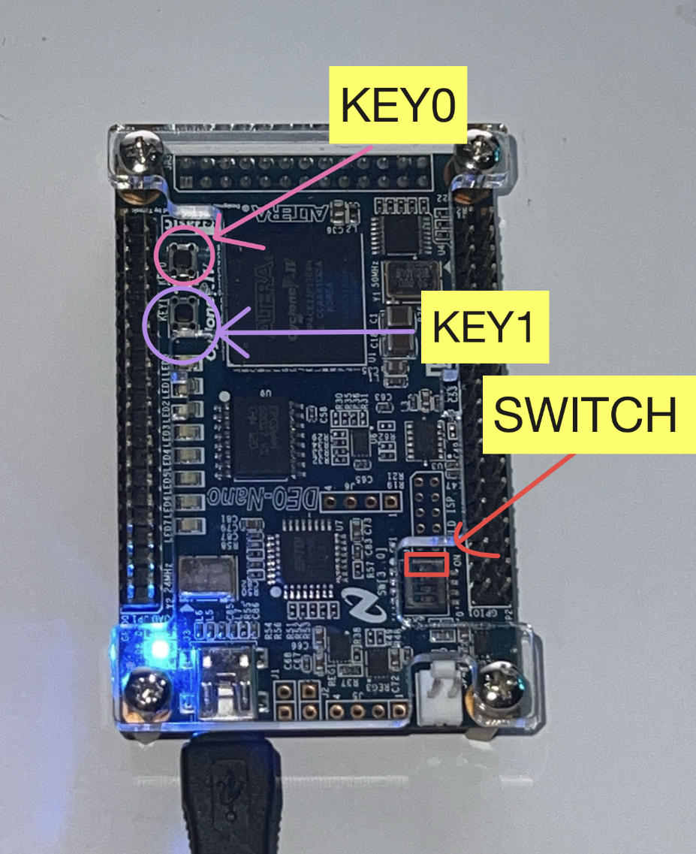

Figure 1. DE0 Nano Board
In Figure 1. We see the labeled switch, and two buttons, that are used to control the program.
- Problem Decomposition

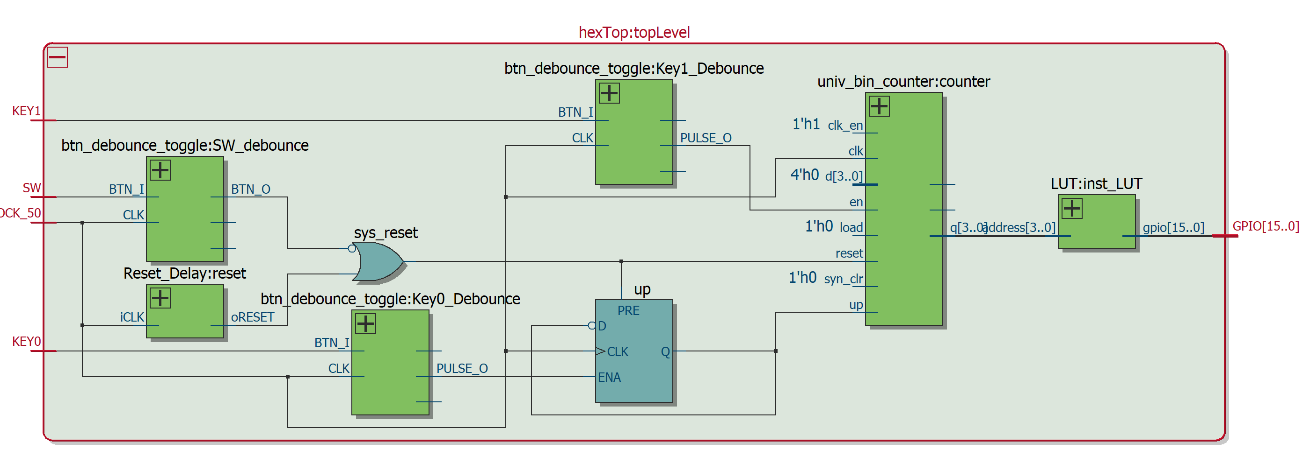
This design was divided into several functional blocks, which would integrate with each other’s signals. Figure 2. below shows the conceptual block diagram of the system, showing the flow of the data.
Figure 2. RTL block diagram generated by Quartus for the top-level file, hexTop
The Reset Delay block was there to ensure that on power-up and when the switch was pressed, the counter would reset, and ‘up’, the signal that told the counter to increment or decrement, would also reset to its default state of ‘1’.
The debouncer code block was there to debounce the raw inputs from the board and then pass the clean inputs to the ‘up’ combinational logic, and to the universal binary counter.
The ‘up’ combinational logic was a flip-flop which acted as a direction register, which calculated and stored whether the system should count up or down.
The universal binary counter was used to take the debounced inputs, and increment or decrement the address that is sent into the lookup table. This counter was a 4-bit binary counter, with a minimum value of 0, and a maximum value of 9, as 10 addresses were required, with the address at 0 giving the hexadecimal output of “0000”.
The Look-up table module maps each 4-bit address to a corresponding 16-bit hexadecimal output. The 10 entries are hard-coded, with a final state in the case of an error of “FFFF”. The lookup table’s output is sent to the GPIO pins on the board, which aren’t currently in use, but could be used to power a 7 segment LED display.
The hexTop file is the controller, which instantiates the other programs, and correctly maps the corresponding signals to the correct ports. There are also two instances of combinational logic within the top level, which is combining the power on cycle with the system reset switch by means of an OR gate. It also has a process that controls the direction of the counter, whether it’s incrementing or decrementing.
The top-level file, DE0_Nano, is the file that instantiates the hexTop file, handles the pin assignments, and maps the ports directly to the physical board. This means we don’t have to deal with checking pin assignments. As seen in Figure 3. this design handles the inputs and outputs sent to and from the board.
Note that the reset switch was fully asynchronous from the clock, as turning the board off does not require a debounce signal.
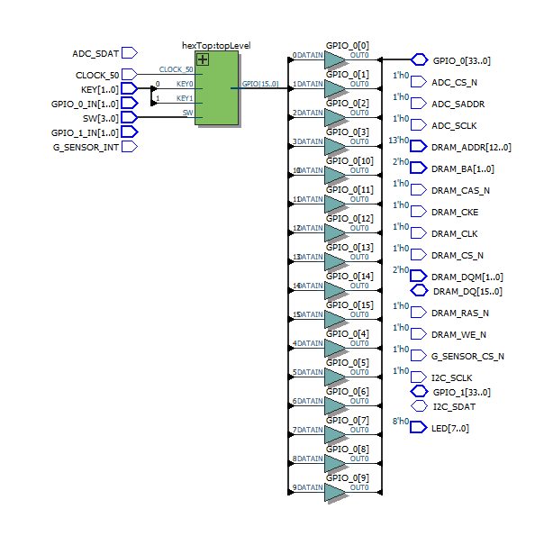

Figure 3. RTL block diagram generated by Quartus of DE0 Nano Top Level

- Detailed Design

The Reset_Delay code was provided for this exam. Its purpose was to generate a reset pulse on power-up to ensure everything starts in a known state. It’s implemented by setting reset to ‘high’ for a short amount of time and then releasing it. Its output ‘reset’ is used with the reset switch from the DE0 Nano board to produce ‘sys_reset’ which would reset the counter on start-up or on button press. The code for this can be found in Appendix 1.
The debouncer code was provided for this exam. The purpose of the debouncer was to stabilize raw input signals from the DE0 Nano board, so that any accidental disruption or non-intended triggers wouldn’t result in any unwanted behavior. It is implemented by using a counter and confirming that the input was stable of the entirety of the counter’s duration, synchronized with the clock. In this case ‘FFFF’ was used as the counter maximum, which equates to waiting 65,353 cycles. This equates to about 1.307ms of delay, which is unnoticeable with human interaction with the board. To test this delay, ModelSim was used to verify that each press produces a clean pulse, after 1.307ms.
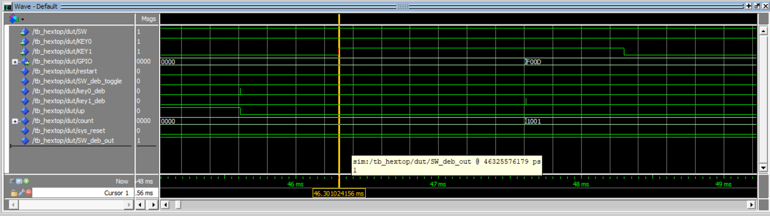
Figure 4. ModelSim output, showing functioning debouncer

As seen in Figure 4. ModelSim shows a functioning debouncer, with approximately 1.3ms of delay time. The highlighted waves show what’s going on. The highlighted wave at the top is KEY0, which is set to ‘0’ by the test bench, for a total of 2ms. After approximately 1.3ms, we see a pulse in the second highlighted wave, in the middle, which is the output of the signal debouncer, a 1 clock cycle pulse. One clock cycle later, (20ns later), the counter decrements one (as up is set to ‘0’). This code snippet can be seen in Figure 5. ahead. The code for the debouncer can be found in Appendix 2., and the code for the ModelSim testbench can be found in Appendix 8.
The Universal Binary Counter code was provided for this exam. The purpose of this program was to track the current address being sent to the lookup table, to a maximum of 9 (“1001”). The provided code was a universal n bit counter, so the count can easily be updated in the code. The parameters of this program were N = 4 (which is the 4-bit counter), N1 = 0, which is the minimum, and N2 = 9, which is the maximum value. Synchronized with the clock, the counter would take the 50MHz clock, ‘sys_reset’, ‘key1_deb’ and ‘up’, as inputs. The system reset would reset the clock back to 0. The ‘key1_deb’ was the debounced signal from the button on the physical board, which would be a pulse sent from the debouncer that caused the counter to either increment or decrement, depending on the ‘up’ signal. ‘Up’ was a signal from the flip-flop that used combinational logic to decide whether the counter should count up or down, based on the other button on the board, Key(0). The other inputs ‘load’, ‘syn_clr’, ‘clk_en’, and ‘d’, where either left open, or set to ‘0’ or ‘1’ depending on necessity for correct function. The code for this can be found in Appendix 3.
The Lookup table code was partially provided for this exam. The main outline was discussed in class, and the implementation of the design was created by me. The table stores 10 16-bit hexadecimal values, all with their own unique assigned address. Any address entered into the lookup table outside the designated addresses will result in an output of “FFFF”. The code for this can be found in Appendix 4.
The top-level code, hexTop was created by me. The top-level block design can be seen in Part C. Figure 2. This code integrates all of the subsystems, by instantiating the reset_delay, the two debouncers, the counter, and the lookup table. There is also some combinational logic. The first combinational logic function is the OR gate, that combines the reset signal with the power-on signal from Reset_Delay to tell the counter to restart its count. The second component is a process that makes sure the ‘up’ signal functions correctly. Seen below is the code snippet that correctly sets ‘up’ from the reset signal and the ‘Key0_deb’ debounced input pulse.

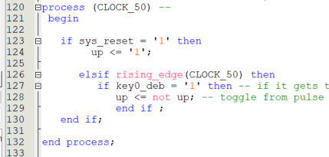

Figure 5. Code snippet for ‘up’ directional signal logic
The code snippet in Figure 5. shows the logic that determines whether the counter will count up or down. If ‘sys_reset’ is ‘1’, which comes from the debounced input from the switch OR the power reset button, then it sets ‘up’ to its default value of ‘1’. Otherwise, it checks every clock cycle to see if the debouncer of the Key(0) input has sent a pulse signal to indicate a debounced signal. The code for hexTop can be found in Appendix 5.
The DE0-Nano top-level file was provided for this exam. This file provides the physical mapping from the hexTop entity. Instantiating the top-level hexTop is all that is required to get the logic from that file to work correctly on the board. The code for this file can be found in Appendix 6.
- Module and Specifications Testing

To test the functionality of this problem, I tested the project with both ModelSim with a testbench, and with SignalTap with the physical board.
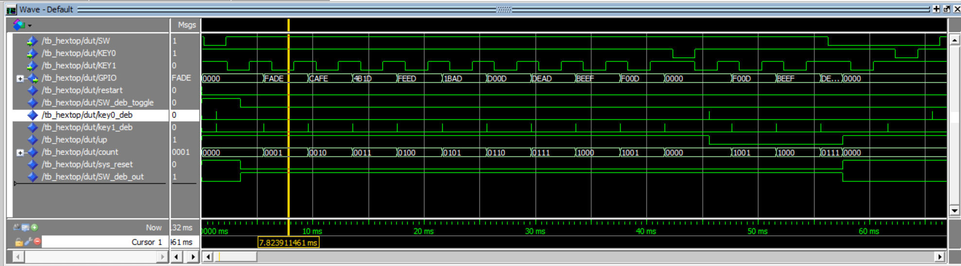
After successfully compiling the code, I created a testbench to simulate the program running, using ModelSim. In the testbench, the code simulates a user holding down the KEY1 button for 2ms each time, to run through the different addresses. After 1.3ms from starting the press, the debouncer sends the signal to the counter, which goes up by 1, which then displays the next value in the lookup table to the GPIO pins, which are shown in GPIO. This is shown in Figure 6. below.
Figure 6. ModelSim Output, showing correct iteration through the look-up table
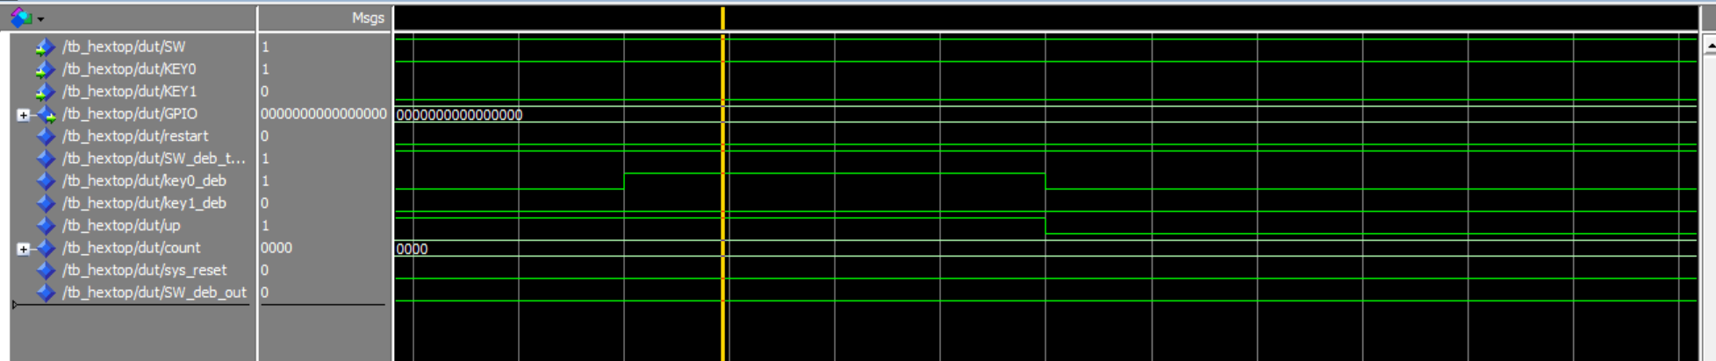
In the testbench, and as shown in Figure 5. we can see the counter correctly traverse through the look-up table. Once it has completed a full rotation through the lookup table, it goes back to the first value, with the output “0000”. We can also see the binary counter output, which counts from 0-9 in binary. Once we reach a full rotation, KEY0 is pressed, which makes ‘up’ change from ‘1’ to ‘0’, and makes the counter count backwards. After 2 iterations of going backwards, the switch is sent a signal from the testbench to switch off, or to ‘0’, which sets ‘up’ back to ‘1’, and renders all other inputs useless. It also resets the counter as shown, as “BEEF” => “0000”. One interesting thing I noticed while conducting testing, was that during the first test-run of this project, the key0 debouncer sent a pulse signal, coming from nowhere.
Figure 7. ModelSim debouncer bug screenshot.
In Figure 7. we can clearly see that the highlighted ‘Key0_deb’ goes high for a clock cycle, which ended up flipping ‘up’, and causing the program to not function as intended. The raw input signal ‘Key0’ which is the only input into the debouncer that should affect the output, was ‘1’ the whole time, and for several ms before and after this random occurrence. After recompiling and relaunching modelsim, I could not replicate the issue. Another screenshot of this bug can be seen in Appendix 8.
All my other testing in ModelSim showed perfect functionality, so this proved full functionality of the program, and I moved on to the next testing software. The code for the ModelSim testbench can be found in Appendix 9.
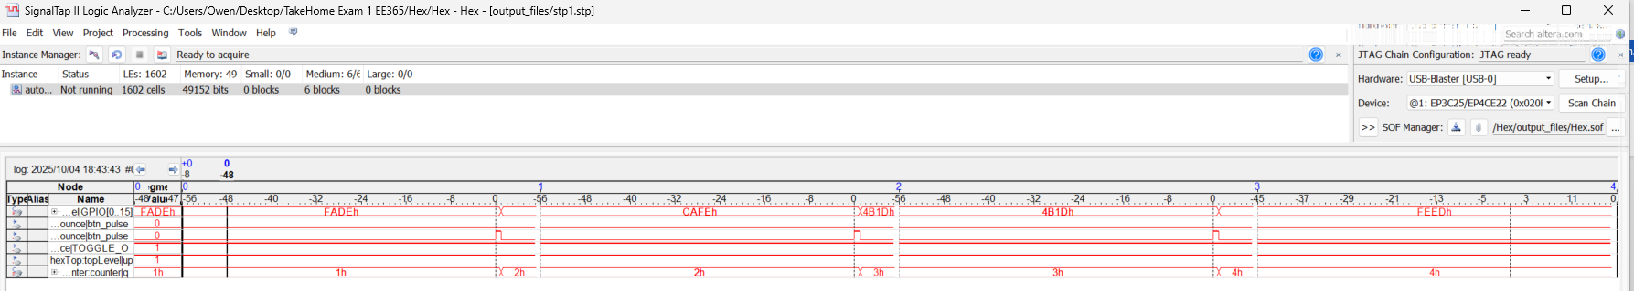
The next software I used to test this project was SignalTap. After successfully compiling the program, I used signal tap to watch the signals sent and received by using the physical board.
Figure 8. SignalTap showing correct function of the counter incrementing
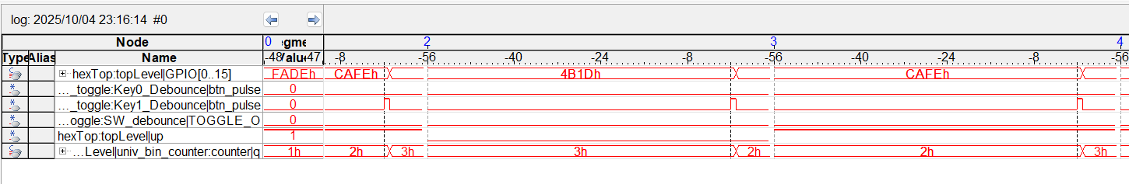
Figure 9. SignalTap showing correct function of the switch, when switched off and then on.

Figure 10. SignalTap showing correct function of counter decrementing

As we can see in Figure 8. and Figure 10. the counter correctly iterates forwards and backwards depending on the ‘up’ signal. In Figure 9. we can see the correct function of the switch, as the SW debounce toggle is set to 0, and no other pulses or signals have any effect on the program, and when the switch is turned back on, ‘up’ is made sure to be set to ‘1’.
This shows full adherence to specifications, and full functionality from the code.
- Results and Analysis
The hexadecimal look-up table program worked completely, and 100% adhered to specifications and assumptions made. The design operated correctly in both the ModelSim simulation testing, and on the DE0-Nano board in SignalTap testing.
Upon first power on, the Reset_Delay module successfully initializes the system, setting the necessary signals to their respective values. Pressing KEY1 reliably iterates through the look-up table, each time incrementing or decrementing the address of the lookup table. Pressing KEY0 reliably toggles the direction of traversal through the lookup table. The switch SW is asynchronous as specified, and does not rely on the clock, aside from the debounced signal, which does rely on the clock to debounce the switch signal. It was not possible to have every signal debounced while also having the switch signal asynchronous and instantaneous. If I wanted the switch to be truly instantaneous, it would be easy to just change the signal in Figure 11. from ‘SW_deb_out’ (the debounced switch signal) to ‘SW’ which is the raw signal from the board.
Figure 11. Code snippet showing where sys_reset could be truly asynchronous

The GPIO output ports correctly reflected each new 16-bit output, and was viewable in SignalTap, with correct function as specified.
All timing and functional behavior matched the ModelSim simulation and SignalTap results. The SignalTap traces verified that each debounced button press generated a single-cycle pulse, which would then prompt the counter to increment or decrement by one. The counter also correctly switched off and reset upon the switch being flipped off on the board, indicating correct functionality of the combinational logic within the top-level code. Overflow and underflow was assumed to be intentional design, and worked as intended.
One interesting thing to note was a glitch with the debouncer code, in which one of the ModelSim simulations had a random pulse come unprompted from the debouncer for KEY0. However this was not replicable after recompilation, and assumed to be a one off issue.
No deviations from specifications were observed, and overall the project was a success, and produced a correct, complete, FPGA design system that fulfills the design goals.
All design specifications were met, and the system functioned as expected in both simulation and hardware verification.

REFERENCES
[1] DE0 Nano User Manual, PDF linked on Moodle https://moodle.clarkson.edu/pluginfile.php/460034/course/section/48501/DE0_Nano_User_Manual_v1.5.pdf
[2] Project 3 code and project report, written by me.
[3] ModelSim Tutorial, PDF linked on Moodle
https://moodle.clarkson.edu/pluginfile.php/460034/course/section/48501/ModelSim_Altera%20Tutorial.pdf
[4] Reset_Delay.vhd, Univ_bin_counter.vhd, and btn_debounce.vhd, provided on Moodle.
[5] Look-up Table rough design, given on One-Note in class

APPENDIX
*Office Blocks the Opening of VHD Files if inserted as objects as icons
This appendix includes every file you would need to replicate this project, not including any of the signal tap or modelsim files. A Zip file of the entire project has been included at the bottom for convenience. Set DE0 Nano as top level.

APPENDIX 1. This file is the RESET_DELAY code provided
library IEEE;
use IEEE.STD_LOGIC_1164.ALL;

--use IEEE.numeric_std.ALL;
use IEEE.STD_LOGIC_ARITH;
use IEEE.STD_LOGIC_UNSIGNED.ALL;

ENTITY Reset_Delay IS
PORT (
SIGNAL iCLK : IN std_logic;
SIGNAL oRESET : OUT std_logic
);
END Reset_Delay;

ARCHITECTURE Arch OF Reset_Delay IS

SIGNAL Cont : std_logic_vector(19 DOWNTO 0):=X"00000";

BEGIN

PROCESS
BEGIN

WAIT UNTIL rising_edge (iCLK);
-- IF Cont /= X"FFFFF" THEN
IF Cont /= X"0000F" THEN
Cont <= Cont + '1';
oRESET <= '1';
ELSE
oRESET <= '0';
END IF;
END PROCESS;

END Arch;

APPENDIX 2. This file is the DEBOUNCER code provided
----------------------------------------------------------------------------
-- btn_debounce.vhd -- Button Debouncer
----------------------------------------------------------------------------
-- Author: Sam Bobrowicz
-- Copyright 2011 Digilent, Inc.
-- Modified: Added toggle output
----------------------------------------------------------------------------
--
----------------------------------------------------------------------------
-- This component is used to debounce signals generated by external push
-- buttons. It is designed to independently debounce a Push button signal.
-- Debouncing is done by only registering a change in a button state if
-- it remains constant for 2^16 clock cycles.
--
-- Port Descriptions:
--
-- BTN_I - The input button signals
-- CLK - Behavior is optimized for a 100 MHz clock
-- BTN_O - The debounced button signals
-- TOGGLE_O - Debounced toggle output
----------------------------------------------------------------------------
--
----------------------------------------------------------------------------
-- Revision History:
-- 08/08/2011(SamB): Created using Xilinx Tools 13.2
-- 10/06/2013 (CU): Converted to one button and added toggle output
----------------------------------------------------------------------------
library IEEE;
use IEEE.STD_LOGIC_1164.ALL;
use IEEE.std_logic_unsigned.all;

entity btn_debounce_toggle is
GENERIC (
CONSTANT CNTR_MAX : std_logic_vector(15 downto 0) := X"FFFF");
Port ( BTN_I : in STD_LOGIC;
CLK : in STD_LOGIC;
BTN_O : out STD_LOGIC;
TOGGLE_O : out STD_LOGIC;
PULSE_O : out STD_LOGIC);
end btn_debounce_toggle;

architecture Behavioral of btn_debounce_toggle is

--constant CNTR_MAX : std_logic_vector(15 downto 0) := X"FFFF";
signal btn_cntr : std_logic_vector(15 downto 0) := (others => '0');
signal btn_reg : std_logic := '0';
signal btn_toggle : std_logic := '1';
signal btn_sync : std_logic_vector(1 downto 0) := (others => '0');
signal btn_pulse : std_logic := '0';

begin

btn_debounce_process : process (CLK)
begin
if (rising_edge(CLK)) then
if (btn_cntr = CNTR_MAX) then
btn_reg <= not(btn_reg);
end if;
end if;
end process;

btn_counter_process : process (CLK)
begin
if (rising_edge(CLK)) then
if ((btn_reg = '1') xor (BTN_I = '1')) then
if (btn_cntr = CNTR_MAX) then
btn_cntr <= (others => '0');
else
btn_cntr <= btn_cntr + 1;
end if;
else
btn_cntr <= (others => '0');
end if;
end if;
end process;

btn_toggle_process : process(CLK)
begin
if (rising_edge(CLK)) then
btn_sync(0) <= btn_reg;
btn_sync(1) <= btn_sync(0);
btn_pulse <= not btn_sync(1) and btn_sync(0);
if btn_pulse = '1' then
btn_toggle <= not btn_toggle;
end if;
end if;
end process;

BTN_O <= btn_reg;
TOGGLE_O <= btn_toggle;
PULSE_O <= btn_pulse;
end Behavioral;

APPENDIX 3. This file is the altered UNIV_BIN_COUNTER code provided
-- Source: http://academic.csuohio.edu/chu_p/rtl/fpga_vhdl.html
-- Listing 4.10
-- modified: added port "clk_en", Sept 5, 2013
-- modified: added upper and lower limits of the counter, Sept 1, 2016

library ieee;
use ieee.std_logic_1164.all;
use ieee.numeric_std.all;

entity univ_bin_counter is
generic(N: integer := 4; N2: integer := 9; N1: integer := 0); -- this should be max of 9, and min of 0 for the TakeHome Exam 1 (10 values specified). Needs 4 bits still. I'm using 9 because 0 would display nothing, and 1-9 will display the specified data
port(
clk, reset : in std_logic;
syn_clr, load, en, up : in std_logic;
clk_en : in std_logic := '1';
d : in std_logic_vector(N-1 downto 0);
max_tick, min_tick : out std_logic;
q : out std_logic_vector(N-1 downto 0)
);
end univ_bin_counter;

architecture arch of univ_bin_counter is
signal r_reg : unsigned(N-1 downto 0);
signal r_next : unsigned(N-1 downto 0);
signal r_1 : unsigned(N-1 downto 0);
signal r_2 : unsigned(N-1 downto 0);

begin
-- register
process(clk,reset)
begin
if (reset='1') then
r_reg <= (others=>'0');
elsif rising_edge(clk) and clk_en = '1' then
r_reg <= r_next;
end if;
end process;

-- next-state logic
r_next <= (others=>'0') when syn_clr='1' else
unsigned(d) when load='1' else
r_1 when en ='1' and up='1' else
r_2 when en ='1' and up='0' else
r_reg;

r_1 <= to_unsigned(N1, r_reg'length) when r_reg = to_unsigned(N2, r_reg'length) else
r_reg + 1;
r_2 <= to_unsigned(N2, r_reg'length) when r_reg = to_unsigned(N1, r_reg'length) else
r_reg - 1;

-- output logic
q <= std_logic_vector(r_reg);
max_tick <= '1' when r_reg=to_unsigned(N2, r_reg'length) else '0';
min_tick <= '1' when r_reg=to_unsigned(N1, r_reg'length) else '0';
end arch;

APPENDIX 4. This file is the Lookup Table code created for this exam
library ieee;
use ieee.std_logic_1164.all;
use ieee.numeric_std.all;

entity LUT is
port(
address : IN STD_LOGIC_VECTOR(3 downto 0); -- this comes from the counter directly
gpio : OUT STD_LOGIC_VECTOR(15 downto 0) -- this outputs to the gpio signal, which is then instantiated in de0 nano and then outputs

);

end entity;

architecture Behavioral of LUT is

begin
with address select
gpio <=
X"0000" when "0000",
X"FADE" when "0001",
X"CAFE" when "0010",
X"4B1D" when "0011",
X"FEED" when "0100",
X"1BAD" when "0101",
X"D00D" when "0110",
X"DEAD" when "0111",
X"BEEF" when "1000",
X"F00D" when "1001",
X"FFFF" when others; -- default case

end architecture;

APPENDIX 5. This file is the hexTop top-level code created for this exam
library ieee;
use ieee.std_logic_1164.all;
use ieee.numeric_std.all;

entity hexTop is
port(
CLOCK_50 : IN std_logic; -- standard clock
SW : IN STD_LOGIC; -- this will come from SW 0 on the board, use btn toggle to function it
KEY0 : IN STD_LOGIC; -- come from button key 0 on the board, use btn toggle, because it toggles between going forward and backward. Default is forward, = 1.
KEY1 : IN STD_LOGIC; -- come from button key 1 on the board, use btn pulse to function it
GPIO : OUT STD_LOGIC_VECTOR(15 downto 0) --- this is the 16 bit number passed from the LUT

);
end entity;

architecture Behavioral of hexTop is
-- gonna need all the debounced signals, toggle for sw, pulse for key0 and key1
-- need some logic to determine reset for the clock and to use power on reset. It will be reset when sw = 0 (low), so that will set en = 0, and reset the clock too
-- once we debounce the signals we send them to the LUT which we need a signal to take from it, and the LUT will send the 16 bit output signal to the GPIO.
signal restart : std_logic; -- send this to counter to reset, happens when sw_deb_toggle is low, and on power on. -- this is supposed to be asynchronous
signal SW_deb_toggle : std_logic;
signal key0_deb : std_logic; -- this is a pulse
signal key1_deb : std_logic;
signal up : std_logic; -- this is the direction of the counter, 0 for down, 1 for up, like in project 3, directly comes from key1_deb pulses and defaults to 1
signal count : std_logic_vector(3 downto 0); -- count output from the univ bin counter, 4 bits
signal sys_reset : std_logic;
signal SW_deb_out : std_logic; -- this is for the output of the button press, so that it will reset asynchronouly

-- LAYOUT:
-- First have inputs
-- Havte a clock
-- Use reset and send that to universal binary counter via a signal on power on, using reset_delay. A
-- Then debounce them
-- Then send to universal binary counter
-- Then send to lookup table, where the outputs from the lookup table will <= gpio, which will then be instantiated in the top level

-- components
COMPONENT reset_delay
PORT(iCLK : IN STD_LOGIC;
oRESET : OUT STD_LOGIC
);
END COMPONENT;

COMPONENT univ_bin_counter
generic(N: integer := 4; N2: integer := 9; N1: integer := 0); -- 4 bit, 9 downto 0
port(
clk, reset : in std_logic;
syn_clr, load, en, up : in std_logic;
clk_en : in std_logic := '1';
d : in std_logic_vector(N-1 downto 0);
max_tick, min_tick : out std_logic;
q : out std_logic_vector(N-1 downto 0)
);
END COMPONENT;

COMPONENT btn_debounce_toggle is
GENERIC (
CONSTANT CNTR_MAX : std_logic_vector(15 downto 0) := X"FFFF"); -- binary max, changed to 000f for testing,
Port ( BTN_I : in STD_LOGIC;
CLK : in STD_LOGIC;
BTN_O : out STD_LOGIC;
TOGGLE_O : out STD_LOGIC;
PULSE_O : out STD_LOGIC);
END COMPONENT;

COMPONENT LUT is
port(
address : IN STD_LOGIC_VECTOR(3 downto 0); -- this comes from the counter directly
gpio : OUT STD_LOGIC_VECTOR(15 downto 0) -- this outputs to the gpio signal, which is then instantiated in de0 nano and then outputs

);

end COMPONENT;

begin

-- debouncers
SW_debounce : btn_debounce_toggle -- this will be a toggle
port map (
BTN_I => SW,
CLK => CLOCK_50,
BTN_O => SW_deb_out,
TOGGLE_O => SW_deb_toggle,
PULSE_O => open
);

Key0_Debounce : btn_debounce_toggle -- this will be a pulse that changes up, which is the toggle for direction, deciding whether its up or down
port map (
BTN_I => key0,
CLK => CLOCK_50,
BTN_O => open,
TOGGLE_O => open,
PULSE_O => key0_deb
);

Key1_Debounce : btn_debounce_toggle -- also a pulse
port map (
BTN_I => key1,
CLK => CLOCK_50,
BTN_O => open,
TOGGLE_O => open,
PULSE_O => key1_deb
);

reset : reset_delay -- the point of this is to reset everything at the start when the board is loaded.
port map ( iCLK => CLOCK_50,
oRESET => restart);

sys_reset <= restart or (not SW_deb_out); -- combinational logic that tells the system to asynchronouly reset upon startup,and upon the switch toggeling.
-- this is not truely asynchronoul, as the debounced signal depends on the clock, so use SW directly?

-- now I've instantiated debounce, and reset delay, I need to do the clock, and the lookup table, and then do instantiate that in top level, and test. I also need to write a testbench for modelsim.
-- we need a clock for the direction, to make sure that on the rising edge its going the correct way or defaulting to 1
process (CLOCK_50) --
begin

if sys_reset = '1' then
up <= '1';

elsif rising_edge(CLOCK_50) then
if key0_deb = '1' then -- if it gets this pulse on the rising edge of a clock it will switch it
up <= not up; -- toggle from pulse instead of driving it twice to make sure it defaults to 1. Even though its active high, it won't reset when we flip the switch without doing this
end if ;
end if;

end process;

counter : univ_bin_counter
generic map ( N => 4, N1 => 0, N2 => 9 ) -- 4 bit counter
port map (
clk => CLOCK_50,
reset => sys_reset,
syn_clr => '0', -- we don't want clear
load => '0',
en => key1_deb, -- this is a pulse from key1_deb
up => up, -- up from the key0
clk_en => '1', -- always able to count if enable is high.
d => (others => '0'),
max_tick => open,
min_tick => open,
q => count -- this is the 4 bit output from the counter, that we will send to the LUT);
);

inst_LUT : LUT
port map(
address => count,
gpio => GPIO

);

end architecture;

APPENDIX 6. This file is the DE0 Nano code provided, with changes made for this project
LIBRARY ieee;
USE ieee.std_logic_1164.all;

ENTITY DE0_NANO IS
PORT (
-- Clock Input
CLOCK_50 : IN STD_LOGIC; -- On Board 50 MHz
-- LED
LED : OUT STD_LOGIC_VECTOR(7 DOWNTO 0); -- LED Green[7:0]

-- Push Button
KEY : IN STD_LOGIC_VECTOR(1 DOWNTO 0); -- Pushbutton[1:0]
-- DPDT Switch
SW : IN STD_LOGIC_VECTOR(3 DOWNTO 0); -- Toggle Switch[3:0]

-- SDRAM Interface
DRAM_DQ : INOUT STD_LOGIC_VECTOR(15 DOWNTO 0); -- SDRAM Data bus 16 Bits
DRAM_ADDR : OUT STD_LOGIC_VECTOR(12 DOWNTO 0); -- SDRAM Address bus 12 Bits
DRAM_DQM : OUT STD_LOGIC_VECTOR(1 DOWNTO 0); -- SDRAM Data Mask
DRAM_WE_N : OUT STD_LOGIC; -- SDRAM Write Enable
DRAM_CAS_N : OUT STD_LOGIC; -- SDRAM Column Address Strobe
DRAM_RAS_N : OUT STD_LOGIC; -- SDRAM Row Address Strobe
DRAM_CS_N : OUT STD_LOGIC; -- SDRAM Chip Select
DRAM_BA : OUT STD_LOGIC_VECTOR(1 DOWNTO 0); -- SDRAM Bank Address
DRAM_CLK : OUT STD_LOGIC; -- SDRAM Clock
DRAM_CKE : OUT STD_LOGIC; -- SDRAM Clock Enable

-- Flash Interface
-- EPCS_ASDO : OUT STD_LOGIC;
-- EPCS_DATA0 : IN STD_LOGIC;
-- EPCS_DCLK : OUT STD_LOGIC;
-- EPCS_NCSO : OUT STD_LOGIC;

-- Accelerometer and EEPROM
G_SENSOR_CS_N : OUT STD_LOGIC;
G_SENSOR_INT : IN STD_LOGIC;
I2C_SCLK : OUT STD_LOGIC;
I2C_SDAT : INOUT STD_LOGIC;

-- ADC
ADC_CS_N : OUT STD_LOGIC;
ADC_SADDR : OUT STD_LOGIC;
ADC_SCLK : OUT STD_LOGIC;
ADC_SDAT : IN STD_LOGIC;

-- 2x13 GPIO Header
-- GPIO_2 : INOUT STD_LOGIC_VECTOR(12 DOWNTO 0);
-- GPIO_2_IN : IN STD_LOGIC_VECTOR(2 DOWNTO 0);

-- GPIO_0, GPIO_0 connect to GPIO Default
GPIO_0 : INOUT STD_LOGIC_VECTOR(33 DOWNTO 0);
GPIO_0_IN : IN STD_LOGIC_VECTOR(1 DOWNTO 0);

-- GPIO_0, GPIO_1 connect to GPIO Default
GPIO_1 : INOUT STD_LOGIC_VECTOR(33 DOWNTO 0);
GPIO_1_IN : IN STD_LOGIC_VECTOR(1 DOWNTO 0)

);
END DE0_NANO;

architecture structural of DE0_NANO is

COMPONENT hexTop is
port(
CLOCK_50 : IN std_logic; -- standard clock
SW : IN STD_LOGIC; -- this will come from SW 0 on the board, use btn toggle to function it
KEY0 : IN STD_LOGIC; -- come from button key 0 on the board, use btn toggle, because it toggles between going forward and backward. Default is forward, = 1.
KEY1 : IN STD_LOGIC; -- come from button key 1 on the board, use btn pulse to function it
GPIO : OUT STD_LOGIC_VECTOR(15 downto 0) --- this is the 16 bit number passed from the LUT

);
end COMPONENT;
begin
topLevel : hexTop
port map (
CLOCK_50 => CLOCK_50,
SW => SW(0),
KEY0 => KEY(0),
KEY1 => KEY(1),
GPIO => GPIO_0(15 downto 0)

);

end structural;

APPENDIX 7. This file is the CSV file with pin assignments provided for this project
# Copyright (C) 1991-2011 Altera Corporation
# Your use of Altera Corporation's design tools, logic functions
# and other software and tools, and its AMPP partner logic
# functions, and any output files from any of the foregoing
# (including device programming or simulation files), and any
# associated documentation or information are expressly subject
# to the terms and conditions of the Altera Program License
# Subscription Agreement, Altera MegaCore Function License
# Agreement, or other applicable license agreement, including,
# without limitation, that your use is for the sole purpose of
# programming logic devices manufactured by Altera and sold by
# Altera or its authorized distributors. Please refer to the
# applicable agreement for further details.

# Quartus II 32-bit Version 11.1 Build 173 11/01/2011 SJ Full Version
# File: C:\Demo\DE0_NANO_ADC\DE0_NANO.csv
# Generated on: Sun Sep 16 19:39:35 2012

# Note: The column header names should not be changed if you wish to import this .csv file into the Quartus II software.

To,Direction,Location,I/O Bank,VREF Group,I/O Standard,Reserved,Current Strength,Slew Rate,Differential Pair
ADC_CS_N,Output,PIN_A10,7,B7_N0,3.3-V LVTTL,,,,
ADC_SADDR,Output,PIN_B10,7,B7_N0,3.3-V LVTTL,,,,
ADC_SCLK,Output,PIN_B14,7,B7_N0,3.3-V LVTTL,,,,
ADC_SDAT,Input,PIN_A9,7,B7_N0,3.3-V LVTTL,,,,
CLOCK_50,Input,PIN_R8,3,B3_N0,3.3-V LVTTL,,,,
DRAM_ADDR[12],Output,PIN_L4,2,B2_N0,3.3-V LVTTL,,,,
DRAM_ADDR[11],Output,PIN_N1,2,B2_N0,3.3-V LVTTL,,,,
DRAM_ADDR[10],Output,PIN_N2,2,B2_N0,3.3-V LVTTL,,,,
DRAM_ADDR[9],Output,PIN_P1,2,B2_N0,3.3-V LVTTL,,,,
DRAM_ADDR[8],Output,PIN_R1,2,B2_N0,3.3-V LVTTL,,,,
DRAM_ADDR[7],Output,PIN_T6,3,B3_N0,3.3-V LVTTL,,,,
DRAM_ADDR[6],Output,PIN_N8,3,B3_N0,3.3-V LVTTL,,,,
DRAM_ADDR[5],Output,PIN_T7,3,B3_N0,3.3-V LVTTL,,,,
DRAM_ADDR[4],Output,PIN_P8,3,B3_N0,3.3-V LVTTL,,,,
DRAM_ADDR[3],Output,PIN_M8,3,B3_N0,3.3-V LVTTL,,,,
DRAM_ADDR[2],Output,PIN_N6,3,B3_N0,3.3-V LVTTL,,,,
DRAM_ADDR[1],Output,PIN_N5,3,B3_N0,3.3-V LVTTL,,,,
DRAM_ADDR[0],Output,PIN_P2,2,B2_N0,3.3-V LVTTL,,,,
DRAM_BA[1],Output,PIN_M6,3,B3_N0,3.3-V LVTTL,,,,
DRAM_BA[0],Output,PIN_M7,3,B3_N0,3.3-V LVTTL,,,,
DRAM_CAS_N,Output,PIN_L1,2,B2_N0,3.3-V LVTTL,,,,
DRAM_CKE,Output,PIN_L7,3,B3_N0,3.3-V LVTTL,,,,
DRAM_CLK,Output,PIN_R4,3,B3_N0,3.3-V LVTTL,,,,
DRAM_CS_N,Output,PIN_P6,3,B3_N0,3.3-V LVTTL,,,,
DRAM_DQ[15],Bidir,PIN_K1,2,B2_N0,3.3-V LVTTL,,,,
DRAM_DQ[14],Bidir,PIN_N3,3,B3_N0,3.3-V LVTTL,,,,
DRAM_DQ[13],Bidir,PIN_P3,3,B3_N0,3.3-V LVTTL,,,,
DRAM_DQ[12],Bidir,PIN_R5,3,B3_N0,3.3-V LVTTL,,,,
DRAM_DQ[11],Bidir,PIN_R3,3,B3_N0,3.3-V LVTTL,,,,
DRAM_DQ[10],Bidir,PIN_T3,3,B3_N0,3.3-V LVTTL,,,,
DRAM_DQ[9],Bidir,PIN_T2,3,B3_N0,3.3-V LVTTL,,,,
DRAM_DQ[8],Bidir,PIN_T4,3,B3_N0,3.3-V LVTTL,,,,
DRAM_DQ[7],Bidir,PIN_R7,3,B3_N0,3.3-V LVTTL,,,,
DRAM_DQ[6],Bidir,PIN_J1,2,B2_N0,3.3-V LVTTL,,,,
DRAM_DQ[5],Bidir,PIN_J2,2,B2_N0,3.3-V LVTTL,,,,
DRAM_DQ[4],Bidir,PIN_K2,2,B2_N0,3.3-V LVTTL,,,,
DRAM_DQ[3],Bidir,PIN_K5,2,B2_N0,3.3-V LVTTL,,,,
DRAM_DQ[2],Bidir,PIN_L8,3,B3_N0,3.3-V LVTTL,,,,
DRAM_DQ[1],Bidir,PIN_G1,1,B1_N0,3.3-V LVTTL,,,,
DRAM_DQ[0],Bidir,PIN_G2,1,B1_N0,3.3-V LVTTL,,,,
DRAM_DQM[1],Output,PIN_T5,3,B3_N0,3.3-V LVTTL,,,,
DRAM_DQM[0],Output,PIN_R6,3,B3_N0,3.3-V LVTTL,,,,
DRAM_RAS_N,Output,PIN_L2,2,B2_N0,3.3-V LVTTL,,,,
DRAM_WE_N,Output,PIN_C2,1,B1_N0,3.3-V LVTTL,,,,
EPCS_ASDO,Output,PIN_C1,1,B1_N0,3.3-V LVTTL,,,,
EPCS_DATA0,Input,PIN_H2,1,B1_N0,3.3-V LVTTL,,,,
EPCS_DCLK,Output,PIN_H1,1,B1_N0,3.3-V LVTTL,,,,
EPCS_NCSO,Output,PIN_D2,1,B1_N0,3.3-V LVTTL,,,,
GPIO_0[33],Bidir,PIN_B12,7,B7_N0,3.3-V LVTTL,,,,
GPIO_0[32],Bidir,PIN_D12,7,B7_N0,3.3-V LVTTL,,,,
GPIO_0[31],Bidir,PIN_D11,7,B7_N0,3.3-V LVTTL,,,,
GPIO_0[30],Bidir,PIN_A12,7,B7_N0,3.3-V LVTTL,,,,
GPIO_0[29],Bidir,PIN_B11,7,B7_N0,3.3-V LVTTL,,,,
GPIO_0[28],Bidir,PIN_C11,7,B7_N0,3.3-V LVTTL,,,,
GPIO_0[27],Bidir,PIN_E10,7,B7_N0,3.3-V LVTTL,,,,
GPIO_0[26],Bidir,PIN_E11,7,B7_N0,3.3-V LVTTL,,,,
GPIO_0[25],Bidir,PIN_D9,7,B7_N0,3.3-V LVTTL,,,,
GPIO_0[24],Bidir,PIN_C9,7,B7_N0,3.3-V LVTTL,,,,
GPIO_0[23],Bidir,PIN_E9,7,B7_N0,3.3-V LVTTL,,,,
GPIO_0[22],Bidir,PIN_F9,7,B7_N0,3.3-V LVTTL,,,,
GPIO_0[21],Bidir,PIN_F8,8,B8_N0,3.3-V LVTTL,,,,
GPIO_0[20],Bidir,PIN_E8,8,B8_N0,3.3-V LVTTL,,,,
GPIO_0[19],Bidir,PIN_D8,8,B8_N0,3.3-V LVTTL,,,,
GPIO_0[18],Bidir,PIN_E7,8,B8_N0,3.3-V LVTTL,,,,
GPIO_0[17],Bidir,PIN_E6,8,B8_N0,3.3-V LVTTL,,,,
GPIO_0[16],Bidir,PIN_C8,8,B8_N0,3.3-V LVTTL,,,,
GPIO_0[15],Bidir,PIN_C6,8,B8_N0,3.3-V LVTTL,,,,
GPIO_0[14],Bidir,PIN_A7,8,B8_N0,3.3-V LVTTL,,,,
GPIO_0[13],Bidir,PIN_D6,8,B8_N0,3.3-V LVTTL,,,,
GPIO_0[12],Bidir,PIN_B7,8,B8_N0,3.3-V LVTTL,,,,
GPIO_0[11],Bidir,PIN_A6,8,B8_N0,3.3-V LVTTL,,,,
GPIO_0[10],Bidir,PIN_B6,8,B8_N0,3.3-V LVTTL,,,,
GPIO_0[9],Bidir,PIN_D5,8,B8_N0,3.3-V LVTTL,,,,
GPIO_0[8],Bidir,PIN_A5,8,B8_N0,3.3-V LVTTL,,,,
GPIO_0[7],Bidir,PIN_B5,8,B8_N0,3.3-V LVTTL,,,,
GPIO_0[6],Bidir,PIN_A4,8,B8_N0,3.3-V LVTTL,,,,
GPIO_0[5],Bidir,PIN_B4,8,B8_N0,3.3-V LVTTL,,,,
GPIO_0[4],Bidir,PIN_B3,8,B8_N0,3.3-V LVTTL,,,,
GPIO_0[3],Bidir,PIN_A3,8,B8_N0,3.3-V LVTTL,,,,
GPIO_0[2],Bidir,PIN_A2,8,B8_N0,3.3-V LVTTL,,,,
GPIO_0[1],Bidir,PIN_C3,8,B8_N0,3.3-V LVTTL,,,,
GPIO_0[0],Bidir,PIN_D3,8,B8_N0,3.3-V LVTTL,,,,
GPIO_0_IN[1],Input,PIN_B8,8,B8_N0,3.3-V LVTTL,,,,
GPIO_0_IN[0],Input,PIN_A8,8,B8_N0,3.3-V LVTTL,,,,
GPIO_1[33],Bidir,PIN_J14,5,B5_N0,3.3-V LVTTL,,,,
GPIO_1[32],Bidir,PIN_J13,5,B5_N0,3.3-V LVTTL,,,,
GPIO_1[31],Bidir,PIN_K15,5,B5_N0,3.3-V LVTTL,,,,
GPIO_1[30],Bidir,PIN_J16,5,B5_N0,3.3-V LVTTL,,,,
GPIO_1[29],Bidir,PIN_L13,5,B5_N0,3.3-V LVTTL,,,,
GPIO_1[28],Bidir,PIN_M10,4,B4_N0,3.3-V LVTTL,,,,
GPIO_1[27],Bidir,PIN_N14,5,B5_N0,3.3-V LVTTL,,,,
GPIO_1[26],Bidir,PIN_L14,5,B5_N0,3.3-V LVTTL,,,,
GPIO_1[25],Bidir,PIN_P14,4,B4_N0,3.3-V LVTTL,,,,
GPIO_1[24],Bidir,PIN_N15,5,B5_N0,3.3-V LVTTL,,,,
GPIO_1[23],Bidir,PIN_N16,5,B5_N0,3.3-V LVTTL,,,,
GPIO_1[22],Bidir,PIN_R14,4,B4_N0,3.3-V LVTTL,,,,
GPIO_1[21],Bidir,PIN_P16,5,B5_N0,3.3-V LVTTL,,,,
GPIO_1[20],Bidir,PIN_P15,5,B5_N0,3.3-V LVTTL,,,,
GPIO_1[19],Bidir,PIN_L15,5,B5_N0,3.3-V LVTTL,,,,
GPIO_1[18],Bidir,PIN_R16,5,B5_N0,3.3-V LVTTL,,,,
GPIO_1[17],Bidir,PIN_K16,5,B5_N0,3.3-V LVTTL,,,,
GPIO_1[16],Bidir,PIN_L16,5,B5_N0,3.3-V LVTTL,,,,
GPIO_1[15],Bidir,PIN_N11,4,B4_N0,3.3-V LVTTL,,,,
GPIO_1[14],Bidir,PIN_N9,4,B4_N0,3.3-V LVTTL,,,,
GPIO_1[13],Bidir,PIN_P9,4,B4_N0,3.3-V LVTTL,,,,
GPIO_1[12],Bidir,PIN_N12,4,B4_N0,3.3-V LVTTL,,,,
GPIO_1[11],Bidir,PIN_R10,4,B4_N0,3.3-V LVTTL,,,,
GPIO_1[10],Bidir,PIN_P11,4,B4_N0,3.3-V LVTTL,,,,
GPIO_1[9],Bidir,PIN_R11,4,B4_N0,3.3-V LVTTL,,,,
GPIO_1[8],Bidir,PIN_T10,4,B4_N0,3.3-V LVTTL,,,,
GPIO_1[7],Bidir,PIN_T11,4,B4_N0,3.3-V LVTTL,,,,
GPIO_1[6],Bidir,PIN_R12,4,B4_N0,3.3-V LVTTL,,,,
GPIO_1[5],Bidir,PIN_T12,4,B4_N0,3.3-V LVTTL,,,,
GPIO_1[4],Bidir,PIN_R13,4,B4_N0,3.3-V LVTTL,,,,
GPIO_1[3],Bidir,PIN_T13,4,B4_N0,3.3-V LVTTL,,,,
GPIO_1[2],Bidir,PIN_T14,4,B4_N0,3.3-V LVTTL,,,,
GPIO_1[1],Bidir,PIN_T15,4,B4_N0,3.3-V LVTTL,,,,
GPIO_1[0],Bidir,PIN_F13,6,B6_N0,3.3-V LVTTL,,,,
GPIO_1_IN[1],Input,PIN_R9,4,B4_N0,3.3-V LVTTL,,,,
GPIO_1_IN[0],Input,PIN_T9,4,B4_N0,3.3-V LVTTL,,,,
GPIO_2[12],Bidir,PIN_G15,6,B6_N0,3.3-V LVTTL,,,,
GPIO_2[11],Bidir,PIN_G16,6,B6_N0,3.3-V LVTTL,,,,
GPIO_2[10],Bidir,PIN_F14,6,B6_N0,3.3-V LVTTL,,,,
GPIO_2[9],Bidir,PIN_F16,6,B6_N0,3.3-V LVTTL,,,,
GPIO_2[8],Bidir,PIN_F15,6,B6_N0,3.3-V LVTTL,,,,
GPIO_2[7],Bidir,PIN_D14,7,B7_N0,3.3-V LVTTL,,,,
GPIO_2[6],Bidir,PIN_D15,6,B6_N0,3.3-V LVTTL,,,,
GPIO_2[5],Bidir,PIN_D16,6,B6_N0,3.3-V LVTTL,,,,
GPIO_2[4],Bidir,PIN_C15,6,B6_N0,3.3-V LVTTL,,,,
GPIO_2[3],Bidir,PIN_C16,6,B6_N0,3.3-V LVTTL,,,,
GPIO_2[2],Bidir,PIN_C14,7,B7_N0,3.3-V LVTTL,,,,
GPIO_2[1],Bidir,PIN_B16,6,B6_N0,3.3-V LVTTL,,,,
GPIO_2[0],Bidir,PIN_A14,7,B7_N0,3.3-V LVTTL,,,,
GPIO_2_IN[2],Input,PIN_M16,5,B5_N0,3.3-V LVTTL,,,,
GPIO_2_IN[1],Input,PIN_E16,6,B6_N0,3.3-V LVTTL,,,,
GPIO_2_IN[0],Input,PIN_E15,6,B6_N0,3.3-V LVTTL,,,,
G_SENSOR_CS_N,Output,PIN_G5,1,B1_N0,3.3-V LVTTL,,,,
G_SENSOR_INT,Input,PIN_M2,2,B2_N0,3.3-V LVTTL,,,,
I2C_SCLK,Output,PIN_F2,1,B1_N0,3.3-V LVTTL,,,,
I2C_SDAT,Bidir,PIN_F1,1,B1_N0,3.3-V LVTTL,,,,
KEY[1],Input,PIN_E1,1,B1_N0,3.3-V LVTTL,,,,
KEY[0],Input,PIN_J15,5,B5_N0,3.3-V LVTTL,,,,
LED[7],Output,PIN_L3,2,B2_N0,3.3-V LVTTL,,,,
LED[6],Output,PIN_B1,1,B1_N0,3.3-V LVTTL,,,,
LED[5],Output,PIN_F3,1,B1_N0,3.3-V LVTTL,,,,
LED[4],Output,PIN_D1,1,B1_N0,3.3-V LVTTL,,,,
LED[3],Output,PIN_A11,7,B7_N0,3.3-V LVTTL,,,,
LED[2],Output,PIN_B13,7,B7_N0,3.3-V LVTTL,,,,
LED[1],Output,PIN_A13,7,B7_N0,3.3-V LVTTL,,,,
LED[0],Output,PIN_A15,7,B7_N0,3.3-V LVTTL,,,,
SW[3],Input,PIN_M15,5,B5_N0,3.3-V LVTTL,,,,
SW[2],Input,PIN_B9,7,B7_N0,3.3-V LVTTL,,,,
SW[1],Input,PIN_T8,3,B3_N0,3.3-V LVTTL,,,,
SW[0],Input,PIN_M1,2,B2_N0,3.3-V LVTTL,,,,
altera_reserved_tck,Input,,,,,,,,
altera_reserved_tdi,Input,,,,,,,,
altera_reserved_tdo,Output,,,,,,,,
altera_reserved_tms,Input,,,,,,,,

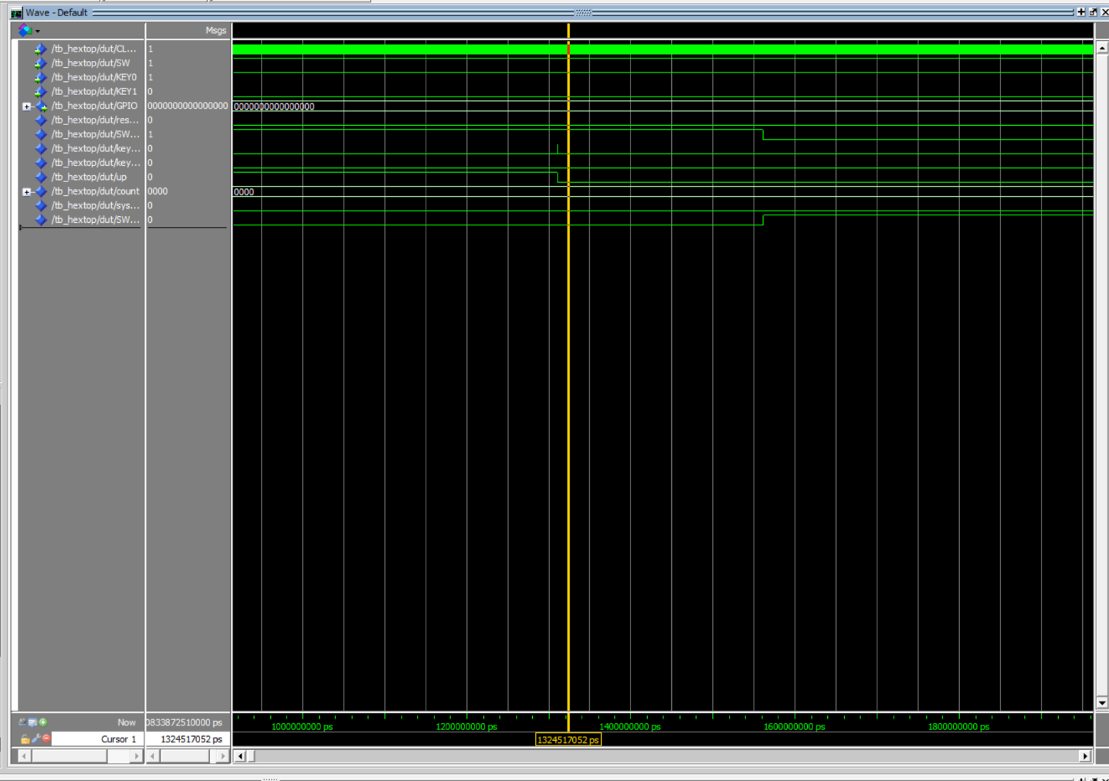
APPENDIX 8. Another screenshot of the debouncer bug, including clock and showing KEY0 was 0 the entire time.

APPENDIX 9. This is the Testbench I created for ModelSim
library ieee;
use ieee.std_logic_1164.all;

entity tb_hexTop is
end entity;

architecture rtl of tb_hexTop is
signal CLOCK_50 : std_logic := '0';
signal SW : std_logic := '1'; -- active low (0) starting out
signal KEY0 : std_logic := '1'; -- toggle up or down
signal KEY1 : std_logic := '1'; -- display

signal GPIO : std_logic_vector(15 downto 0); -- output

constant CLK_HALF : time := 10 ns; -- 50mhz clock is 20 ns cycles, so up is 10 down is 10\

begin
-- simulates clock
clk : process
begin
CLOCK_50 <= '0'; wait for CLK_HALF;
CLOCK_50 <= '1'; wait for CLK_HALF;
end process;

dut : entity work.hexTop
port map (
CLOCK_50 => CLOCK_50,
SW => SW,
KEY0 => KEY0,
KEY1 => KEY1,
GPIO => GPIO
);

-- start up
hexTopSim : process
begin
-- make sure reset_delay isn't doing anything still when test starting
wait for 200 us;

-- SW low (active-low)
SW <= '0'; wait for 2 ms; SW <= '1';

-- see that Key1 steps the data forward
wait for 100 us;
-- for some reason theres a bug in the debouncer code that causes it, under simulation levels, to randomly go low.
--KEY0 <= '0'; wait for 2ms; KEY0 <= '1'; --unfortunately KEY0 is reversed now, but to check sim is working for everything else we'll keep it as is
KEY1 <= '0'; wait for 2 ms; KEY1 <= '1'; -- debounce is 65,353 cycles, which is around 1.3ms, so use 2ms to be safe (or change debounce for testing, but this is fine)

wait for 2 ms;
KEY1 <= '0'; wait for 2 ms; KEY1 <= '1';

wait for 2 ms;
KEY1 <= '0'; wait for 2 ms; KEY1 <= '1';

wait for 2 ms;--3
KEY1 <= '0'; wait for 2 ms; KEY1 <= '1';

wait for 2 ms;--4
KEY1 <= '0'; wait for 2 ms; KEY1 <= '1';

wait for 2 ms;--5
KEY1 <= '0'; wait for 2 ms; KEY1 <= '1';

wait for 2 ms;--6
KEY1 <= '0'; wait for 2 ms; KEY1 <= '1';

wait for 2 ms;--7
KEY1 <= '0'; wait for 2 ms; KEY1 <= '1';

wait for 2 ms;--8
KEY1 <= '0'; wait for 2 ms; KEY1 <= '1';

wait for 2 ms;--9
KEY1 <= '0'; wait for 2 ms; KEY1 <= '1';

wait for 2 ms;--10
-- completes testing of the key1, now lets test direction
KEY0 <= '0'; wait for 2 ms; KEY0 <= '1';
KEY1 <= '0'; wait for 2 ms; KEY1 <= '1';

-- this should go down 1
wait for 2 ms;
KEY1 <= '0'; wait for 2 ms; KEY1 <= '1';

wait for 2 ms; -- should go down again
KEY1 <= '0'; wait for 2 ms; KEY1 <= '1';

wait for 2 ms;--should go down a 3rd time

-- now test reset
SW <= '0'; wait for 2ms;

-- now the switch is off, meaning nothing should happen with other inputs
KEY1 <= '0'; wait for 2 ms; KEY1 <= '1';

wait for 2 ms;
KEY0 <= '0'; wait for 2 ms; KEY0 <= '1';

wait for 2 ms;

SW <= '1'; wait for 2ms; -- turning it back on
-- default values should be set, ASSERT that up = 1, which it is on reset

wait;

end process;

end architecture;

