Report Evaluation Form:
EE 365 Advanced Digital Design, Fall 2025

Total Grade _______/50

Project Title _______Parking Lot Car Counter___________ Project Grade _______/

Report Writers ___Owen Wild and Brendan Kelley__________________________________ Report Grade _______/

I. Report Content (20 points): If any area below is entirely missing, 0 points are given.

A. Summary (Executive summary or abstract) ____/2
It should summarize the design problem, the overall approach, and the results regarding how well the specifications were met.
____Excellent _____Good _____Average _____Fair _____None

B. Design Problem Statement (Interpretation of the Specification) ____/2
Explain what was to be designed, what assumptions were made, and what constraints were placed on your design.
____Excellent _____Good _____Average _____Fair _____None

C. Problem Decomposition ____/4
It should describe the overall design in terms of functional blocks needed to meet the specifications, explain what each functional block is intended to do, and include a block diagram showing the inputs and outputs of each functional block.
____Excellent _____Good _____Average _____Fair _____None

D. Detailed Design ____/6
It should describe how the design works in sufficient detail so that a knowledgeable person can understand and verify that the design is technically sound. There should be adequate documentation to allow a knowledgeable person to duplicate your design. It would be best to have schematics for all hardware and source code for all programmable logic, VHDL, etc.
____Excellent _____Good _____Average _____Fair _____None

E. Module and Specifications Testing ____/4
It should also describe how the design was tested at the module level and corrections made. It should also describe how the completed design was tested to verify that it meets specifications or identifies any deviations from the specifications.
____Excellent _____Good _____Average _____Fair _____None

F. Results and Analysis ____/2
Describe how well your design met the specifications and discuss any deviations from those specifications. Give an analysis of any deviations from the specification and explain what should be done to correct these.
____Excellent _____Good _____Average _____Fair _____None

II. Report form. (5 points) The report should be produced professionally. Basis of Evaluation:
1 - no deficiencies, 1/2- no more than two minor deficiencies, 0-1, major or multiple minor deficiencies

The report is well organized, with explanatory text for each section. | ____/1
The written language is clear and grammatically correct. | ____/1
All figures and tables are referenced in the text and appear shortly after the reference or are located in an appendix with appropriate text to refer the reader to. All figures and tables have a caption | ____/1
All diagrams and schematics are drawn using CAD-type software with no hand drawing or lettering | ____/1
The report includes a list of references used in completing the design and documenting your results | ____/1

Owen Wild and Brendan Kelley 9/23/2025
EE 365 Advanced Digital Design Project 3

Parking Lot Car Counter Design

- Summary/Abstract
The goal of this lab is to design and implement a parking lot counter using the DE0 Nano FPGA board, with a 50MHz clock. The core design that was developed for this lab was a finite state machine that would interpret the inputs from the KY-040 Rotary Encoder. The problem required using the Encoder was used to simulate vehicle sensors at a gate, which would be able to distinguish between cars entering, cars leaving, and cars partially entering or leaving and then changing their mind. The finite state machine, after determining whether a car has entered or exited, will send a pulse to a counter, which will add or subtract 1 from the count, unless the lot is full and another car tries to enter, or the lot is empty, and a car tries to leave.
Using the provided univ_bin _counter (set up as a 5-bit counter), Btn_Debouncer, and reset_delay VHD files, we wrote a state machine and a top level VHD file, which was instantiated in the DE0 Nano file provided, to ensure correct pin assignments.
Overall we were able to successfully adhere to all of these design specifications, creating a product with a working state machine and top-level, that successfully passes all signaltap and modelsim tests.

- Design Problem Statement
The objective of this project was to design and implement a finite state machine, and design a top-level design, and then instantiate the top-level design in the DE0 Nano file.
For this project it was assumed that there would be no way for a car to be between two sensors and not be detected by at least one. It was also assumed that each click from the rotary encoder corresponds to a full entry/exit sequence, where a clockwise rotation would simulate a car entering, and a counterclockwise rotation would simulate a car leaving.
There were several constraints placed on this project. Firstly, there was a limited capacity for the parking lot of 25 cars. Secondly, the count could not go below 0, as the concept of negative cars would not make sense. Third, the system must reset at power-on, and have a reset switch, which would reset the count on startup and at the press of the KY040 Rotary Encoder knob.
The finite state machine also had constraints applied. The design of the finite state machine was planned out, such that it would cycle through the following inputs, only sending an enable and increment/decrement pulse when reaching the final state.
Car entering / Clockwise state machine states: 11, 01, 00, 10 to 11
Car leaving / Counter-clockwise state machine states: 11, 10, 00, 10 to 11

- Problem Decomposition

This design was divided into several functional blocks, which would integrate with each other’s signals. The figure below is my handwritten approach of the design, when planning out the design of the top level. 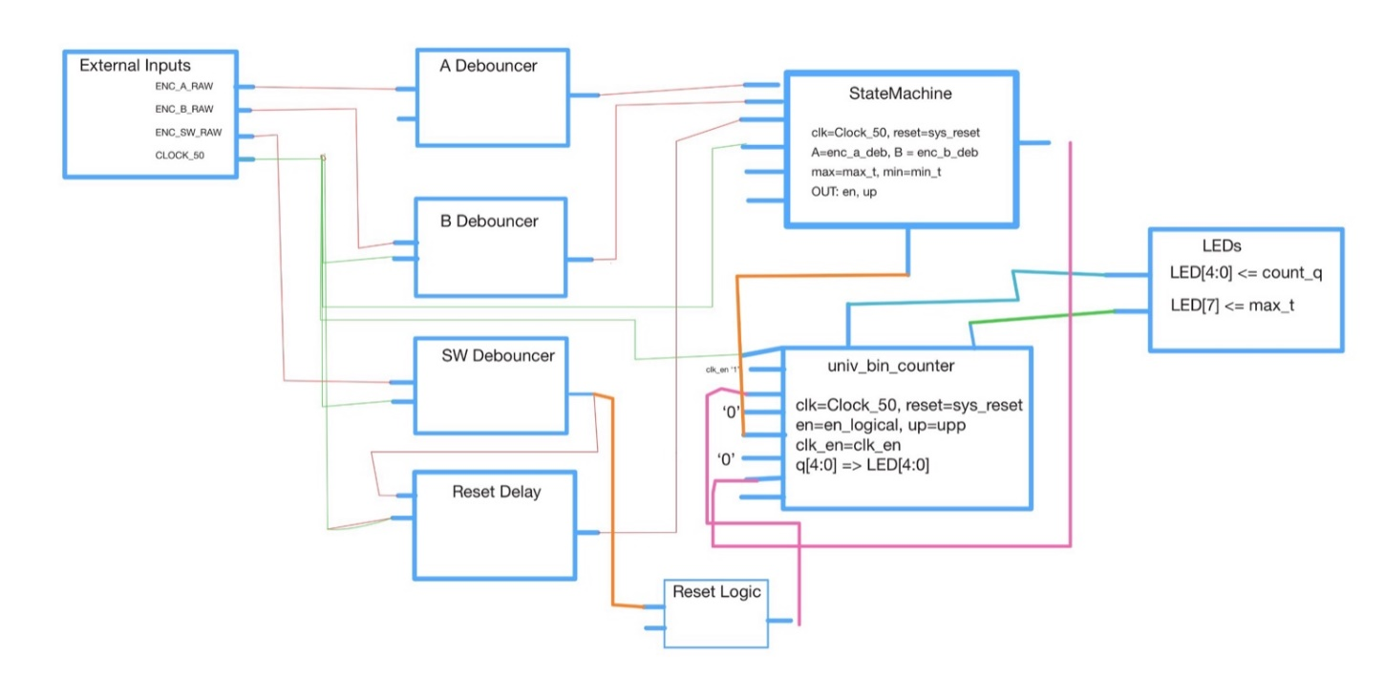
Figure 1. Hand-drawn plan for the circuit.
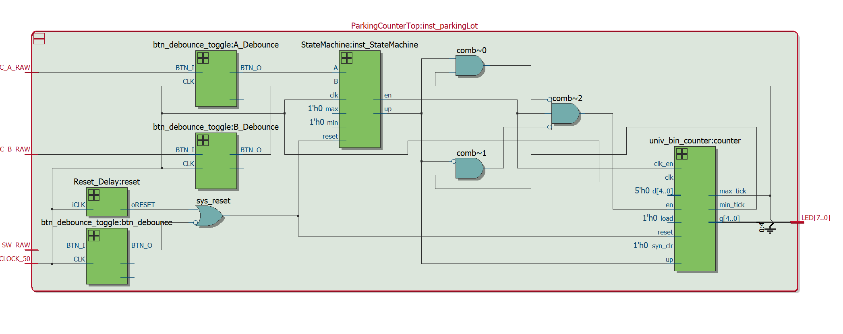
Figure 2. RTL generated by Quartus for the Top-Level instantiation
Figure 1. shows the basic design and outlined plan for the circuit. Figure 2. shows the generated RTL from the final project, including the logic specified in the top level, shown as comb~0,1,2 and sys_reset. The external inputs from the rotary knob would be ENC_A_RAW, ENC_B_RAW, and ENC_SW_RAW. The other external input was the clock, which was a 50MHz clock.
There were 3 debounce instantiations from the provided button debouncer programs. These would make sure that the external input did not create any unwanted behavior from false triggers. These created enc_a_deb, and enc_b_deb, which were the debounced signals.
The Reset_Delay block was there to ensure that on power-up and when the switch was pressed, the counter would reset. This would clear the state machine and counter.
The State Machine would interpret the debounced A and B inputs, and when it reached the correct state (a clockwise or counterclockwise click, simulating a car entering and exiting respectively), it would increment or decrement the counter. After completing the code, the state machine ended up taking inputs from the universal binary counter, as it needed to know if it had reached max capacity (25) or minimum capacity (0).
The Universal Binary Counter was a 5 bit counter, which would increment or decrement, based on the ‘up’ signal given by the state machine.
The logic in the top level would also check if it had reached its maximum allowed value of 25, or minimum allowed value of 0, which would change ‘en’ so that no changes could be made.
The LED signals in the top-level design are given the output of the count, using the first 5 LEDs on the board to display the binary signal. It would also turn on the 7th LED when max_t is ‘1’, to indicate that the parking lot is full and the counter has reached its maximum value of 25. These signals would ultimately be connected to the DE0 Nano instantiation, seen in Figure 3.
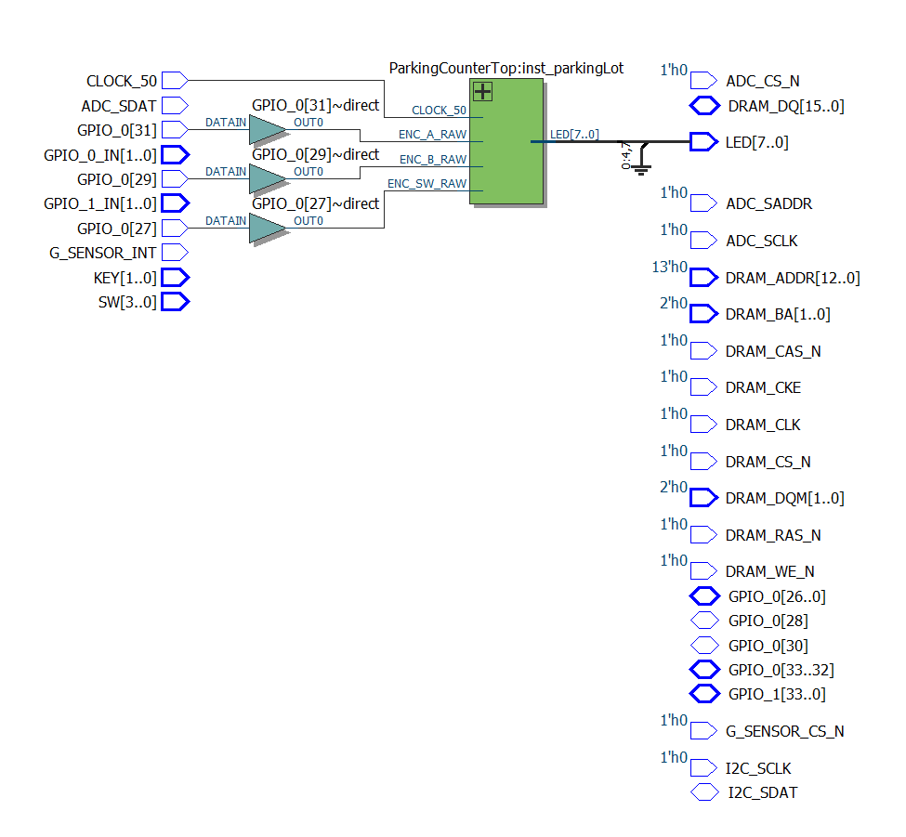
Figure 3. Top Level DE0 Nano instantiation of ParkingCounterTop top level VHD file.

- Detailed Design

The Reset_Delay code was provided. Its purpose was to generate a reset pulse on power-up to ensure everything starts in a known state. It’s implemented by setting reset to ‘high’ for a short amount of time, and then releasing it. Its output ‘reset’ is used with the reset switch from the rotary encoder to produce ‘sys_reset’ which would reset the counter on start-up or on button press. The code for this can be found in Appendix 1.
The debouncer code was provided. The purpose of the debouncer was to stabilize raw input signal from the KY040 Rotary Encoder, so that any accidental disruption or non-intended triggers wouldn’t affect the state machine or give any unwanted behavior. It is implemented by using a counter and confirming that the input was stable of the entirety of the counters duration, synchronized with the clock. In this case, ‘FFFF’ was used as the counter maximum, which equates to waiting 65,353 cycles. This equates to about 1.307ms of delay, which is unnoticeable with human interaction with the Rotary Encoder. The code for this can be found in Appendix 2.
The Universal Binary Counter code was provided. The purpose of this program was to track the number of vehicles in the lot, to a maximum of 25. The provided code was a universal n bit counter, so the count can easily be updated in the code. The parameters of this program were N = 5 (which is the 5-bit counter), N1 = 0, which is the minimum, and N2 = 25, which is the maximum value. Note that without the use of combinational logic within the top level, the counter would just restart from 0 after passing 25 instead of stopping. Synchronized with the clock, it would take sys_reset, clk_en, and upp, as inputs. The system reset would reset the clock back to 0. The clk_en was the clock enable, calculated by the logical components of the top level based on whether the counter was at its minimum or maximum value, and from the state machine, which would allow the counter to increment or decrement. ‘Upp’ was a signal from the state machine letting it know whether to increment or decrement. The code for this can be found in Appendix 3.
The State Machine was used to interpret the debounced signals from the encoder to detect a full entry (clockwise turn) or exit (counter-clockwise turn). This would take the inputs enc_a_deb, enc_b_deb, sys_reset, and max_t, min_t. Below is Figure 4. which is the design of the finite state machine. A and B are the internal signals of the state machine, which are taken from the debounced output of the signals sent directly from the Rotary Encoder.

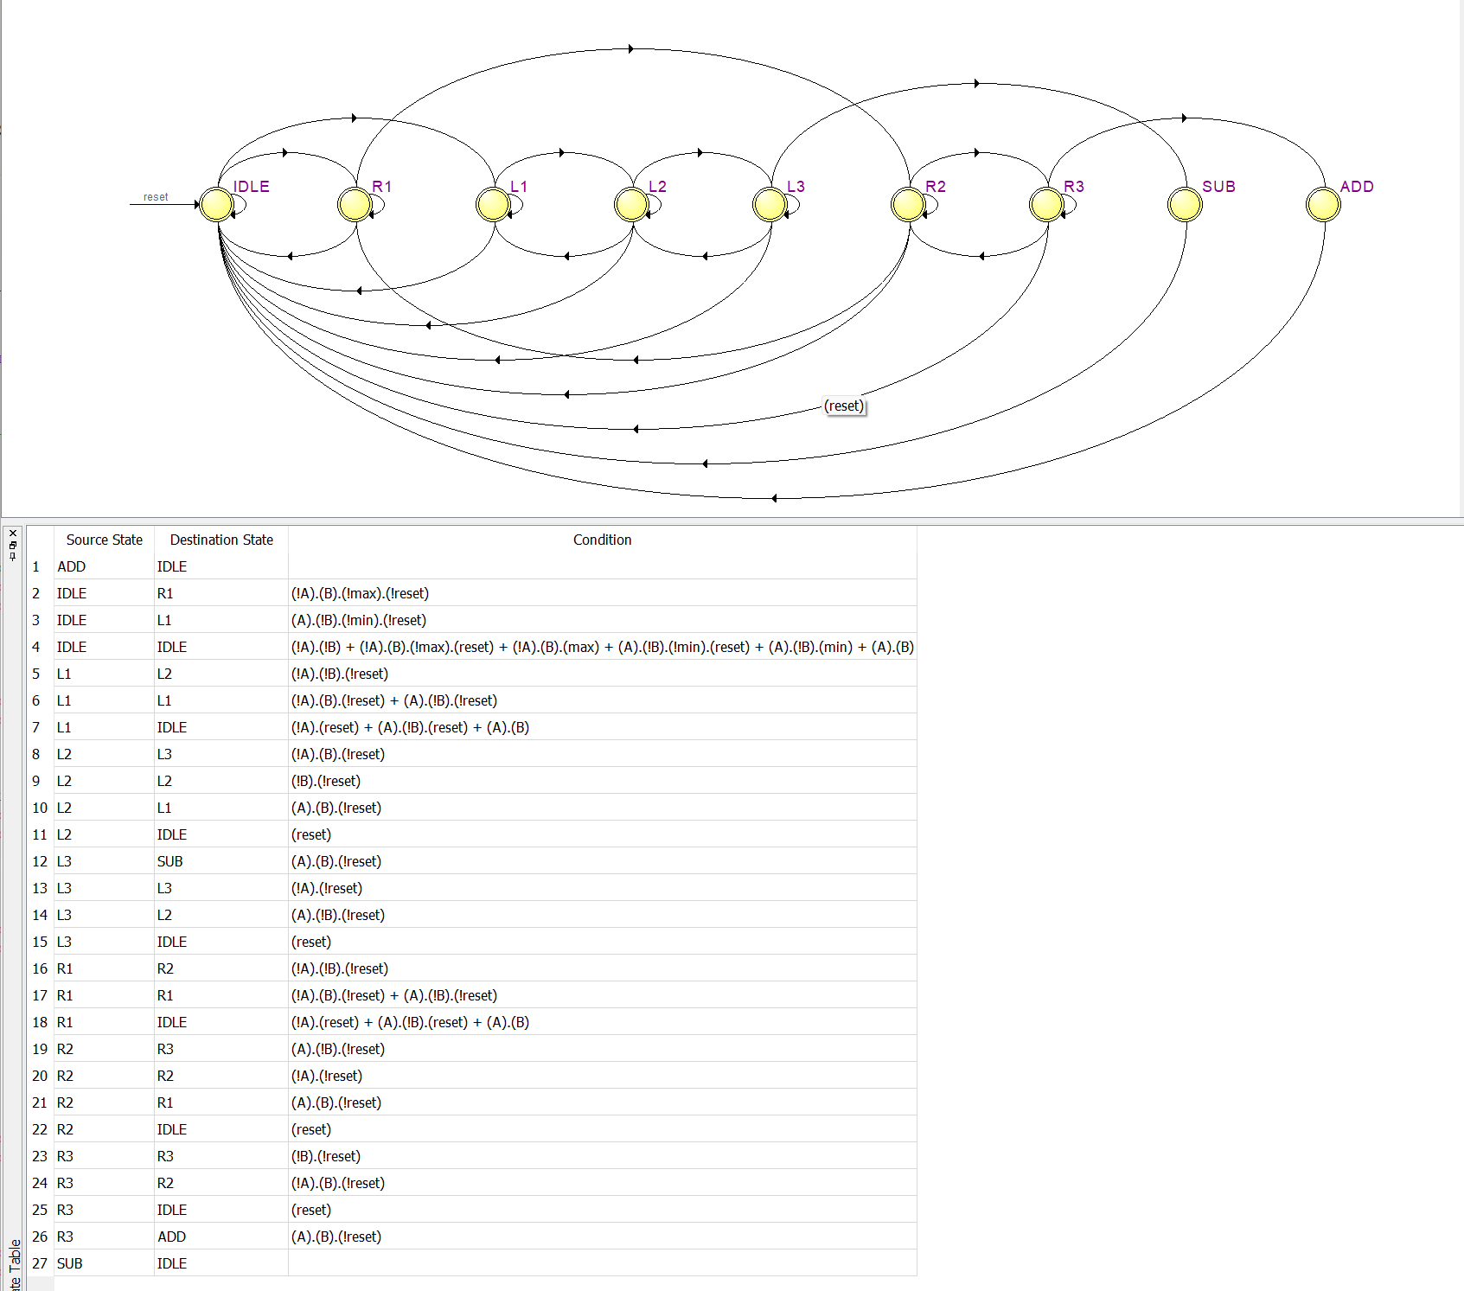
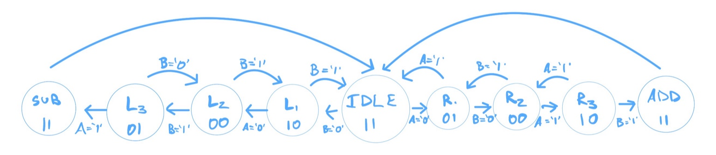
Figure 4. Hand-drawn design layout of the Finite State Machine.
Figure 5. Quartus-Generated Finite State Machine layout

The Finite State Machines shown in Figure 4. and Figure 5. are identical. For the combinational logic of the finite state machine generated by Quartus, see Appendix 4. There are 9 states given by this state machine. IDLE is the base state where the state machine generally lives. Passing a signal through the debouncer that changes A or B determines the states that it will next go to. In Figure 4. it is shown which value of A or B is required to move to each next state. The code for the can be found in Appendix 5.
The Top Level integrates all these components together, instantiates the required ones, and ports all the signals to their respective locations. The Top Level also includes some combinational logic, like the sys_reset logic, and the enable logic. In Figure 6. below we can see the system reset combinational logic, using restart (which happens on start-up) and btn_level, which is an active high signal from the encoder, that determines if the reset button on the Rotary Encoder is being pressed.
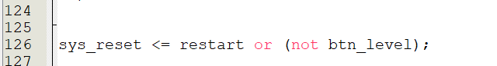
Figure 6. Sys reset combinational logic
The other example of combinational logic in the top-level code is in the universal binary counter instantiation, seen in Figure 7. 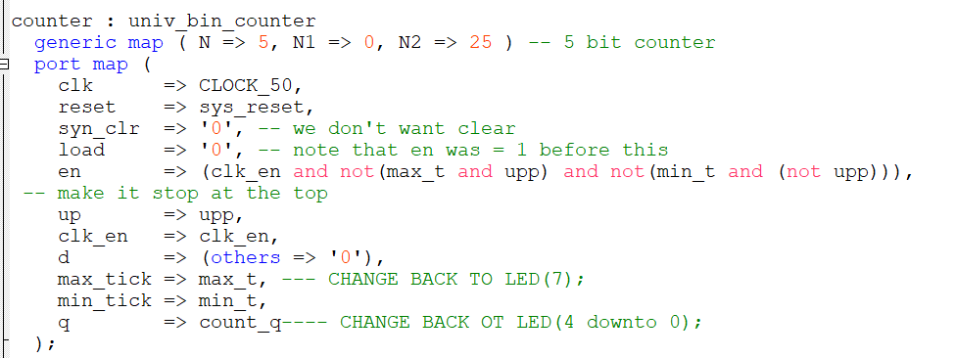
Figure 7. Instantiation of Universal Binary Counter in Top Level code

This figure shows that the ‘en’ input signal into the counter instantiation is based on two things. Firstly, the clock enable must be on. Secondly, ‘upp’ which is the signal provided by the state machine as a 0 or a 1, indicating a decrement or an increment respectively, and ‘max_t’, the signal that goes high only when the counter reaches 25, its maximum allowed value, must not both be true, as when its at its max capacity it will not increment any further. Following this, the opposite is also checked, to make sure that no decrement occurs when the counter is at its minimum value. The code for this can be found in Appendix 6.
Lastly, the LED outputs interface is outputting the count as a binary value on the first 5 bits, outputting the signal given by the universal binary counter. The 7th LED also outputs the max_t signal, which indicates that the lot is full.

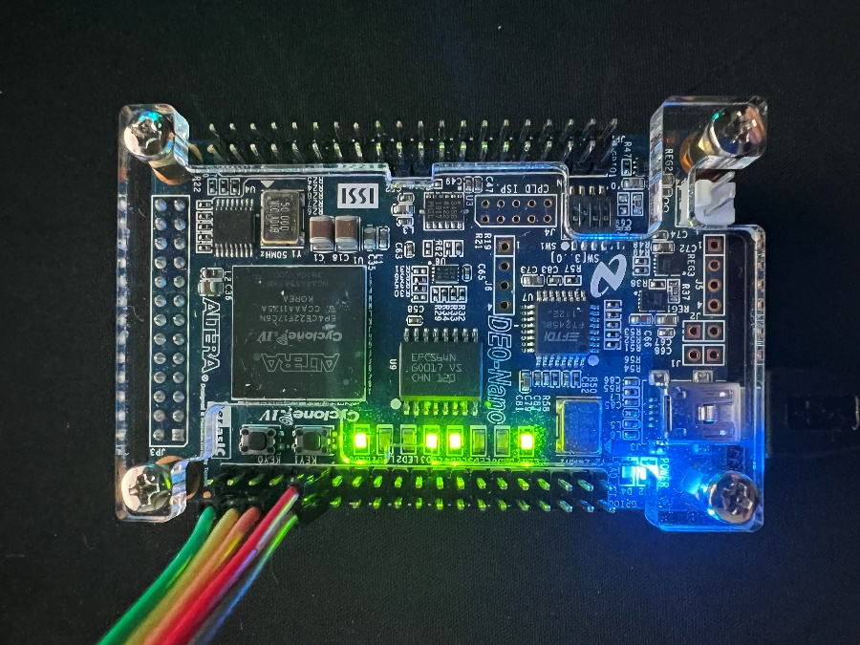
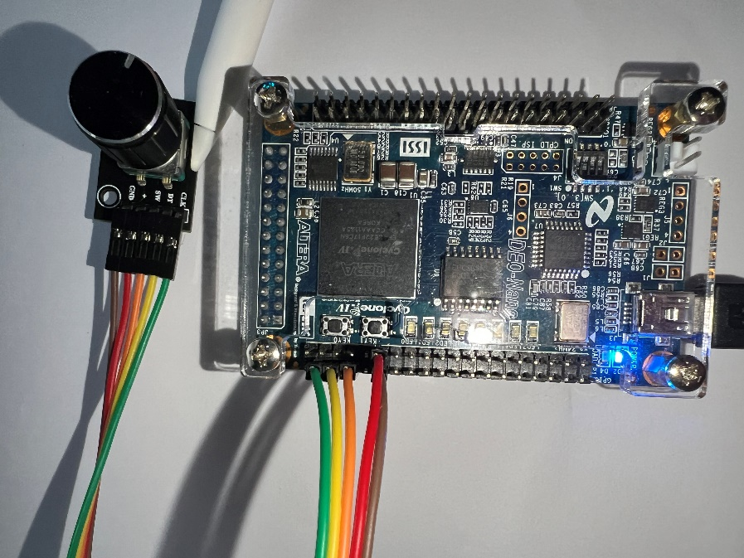

Figure 8. (Left): DE0 Nano Board, with rotary encoder
Figure 9. (Right): DE0 Nano Board, with LEDs on, in the state of the parking lot being full.
In Figure 8. we can see the DE0 Nano Board with the corresponding pins from the encoder properly connected. Figure 9. shows the board with the LEDs in the ‘parking lot full’ state. LED (7) is lit up, and the LED (4:0) show “11001”, which is 25 in binary.
Figure 10. shows the encoders ‘Clk’ is connected to GPIO_0(31), ‘DT’ is connected to GPIO_0(29), and ‘SW’ is connected to GPIO_0(27). ‘GND’ and ‘+’ are connected to Ground and + 3.3V respectively.
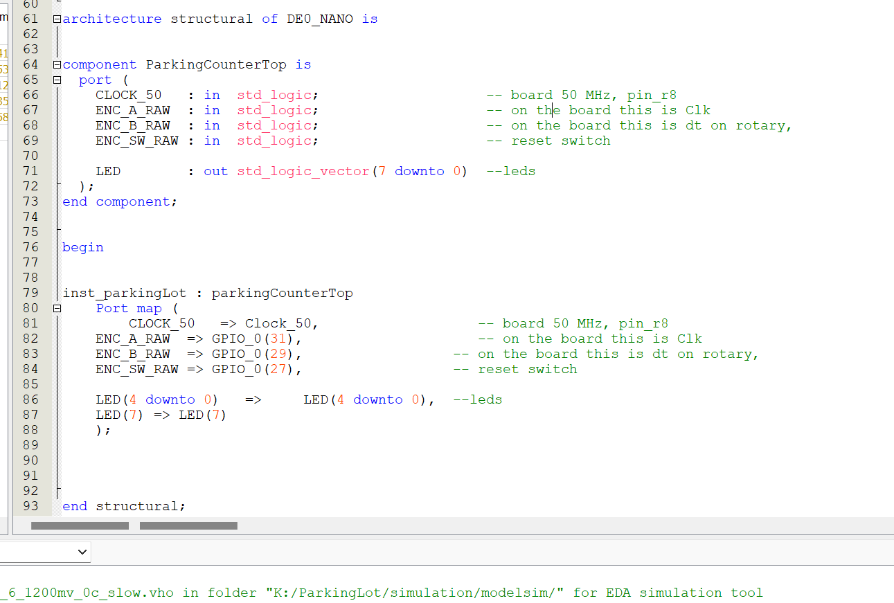

Figure 10. Instantiation of Top Level of ParkingLot, in DE0 Nano Top Level file
This implementation of the top level in the DE0 Nano file was not the original plan for this project. Originally, we assigned pins directly on the board, however this made it difficult to show the required pins in Signal Tap, so we ended up switching to the implementation using the DE0 Nano Board, and the given CSV file with pin assignments. The code for this can be found in Appendix 7 and the CSV file can be found is Appendix 8.

- Module and Specifications Testing

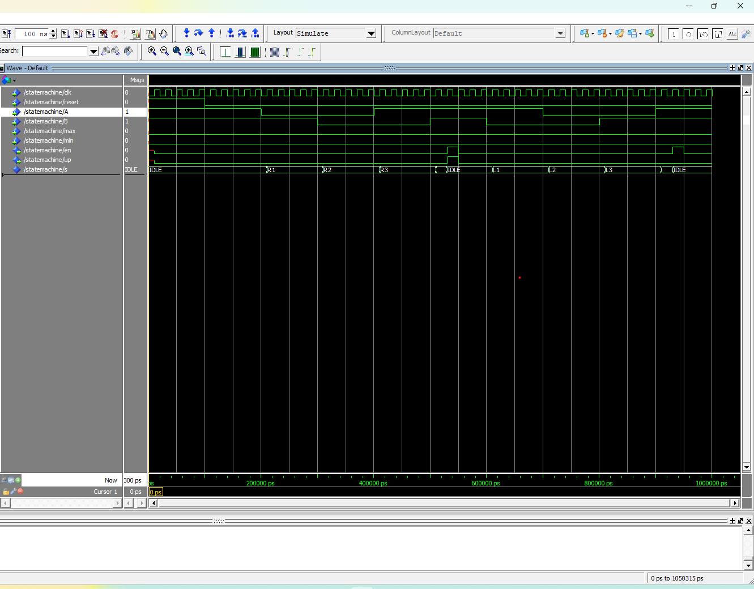
To test the state machine, we used ModelSim to confirm that everything was working correctly. By forcing each input value for A and B, we were able to show that the state machine was going from state to state correctly. In Figure 11. below, we see the model sim working correctly. The reset starts at high, and then as we change the inputs of A and B, it changes what state it is in. After we force reset to 0, we force A to 1 and run for 100ns again. This then sets the state machine state (the bottom row) to R1. Repeating the sequence required to show the state machine correctly going to the state it’s designed to go to shows that the state machine is working correctly. One of the things noticed that was not intentional design was that the enable and up signal pulse from add and subtract would happen 1 clock cycle late. This did not have an impact on the functionality of the code, so it was not changed.
Figure 11. Model Sim testing state machine states, up, and enable.

Next, we compiled the project using the DE0 Nano Top Level, instantiating the ParkingLot Top level, and tested the logic in SignalTap. Setting the clock to CLOCK_50, and segmenting the output with 32 64 segments, we added the appropriate nodes to see the design working.
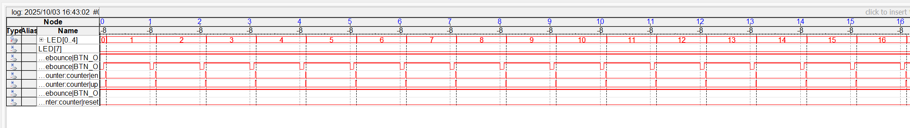
As seen in Figure 12. and Figure 13. The program is working correctly. LED[0,4] is running correctly from 0 to 25. These two figures show the full functionality of the program. The second BTN_O is the debounced signal directly from the encoder, and each time it goes from low to high the finite state machine sends a pulse of en and up to the counter, which then increments the LEDs. When the reset button is pressed, it stops signal tap and resets the circuit.
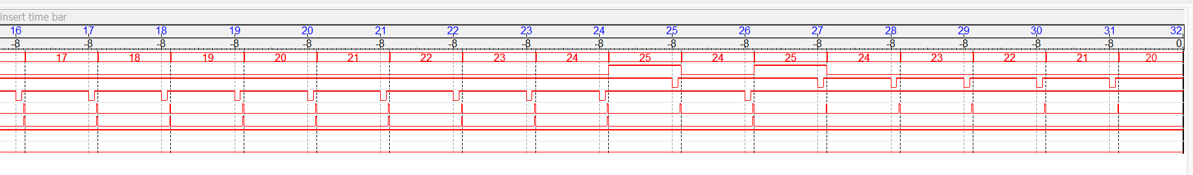
Figure 12. Signal Tap output, part 1
Figure 13. Signal Tap output, part 2

As we can see in Figure 13. the LED[7] which is the second line on the graph, goes to high whenever the counter reaches 25. This shows intended design, and full functionality of the program. Earlier in the design process SignalTap (and usage of the board) pointed us to the error that the counter would underflow and overflow, instead of stopping at the maximum and minimum value specified. This was corrected by gating the input with max_t and min_t, with the combinational logic done in the top level parking lot design.
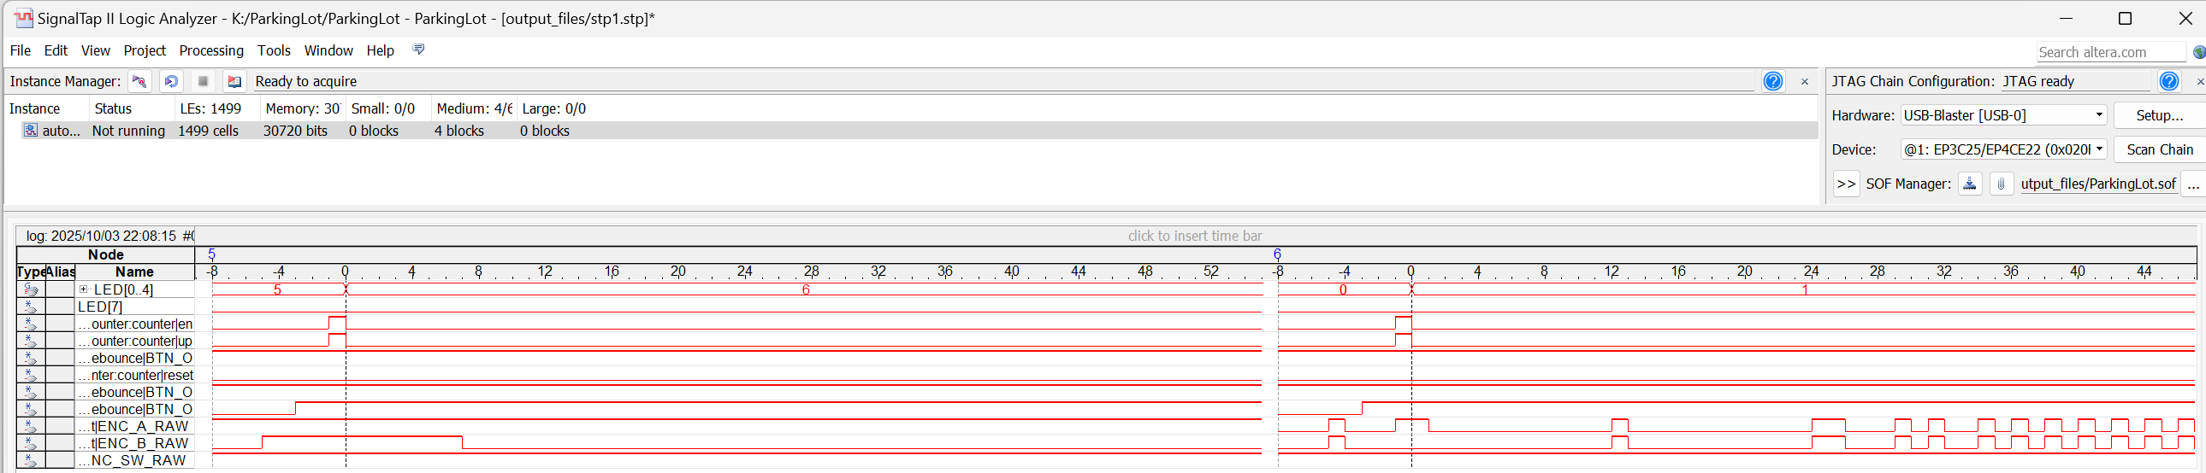
In Figure 14. we can see the correct functionality of the debouncer as well, as there is significant chatter from the Rotary Encoder before our debouncer functions clean the signals.
Figure 14. Signal Tap with Raw Encoder signals vs debounced signal, + reset functionality
This Signal Tap output in Figure 14. shows us the very chattery and sporadic input that we get from the encoder before it’s debounced. It also shows us the functionality of the reset switch, which resets the count from 6 to 0.
- Results and Analysis
The parking lot counter design successfully met the specifications outlined in the project. The system was able to accurately track the number of vehicles in the lot using the KY 040 Rotary Encoder as input, and successfully debouncing the signals. The counter correctly displayed the values on LED[4:0], and LED[7] correctly lit up when it reached the maximum capacity of the parking lot.
During initial testing, the universal binary counter would overflow and underflow the maximum and minimum allowed values. This was then mitigated by gating the inputs so that it would stop at the specified maximum and minimum values.
ModelSim captures show that the finite state machine is working as intended and sends the correct pulse for up and down. Hardware testing on the DE0 Nano board shows the correct operation too.
Currently the finite state machine sends the enable and up signal one clock cycle after, which doesn’t affect the functionality of the program, however could be changed for a more precise program. Another improvement could be not using the LEDs as signals in the ParkingLot Top Level file, as it led to a slightly more convoluted design than the example design showed in class, however it did not impact functionality, and this project was still a perfect success that met all of the design specifications.

REFERENCES
[1] DE0 Nano User Manual, PDF linked on Moodle https://moodle.clarkson.edu/pluginfile.php/460034/course/section/48501/DE0_Nano_User_Manual_v1.5.pdf
[2] Pin assignments and GPIO assignments https://ti.com/lit/ug/tidu737/tidu737.pdf
[3] ModelSim Tutorial, PDF linked on Moodle
https://moodle.clarkson.edu/pluginfile.php/460034/course/section/48501/ModelSim_Altera%20Tutorial.pdf
[4] Reset_Delay.vhd, Univ_bin_counter.vhd, and btn_debounce.vhd, provided on Moodle.

APPENDIX
*Office Blocks the Opening of VHD Files if inserted as objects as icons
This appendix includes every file you would need to replicate this project, not including any of the signal tap or modelsim files. A Zip file of the entire project has been included at the bottom for convenience. Set DE0 Nano as top level.

APPENDIX 1. This file is the RESET_DELAY code provided

library IEEE;
use IEEE.STD_LOGIC_1164.ALL;

--use IEEE.numeric_std.ALL;
use IEEE.STD_LOGIC_ARITH;
use IEEE.STD_LOGIC_UNSIGNED.ALL;

ENTITY Reset_Delay IS
PORT (
SIGNAL iCLK : IN std_logic;
SIGNAL oRESET : OUT std_logic
);
END Reset_Delay;

ARCHITECTURE Arch OF Reset_Delay IS

SIGNAL Cont : std_logic_vector(19 DOWNTO 0):=X"00000";

BEGIN

PROCESS
BEGIN

WAIT UNTIL rising_edge (iCLK);
-- IF Cont /= X"FFFFF" THEN
IF Cont /= X"0000F" THEN
Cont <= Cont + '1';
oRESET <= '1';
ELSE
oRESET <= '0';
END IF;
END PROCESS;

END Arch;

APPENDIX 2. This file is the DEBOUNCER code provided
----------------------------------------------------------------------------
-- btn_debounce.vhd -- Button Debouncer
----------------------------------------------------------------------------
-- Author: Sam Bobrowicz
-- Copyright 2011 Digilent, Inc.
-- Modified: Added toggle output
----------------------------------------------------------------------------
--
----------------------------------------------------------------------------
-- This component is used to debounce signals generated by external push
-- buttons. It is designed to independently debounce a Push button signal.
-- Debouncing is done by only registering a change in a button state if
-- it remains constant for 2^16 clock cycles.
--
-- Port Descriptions:
--
-- BTN_I - The input button signals
-- CLK - Behavior is optimized for a 100 MHz clock
-- BTN_O - The debounced button signals
-- TOGGLE_O - Debounced toggle output
----------------------------------------------------------------------------
--
----------------------------------------------------------------------------
-- Revision History:
-- 08/08/2011(SamB): Created using Xilinx Tools 13.2
-- 10/06/2013 (CU): Converted to one button and added toggle output
----------------------------------------------------------------------------
library IEEE;
use IEEE.STD_LOGIC_1164.ALL;
use IEEE.std_logic_unsigned.all;

entity btn_debounce_toggle is
GENERIC (
CONSTANT CNTR_MAX : std_logic_vector(15 downto 0) := X"FFFF");
Port ( BTN_I : in STD_LOGIC;
CLK : in STD_LOGIC;
BTN_O : out STD_LOGIC;
TOGGLE_O : out STD_LOGIC;
PULSE_O : out STD_LOGIC);
end btn_debounce_toggle;

architecture Behavioral of btn_debounce_toggle is

--constant CNTR_MAX : std_logic_vector(15 downto 0) := X"FFFF";
signal btn_cntr : std_logic_vector(15 downto 0) := (others => '0');
signal btn_reg : std_logic := '0';
signal btn_toggle : std_logic := '1';
signal btn_sync : std_logic_vector(1 downto 0) := (others => '0');
signal btn_pulse : std_logic := '0';

begin

btn_debounce_process : process (CLK)
begin
if (rising_edge(CLK)) then
if (btn_cntr = CNTR_MAX) then
btn_reg <= not(btn_reg);
end if;
end if;
end process;

btn_counter_process : process (CLK)
begin
if (rising_edge(CLK)) then
if ((btn_reg = '1') xor (BTN_I = '1')) then
if (btn_cntr = CNTR_MAX) then
btn_cntr <= (others => '0');
else
btn_cntr <= btn_cntr + 1;
end if;
else
btn_cntr <= (others => '0');
end if;
end if;
end process;

btn_toggle_process : process(CLK)
begin
if (rising_edge(CLK)) then
btn_sync(0) <= btn_reg;
btn_sync(1) <= btn_sync(0);
btn_pulse <= not btn_sync(1) and btn_sync(0);
if btn_pulse = '1' then
btn_toggle <= not btn_toggle;
end if;
end if;
end process;

BTN_O <= btn_reg;
TOGGLE_O <= btn_toggle;
PULSE_O <= btn_pulse;
end Behavioral;

APPENDIX 3. This file is the UNIV_BIN_COUNTER code provided
-- Source: http://academic.csuohio.edu/chu_p/rtl/fpga_vhdl.html
-- Listing 4.10
-- modified: added port "clk_en", Sept 5, 2013
-- modified: added upper and lower limits of the counter, Sept 1, 2016

library ieee;
use ieee.std_logic_1164.all;
use ieee.numeric_std.all;

entity univ_bin_counter is
generic(N: integer := 5; N2: integer := 25; N1: integer := 0);
port(
clk, reset : in std_logic;
syn_clr, load, en, up : in std_logic;
clk_en : in std_logic := '1';
d : in std_logic_vector(N-1 downto 0);
max_tick, min_tick : out std_logic;
q : out std_logic_vector(N-1 downto 0)
);
end univ_bin_counter;

architecture arch of univ_bin_counter is
signal r_reg : unsigned(N-1 downto 0);
signal r_next : unsigned(N-1 downto 0);
signal r_1 : unsigned(N-1 downto 0);
signal r_2 : unsigned(N-1 downto 0);

begin
-- register
process(clk,reset)
begin
if (reset='1') then
r_reg <= (others=>'0');
elsif rising_edge(clk) and clk_en = '1' then
r_reg <= r_next;
end if;
end process;

-- next-state logic
r_next <= (others=>'0') when syn_clr='1' else
unsigned(d) when load='1' else
r_1 when en ='1' and up='1' else
r_2 when en ='1' and up='0' else
r_reg;

r_1 <= to_unsigned(N1, r_reg'length) when r_reg = to_unsigned(N2, r_reg'length) else
r_reg + 1;
r_2 <= to_unsigned(N2, r_reg'length) when r_reg = to_unsigned(N1, r_reg'length) else
r_reg - 1;

-- output logic
q <= std_logic_vector(r_reg);
max_tick <= '1' when r_reg=to_unsigned(N2, r_reg'length) else '0';
min_tick <= '1' when r_reg=to_unsigned(N1, r_reg'length) else '0';
end arch;

APPENDIX 4.

Appendix 1. Depicts the combinational logic generated by Quartus for the State machine in Figure 4.

APPENDIX 5. This file is the State_Machine code created for this project
library ieee;
use ieee.std_logic_1164.all;

entity StateMachine is
port (
clk : in std_logic;
reset : in std_logic; -- synchronous, active high
A : in std_logic;
B : in std_logic;
max : IN STD_LOGIC;
min : IN STD_LOGIC;
en : out std_logic; -- 1 clk pulse when a full step completes
up : out std_logic -- acts as counter

);

end StateMachine;

architecture Behavioral of StateMachine is

type State_type is (IDLE, R1, R2, R3, ADD, L1, L2, L3, SUB) ;
signal s : State_type := IDLE;

begin
process(clk)
variable next_s : State_type;
begin

if rising_edge(clk) then
en <= '0';
up <= '0';

if reset = '1' then -- if we press the reset button, it sets the state machine into the idle state, and doesn't send a count signal
s <= IDLE;
up <= '0';
else
next_s := s;

case s is
when IDLE => -- idle is 11
if (A='0' and B='1' and max='0') then next_s := R1;
elsif (A='1' and B='0' and min='0') then next_s := L1;
-- else next_s := IDLE; don't need it automatically stays in this state
end if;

when R1 =>
if (A='0' and B='0') then next_s := R2;
elsif (A='1' and B='1') then next_s := IDLE;

end if;

when R2 => -- r2 is 00
if (A='1' and B='0') then next_s := R3;
elsif (A='1' and B='1') then next_s := R1;

end if;

when R3 => -- r3 is 10
if (A='1' and B='1') then next_s := ADD;
elsif (A='0' and B='1') then next_s := R2;

end if;

when ADD =>
en <= '1';
up <= '1';
next_s := IDLE;

when L1 =>
if (A='0' and B='0') then next_s := L2;
elsif (A='1' and B='1') then next_s := IDLE;

end if;

when L2 =>
if (A='0' and B='1') then next_s := L3;
elsif (A='1' and B='1') then next_s := L1;

end if;

when L3 =>
if (A='1' and B='1') then next_s := SUB;
elsif (A='1' and B='0') then next_s := L2;

end if;

when SUB =>
en <= '1';
up <= '0';
next_s := IDLE;

when others =>
next_s := IDLE;
end case;

s <= next_s;
end if;
end if;
end process;
end Behavioral;

APPENDIX 6. This file is the ParkingLot Top Level code created for this project
library ieee;
use ieee.std_logic_1164.all;
use ieee.numeric_std.all;

entity ParkingCounterTop is
port (
CLOCK_50 : in std_logic; -- board 50 MHz, pin_r8
ENC_A_RAW : in std_logic; -- on the board this is Clk
ENC_B_RAW : in std_logic; -- on the board this is dt on rotary,
ENC_SW_RAW : in std_logic; -- reset switch

LED : out std_logic_vector(7 downto 0) --leds
);
end entity;

architecture Behavioral of ParkingCounterTop is
-- signals that are inside toplevel
signal enc_a_deb, enc_b_deb : std_logic;
signal enc_a, enc_b : std_logic;
signal restart : std_logic;
signal btn_level : std_logic;
signal btn_pulse : std_logic;
signal clk_en : std_logic;
signal sys_reset : std_logic;
signal upp : std_logic;
signal count_q : std_logic_vector(4 downto 0);
signal max_t : std_logic;
signal min_t : std_logic;

COMPONENT reset_delay
PORT(iCLK : IN STD_LOGIC;
oRESET : OUT STD_LOGIC
);
END COMPONENT;

COMPONENT univ_bin_counter
generic(N: integer := 5; N2: integer := 25; N1: integer := 0);
port(
clk, reset : in std_logic;
syn_clr, load, en, up : in std_logic;
clk_en : in std_logic := '1';
d : in std_logic_vector(N-1 downto 0);
max_tick, min_tick : out std_logic;
q : out std_logic_vector(N-1 downto 0)
);
END COMPONENT;

COMPONENT btn_debounce_toggle is
GENERIC (
CONSTANT CNTR_MAX : std_logic_vector(15 downto 0) := X"FFFF"); -- binary max, changed to 000f for testing,
Port ( BTN_I : in STD_LOGIC;
CLK : in STD_LOGIC;
BTN_O : out STD_LOGIC;
TOGGLE_O : out STD_LOGIC;
PULSE_O : out STD_LOGIC);
END COMPONENT;

COMPONENT StateMachine is
port (
clk : in std_logic;
reset : in std_logic; -- synchronous, active high
A : in std_logic;
B : in std_logic;
max : IN STD_LOGIC;
min : IN STD_LOGIC;
en : out std_logic; -- 1 clk pulse when a full step completes
up : out std_logic -- acts as counter

);

END COMPONENT;

begin
-- Light leds test(active low invert)

-- LED <= (others => not ENC_SW_RAW);
process (CLOCK_50) -- doing this clock makes it so that it only gets the inputs on the rising clock edge, cause enc_A_RAW is not with clock
begin

if rising_edge(CLOCK_50) then
enc_a <= ENC_A_RAW;
enc_b <= ENC_B_RAW;
-- if (sys_reset = '1') then LED(7) <= '1';end if;
end if;
end process;

reset : reset_delay -- the point of this is to reset everything at the start when the board is loaded.
port map ( iCLK => CLOCK_50,
oRESET => restart);

btn_debounce : btn_debounce_toggle -- instantiates debouncer component
port map (
BTN_I => ENC_SW_RAW,
CLK => CLOCK_50,
BTN_O => btn_level,
TOGGLE_O => open,
PULSE_O => btn_pulse
);

A_Debounce : btn_debounce_toggle
port map (
BTN_I => ENC_A_RAW,
CLK => CLOCK_50,
BTN_O => enc_a_deb,
TOGGLE_O => open,
PULSE_O => open
);

B_Debounce : btn_debounce_toggle
port map (
BTN_I => ENC_B_RAW,
CLK => CLOCK_50,
BTN_O => enc_b_deb,
TOGGLE_O => open,
PULSE_O => open
);

sys_reset <= restart or (not btn_level);

inst_StateMachine : StateMachine
port map (
-- need to port this with my own state machine
clk => CLOCK_50,
reset => sys_reset, -- synchronous, active high
A => enc_a_deb,
B => enc_b_deb,
max => '0', -- get this from counter later
min => '0', -- get tihs from counter later
en => clk_en, -- 1 clk pulse when a full step completes
up => upp -- acts as counter

);

counter : univ_bin_counter
generic map ( N => 5, N1 => 0, N2 => 25 ) -- 5 bit counter
port map (
clk => CLOCK_50,
reset => sys_reset,
syn_clr => '0', -- we don't want clear
load => '0', -- note that en was = 1 before this
en => (clk_en and not(max_t and upp) and not(min_t and (not upp))),
-- make it stop at the top
up => upp,
clk_en => clk_en,
d => (others => '0'),
max_tick => max_t, --- CHANGE BACK TO LED(7);
min_tick => min_t,
q => count_q---- CHANGE BACK OT LED(4 downto 0);
);
--LED(7 downto 5) <= (others => '0');
LED(7) <= max_t;
LED(4 downto 0) <= count_q;

end architecture;

APPENDIX 7. This file is the DE0 Nano code provided, with changes made for this project
LIBRARY ieee;
USE ieee.std_logic_1164.all;

ENTITY DE0_NANO IS
PORT (
-- Clock Input
CLOCK_50 : IN STD_LOGIC; -- On Board 50 MHz
-- LED
LED : OUT STD_LOGIC_VECTOR(7 DOWNTO 0); -- LED Green[7:0]

-- Push Button
KEY : IN STD_LOGIC_VECTOR(1 DOWNTO 0); -- Pushbutton[1:0]
-- DPDT Switch
SW : IN STD_LOGIC_VECTOR(3 DOWNTO 0); -- Toggle Switch[3:0]

-- SDRAM Interface
DRAM_DQ : INOUT STD_LOGIC_VECTOR(15 DOWNTO 0); -- SDRAM Data bus 16 Bits
DRAM_ADDR : OUT STD_LOGIC_VECTOR(12 DOWNTO 0); -- SDRAM Address bus 12 Bits
DRAM_DQM : OUT STD_LOGIC_VECTOR(1 DOWNTO 0); -- SDRAM Data Mask
DRAM_WE_N : OUT STD_LOGIC; -- SDRAM Write Enable
DRAM_CAS_N : OUT STD_LOGIC; -- SDRAM Column Address Strobe
DRAM_RAS_N : OUT STD_LOGIC; -- SDRAM Row Address Strobe
DRAM_CS_N : OUT STD_LOGIC; -- SDRAM Chip Select
DRAM_BA : OUT STD_LOGIC_VECTOR(1 DOWNTO 0); -- SDRAM Bank Address
DRAM_CLK : OUT STD_LOGIC; -- SDRAM Clock
DRAM_CKE : OUT STD_LOGIC; -- SDRAM Clock Enable

-- Flash Interface
-- EPCS_ASDO : OUT STD_LOGIC;
-- EPCS_DATA0 : IN STD_LOGIC;
-- EPCS_DCLK : OUT STD_LOGIC;
-- EPCS_NCSO : OUT STD_LOGIC;

-- Accelerometer and EEPROM
G_SENSOR_CS_N : OUT STD_LOGIC;
G_SENSOR_INT : IN STD_LOGIC;
I2C_SCLK : OUT STD_LOGIC;
I2C_SDAT : INOUT STD_LOGIC;

-- ADC
ADC_CS_N : OUT STD_LOGIC;
ADC_SADDR : OUT STD_LOGIC;
ADC_SCLK : OUT STD_LOGIC;
ADC_SDAT : IN STD_LOGIC;

-- 2x13 GPIO Header
-- GPIO_2 : INOUT STD_LOGIC_VECTOR(12 DOWNTO 0);
-- GPIO_2_IN : IN STD_LOGIC_VECTOR(2 DOWNTO 0);

-- GPIO_0, GPIO_0 connect to GPIO Default
GPIO_0 : INOUT STD_LOGIC_VECTOR(33 DOWNTO 0);
GPIO_0_IN : IN STD_LOGIC_VECTOR(1 DOWNTO 0);

-- GPIO_0, GPIO_1 connect to GPIO Default
GPIO_1 : INOUT STD_LOGIC_VECTOR(33 DOWNTO 0);
GPIO_1_IN : IN STD_LOGIC_VECTOR(1 DOWNTO 0)

);
END DE0_NANO;

architecture structural of DE0_NANO is

component ParkingCounterTop is
port (
CLOCK_50 : in std_logic; -- board 50 MHz, pin_r8
ENC_A_RAW : in std_logic; -- on the board this is Clk
ENC_B_RAW : in std_logic; -- on the board this is dt on rotary,
ENC_SW_RAW : in std_logic; -- reset switch

LED : out std_logic_vector(7 downto 0) --leds
);
end component;

begin

inst_parkingLot : parkingCounterTop
Port map (
CLOCK_50 => Clock_50, -- board 50 MHz, pin_r8
ENC_A_RAW => GPIO_0(31), -- on the board this is Clk
ENC_B_RAW => GPIO_0(29), -- on the board this is dt on rotary,
ENC_SW_RAW => GPIO_0(27), -- reset switch

LED(4 downto 0) => LED(4 downto 0), --leds
LED(7) => LED(7)
);

end structural;

APPENDIX 8. This file is the CSV file with pin assignments provided for this project
# Copyright (C) 1991-2011 Altera Corporation
# Your use of Altera Corporation's design tools, logic functions
# and other software and tools, and its AMPP partner logic
# functions, and any output files from any of the foregoing
# (including device programming or simulation files), and any
# associated documentation or information are expressly subject
# to the terms and conditions of the Altera Program License
# Subscription Agreement, Altera MegaCore Function License
# Agreement, or other applicable license agreement, including,
# without limitation, that your use is for the sole purpose of
# programming logic devices manufactured by Altera and sold by
# Altera or its authorized distributors. Please refer to the
# applicable agreement for further details.

# Quartus II 32-bit Version 11.1 Build 173 11/01/2011 SJ Full Version
# File: C:\Demo\DE0_NANO_ADC\DE0_NANO.csv
# Generated on: Sun Sep 16 19:39:35 2012

# Note: The column header names should not be changed if you wish to import this .csv file into the Quartus II software.

To,Direction,Location,I/O Bank,VREF Group,I/O Standard,Reserved,Current Strength,Slew Rate,Differential Pair
ADC_CS_N,Output,PIN_A10,7,B7_N0,3.3-V LVTTL,,,,
ADC_SADDR,Output,PIN_B10,7,B7_N0,3.3-V LVTTL,,,,
ADC_SCLK,Output,PIN_B14,7,B7_N0,3.3-V LVTTL,,,,
ADC_SDAT,Input,PIN_A9,7,B7_N0,3.3-V LVTTL,,,,
CLOCK_50,Input,PIN_R8,3,B3_N0,3.3-V LVTTL,,,,
DRAM_ADDR[12],Output,PIN_L4,2,B2_N0,3.3-V LVTTL,,,,
DRAM_ADDR[11],Output,PIN_N1,2,B2_N0,3.3-V LVTTL,,,,
DRAM_ADDR[10],Output,PIN_N2,2,B2_N0,3.3-V LVTTL,,,,
DRAM_ADDR[9],Output,PIN_P1,2,B2_N0,3.3-V LVTTL,,,,
DRAM_ADDR[8],Output,PIN_R1,2,B2_N0,3.3-V LVTTL,,,,
DRAM_ADDR[7],Output,PIN_T6,3,B3_N0,3.3-V LVTTL,,,,
DRAM_ADDR[6],Output,PIN_N8,3,B3_N0,3.3-V LVTTL,,,,
DRAM_ADDR[5],Output,PIN_T7,3,B3_N0,3.3-V LVTTL,,,,
DRAM_ADDR[4],Output,PIN_P8,3,B3_N0,3.3-V LVTTL,,,,
DRAM_ADDR[3],Output,PIN_M8,3,B3_N0,3.3-V LVTTL,,,,
DRAM_ADDR[2],Output,PIN_N6,3,B3_N0,3.3-V LVTTL,,,,
DRAM_ADDR[1],Output,PIN_N5,3,B3_N0,3.3-V LVTTL,,,,
DRAM_ADDR[0],Output,PIN_P2,2,B2_N0,3.3-V LVTTL,,,,
DRAM_BA[1],Output,PIN_M6,3,B3_N0,3.3-V LVTTL,,,,
DRAM_BA[0],Output,PIN_M7,3,B3_N0,3.3-V LVTTL,,,,
DRAM_CAS_N,Output,PIN_L1,2,B2_N0,3.3-V LVTTL,,,,
DRAM_CKE,Output,PIN_L7,3,B3_N0,3.3-V LVTTL,,,,
DRAM_CLK,Output,PIN_R4,3,B3_N0,3.3-V LVTTL,,,,
DRAM_CS_N,Output,PIN_P6,3,B3_N0,3.3-V LVTTL,,,,
DRAM_DQ[15],Bidir,PIN_K1,2,B2_N0,3.3-V LVTTL,,,,
DRAM_DQ[14],Bidir,PIN_N3,3,B3_N0,3.3-V LVTTL,,,,
DRAM_DQ[13],Bidir,PIN_P3,3,B3_N0,3.3-V LVTTL,,,,
DRAM_DQ[12],Bidir,PIN_R5,3,B3_N0,3.3-V LVTTL,,,,
DRAM_DQ[11],Bidir,PIN_R3,3,B3_N0,3.3-V LVTTL,,,,
DRAM_DQ[10],Bidir,PIN_T3,3,B3_N0,3.3-V LVTTL,,,,
DRAM_DQ[9],Bidir,PIN_T2,3,B3_N0,3.3-V LVTTL,,,,
DRAM_DQ[8],Bidir,PIN_T4,3,B3_N0,3.3-V LVTTL,,,,
DRAM_DQ[7],Bidir,PIN_R7,3,B3_N0,3.3-V LVTTL,,,,
DRAM_DQ[6],Bidir,PIN_J1,2,B2_N0,3.3-V LVTTL,,,,
DRAM_DQ[5],Bidir,PIN_J2,2,B2_N0,3.3-V LVTTL,,,,
DRAM_DQ[4],Bidir,PIN_K2,2,B2_N0,3.3-V LVTTL,,,,
DRAM_DQ[3],Bidir,PIN_K5,2,B2_N0,3.3-V LVTTL,,,,
DRAM_DQ[2],Bidir,PIN_L8,3,B3_N0,3.3-V LVTTL,,,,
DRAM_DQ[1],Bidir,PIN_G1,1,B1_N0,3.3-V LVTTL,,,,
DRAM_DQ[0],Bidir,PIN_G2,1,B1_N0,3.3-V LVTTL,,,,
DRAM_DQM[1],Output,PIN_T5,3,B3_N0,3.3-V LVTTL,,,,
DRAM_DQM[0],Output,PIN_R6,3,B3_N0,3.3-V LVTTL,,,,
DRAM_RAS_N,Output,PIN_L2,2,B2_N0,3.3-V LVTTL,,,,
DRAM_WE_N,Output,PIN_C2,1,B1_N0,3.3-V LVTTL,,,,
EPCS_ASDO,Output,PIN_C1,1,B1_N0,3.3-V LVTTL,,,,
EPCS_DATA0,Input,PIN_H2,1,B1_N0,3.3-V LVTTL,,,,
EPCS_DCLK,Output,PIN_H1,1,B1_N0,3.3-V LVTTL,,,,
EPCS_NCSO,Output,PIN_D2,1,B1_N0,3.3-V LVTTL,,,,
GPIO_0[33],Bidir,PIN_B12,7,B7_N0,3.3-V LVTTL,,,,
GPIO_0[32],Bidir,PIN_D12,7,B7_N0,3.3-V LVTTL,,,,
GPIO_0[31],Bidir,PIN_D11,7,B7_N0,3.3-V LVTTL,,,,
GPIO_0[30],Bidir,PIN_A12,7,B7_N0,3.3-V LVTTL,,,,
GPIO_0[29],Bidir,PIN_B11,7,B7_N0,3.3-V LVTTL,,,,
GPIO_0[28],Bidir,PIN_C11,7,B7_N0,3.3-V LVTTL,,,,
GPIO_0[27],Bidir,PIN_E10,7,B7_N0,3.3-V LVTTL,,,,
GPIO_0[26],Bidir,PIN_E11,7,B7_N0,3.3-V LVTTL,,,,
GPIO_0[25],Bidir,PIN_D9,7,B7_N0,3.3-V LVTTL,,,,
GPIO_0[24],Bidir,PIN_C9,7,B7_N0,3.3-V LVTTL,,,,
GPIO_0[23],Bidir,PIN_E9,7,B7_N0,3.3-V LVTTL,,,,
GPIO_0[22],Bidir,PIN_F9,7,B7_N0,3.3-V LVTTL,,,,
GPIO_0[21],Bidir,PIN_F8,8,B8_N0,3.3-V LVTTL,,,,
GPIO_0[20],Bidir,PIN_E8,8,B8_N0,3.3-V LVTTL,,,,
GPIO_0[19],Bidir,PIN_D8,8,B8_N0,3.3-V LVTTL,,,,
GPIO_0[18],Bidir,PIN_E7,8,B8_N0,3.3-V LVTTL,,,,
GPIO_0[17],Bidir,PIN_E6,8,B8_N0,3.3-V LVTTL,,,,
GPIO_0[16],Bidir,PIN_C8,8,B8_N0,3.3-V LVTTL,,,,
GPIO_0[15],Bidir,PIN_C6,8,B8_N0,3.3-V LVTTL,,,,
GPIO_0[14],Bidir,PIN_A7,8,B8_N0,3.3-V LVTTL,,,,
GPIO_0[13],Bidir,PIN_D6,8,B8_N0,3.3-V LVTTL,,,,
GPIO_0[12],Bidir,PIN_B7,8,B8_N0,3.3-V LVTTL,,,,
GPIO_0[11],Bidir,PIN_A6,8,B8_N0,3.3-V LVTTL,,,,
GPIO_0[10],Bidir,PIN_B6,8,B8_N0,3.3-V LVTTL,,,,
GPIO_0[9],Bidir,PIN_D5,8,B8_N0,3.3-V LVTTL,,,,
GPIO_0[8],Bidir,PIN_A5,8,B8_N0,3.3-V LVTTL,,,,
GPIO_0[7],Bidir,PIN_B5,8,B8_N0,3.3-V LVTTL,,,,
GPIO_0[6],Bidir,PIN_A4,8,B8_N0,3.3-V LVTTL,,,,
GPIO_0[5],Bidir,PIN_B4,8,B8_N0,3.3-V LVTTL,,,,
GPIO_0[4],Bidir,PIN_B3,8,B8_N0,3.3-V LVTTL,,,,
GPIO_0[3],Bidir,PIN_A3,8,B8_N0,3.3-V LVTTL,,,,
GPIO_0[2],Bidir,PIN_A2,8,B8_N0,3.3-V LVTTL,,,,
GPIO_0[1],Bidir,PIN_C3,8,B8_N0,3.3-V LVTTL,,,,
GPIO_0[0],Bidir,PIN_D3,8,B8_N0,3.3-V LVTTL,,,,
GPIO_0_IN[1],Input,PIN_B8,8,B8_N0,3.3-V LVTTL,,,,
GPIO_0_IN[0],Input,PIN_A8,8,B8_N0,3.3-V LVTTL,,,,
GPIO_1[33],Bidir,PIN_J14,5,B5_N0,3.3-V LVTTL,,,,
GPIO_1[32],Bidir,PIN_J13,5,B5_N0,3.3-V LVTTL,,,,
GPIO_1[31],Bidir,PIN_K15,5,B5_N0,3.3-V LVTTL,,,,
GPIO_1[30],Bidir,PIN_J16,5,B5_N0,3.3-V LVTTL,,,,
GPIO_1[29],Bidir,PIN_L13,5,B5_N0,3.3-V LVTTL,,,,
GPIO_1[28],Bidir,PIN_M10,4,B4_N0,3.3-V LVTTL,,,,
GPIO_1[27],Bidir,PIN_N14,5,B5_N0,3.3-V LVTTL,,,,
GPIO_1[26],Bidir,PIN_L14,5,B5_N0,3.3-V LVTTL,,,,
GPIO_1[25],Bidir,PIN_P14,4,B4_N0,3.3-V LVTTL,,,,
GPIO_1[24],Bidir,PIN_N15,5,B5_N0,3.3-V LVTTL,,,,
GPIO_1[23],Bidir,PIN_N16,5,B5_N0,3.3-V LVTTL,,,,
GPIO_1[22],Bidir,PIN_R14,4,B4_N0,3.3-V LVTTL,,,,
GPIO_1[21],Bidir,PIN_P16,5,B5_N0,3.3-V LVTTL,,,,
GPIO_1[20],Bidir,PIN_P15,5,B5_N0,3.3-V LVTTL,,,,
GPIO_1[19],Bidir,PIN_L15,5,B5_N0,3.3-V LVTTL,,,,
GPIO_1[18],Bidir,PIN_R16,5,B5_N0,3.3-V LVTTL,,,,
GPIO_1[17],Bidir,PIN_K16,5,B5_N0,3.3-V LVTTL,,,,
GPIO_1[16],Bidir,PIN_L16,5,B5_N0,3.3-V LVTTL,,,,
GPIO_1[15],Bidir,PIN_N11,4,B4_N0,3.3-V LVTTL,,,,
GPIO_1[14],Bidir,PIN_N9,4,B4_N0,3.3-V LVTTL,,,,
GPIO_1[13],Bidir,PIN_P9,4,B4_N0,3.3-V LVTTL,,,,
GPIO_1[12],Bidir,PIN_N12,4,B4_N0,3.3-V LVTTL,,,,
GPIO_1[11],Bidir,PIN_R10,4,B4_N0,3.3-V LVTTL,,,,
GPIO_1[10],Bidir,PIN_P11,4,B4_N0,3.3-V LVTTL,,,,
GPIO_1[9],Bidir,PIN_R11,4,B4_N0,3.3-V LVTTL,,,,
GPIO_1[8],Bidir,PIN_T10,4,B4_N0,3.3-V LVTTL,,,,
GPIO_1[7],Bidir,PIN_T11,4,B4_N0,3.3-V LVTTL,,,,
GPIO_1[6],Bidir,PIN_R12,4,B4_N0,3.3-V LVTTL,,,,
GPIO_1[5],Bidir,PIN_T12,4,B4_N0,3.3-V LVTTL,,,,
GPIO_1[4],Bidir,PIN_R13,4,B4_N0,3.3-V LVTTL,,,,
GPIO_1[3],Bidir,PIN_T13,4,B4_N0,3.3-V LVTTL,,,,
GPIO_1[2],Bidir,PIN_T14,4,B4_N0,3.3-V LVTTL,,,,
GPIO_1[1],Bidir,PIN_T15,4,B4_N0,3.3-V LVTTL,,,,
GPIO_1[0],Bidir,PIN_F13,6,B6_N0,3.3-V LVTTL,,,,
GPIO_1_IN[1],Input,PIN_R9,4,B4_N0,3.3-V LVTTL,,,,
GPIO_1_IN[0],Input,PIN_T9,4,B4_N0,3.3-V LVTTL,,,,
GPIO_2[12],Bidir,PIN_G15,6,B6_N0,3.3-V LVTTL,,,,
GPIO_2[11],Bidir,PIN_G16,6,B6_N0,3.3-V LVTTL,,,,
GPIO_2[10],Bidir,PIN_F14,6,B6_N0,3.3-V LVTTL,,,,
GPIO_2[9],Bidir,PIN_F16,6,B6_N0,3.3-V LVTTL,,,,
GPIO_2[8],Bidir,PIN_F15,6,B6_N0,3.3-V LVTTL,,,,
GPIO_2[7],Bidir,PIN_D14,7,B7_N0,3.3-V LVTTL,,,,
GPIO_2[6],Bidir,PIN_D15,6,B6_N0,3.3-V LVTTL,,,,
GPIO_2[5],Bidir,PIN_D16,6,B6_N0,3.3-V LVTTL,,,,
GPIO_2[4],Bidir,PIN_C15,6,B6_N0,3.3-V LVTTL,,,,
GPIO_2[3],Bidir,PIN_C16,6,B6_N0,3.3-V LVTTL,,,,
GPIO_2[2],Bidir,PIN_C14,7,B7_N0,3.3-V LVTTL,,,,
GPIO_2[1],Bidir,PIN_B16,6,B6_N0,3.3-V LVTTL,,,,
GPIO_2[0],Bidir,PIN_A14,7,B7_N0,3.3-V LVTTL,,,,
GPIO_2_IN[2],Input,PIN_M16,5,B5_N0,3.3-V LVTTL,,,,
GPIO_2_IN[1],Input,PIN_E16,6,B6_N0,3.3-V LVTTL,,,,
GPIO_2_IN[0],Input,PIN_E15,6,B6_N0,3.3-V LVTTL,,,,
G_SENSOR_CS_N,Output,PIN_G5,1,B1_N0,3.3-V LVTTL,,,,
G_SENSOR_INT,Input,PIN_M2,2,B2_N0,3.3-V LVTTL,,,,
I2C_SCLK,Output,PIN_F2,1,B1_N0,3.3-V LVTTL,,,,
I2C_SDAT,Bidir,PIN_F1,1,B1_N0,3.3-V LVTTL,,,,
KEY[1],Input,PIN_E1,1,B1_N0,3.3-V LVTTL,,,,
KEY[0],Input,PIN_J15,5,B5_N0,3.3-V LVTTL,,,,
LED[7],Output,PIN_L3,2,B2_N0,3.3-V LVTTL,,,,
LED[6],Output,PIN_B1,1,B1_N0,3.3-V LVTTL,,,,
LED[5],Output,PIN_F3,1,B1_N0,3.3-V LVTTL,,,,
LED[4],Output,PIN_D1,1,B1_N0,3.3-V LVTTL,,,,
LED[3],Output,PIN_A11,7,B7_N0,3.3-V LVTTL,,,,
LED[2],Output,PIN_B13,7,B7_N0,3.3-V LVTTL,,,,
LED[1],Output,PIN_A13,7,B7_N0,3.3-V LVTTL,,,,
LED[0],Output,PIN_A15,7,B7_N0,3.3-V LVTTL,,,,
SW[3],Input,PIN_M15,5,B5_N0,3.3-V LVTTL,,,,
SW[2],Input,PIN_B9,7,B7_N0,3.3-V LVTTL,,,,
SW[1],Input,PIN_T8,3,B3_N0,3.3-V LVTTL,,,,
SW[0],Input,PIN_M1,2,B2_N0,3.3-V LVTTL,,,,
altera_reserved_tck,Input,,,,,,,,
altera_reserved_tdi,Input,,,,,,,,
altera_reserved_tdo,Output,,,,,,,,
altera_reserved_tms,Input,,,,,,,,

APPENDIX 9. This is the complete zipped project source files, everything needed to instantly replicate the project.

