Report Evaluation Form:
EE 365 Advanced Digital Design, Fall 2025

Total Grade ______/75

Project Title ______Project 5_________________________________ Project Grade _______/

Report Writers _______Owen Wild, Brendan Kelley_______________ Report Grade _______/

I. Report Content (20 points): If any area below is entirely missing, 0 points are given.

A. Summary (Executive summary or abstract) ____/2
It should summarize the design problem, the overall approach, and the results regarding how well the specifications were met.
____Excellent _____Good _____Average _____Fair _____None

B. Design Problem Statement (Interpretation of the Specification) ____/2
Explain what was to be designed, what assumptions were made, and what constraints were placed on your design.
____Excellent _____Good _____Average _____Fair _____None

C. Problem Decomposition ____/4
It should describe the overall design in terms of functional blocks needed to meet the specifications, explain what each functional block is intended to do, and include a block diagram showing the inputs and outputs of each functional block.
____Excellent _____Good _____Average _____Fair _____None

D. Detailed Design ____/6
It should describe how the design works in sufficient detail so that a knowledgeable person can understand and verify that the design is technically sound. There should be adequate documentation to allow a knowledgeable person to duplicate your design. It would be best to have schematics for all hardware and source code for all programmable logic, VHDL, etc.
____Excellent _____Good _____Average _____Fair _____None

E. Module and Specifications Testing ____/4
It should also describe how the design was tested at the module level and corrections made. It should also describe how the completed design was tested to verify that it meets specifications or identifies any deviations from the specifications.
____Excellent _____Good _____Average _____Fair _____None

F. Results and Analysis ____/2
Describe how well your design met the specifications and discuss any deviations from those specifications. Give an analysis of any deviations from the specification and explain what should be done to correct these.
____Excellent _____Good _____Average _____Fair _____None

II. Report form. (5 points) The report should be produced professionally. Basis of Evaluation:
1 - no deficiencies, 1/2- no more than two minor deficiencies, 0-1, major or multiple minor deficiencies

The report is well organized, with explanatory text for each section. | ____/1
The written language is clear and grammatically correct. | ____/1
All figures and tables are referenced in the text and appear shortly after the reference or are located in an appendix with appropriate text to refer the reader to. All figures and tables have a caption | ____/1
All diagrams and schematics are drawn using CAD-type software with no hand drawing or lettering | ____/1
The report includes a list of references used in completing the design and documenting your results | ____/1
Owen Wild, Brendan Kelley 10/29/2025
EE 365 Advanced Digital Design Project 5

Project 5, 7 Segment 1Hz ROM

- Summary/Abstract
The objective of this project was to design and implement a synchronous digital system that operates at an ‘effective clock’ of 1Hz on the Cora Z7 FPGA. This program would look up addresses in ROM, from 256 16 bit data points, and display them one at a time, counting up each second. The data sequence is accessed sequentially from the ROM (read only memory) from a given file, MyROM.coe. The universal binary counter given controls the address displayed, and either increments or decrements the current address by 1 depending on the state of button 1 on the Cora Z7 board.
The system is controlled by 2 inputs on the board. Button 0 is the reset button, and by pressing the reset button the count resets, and the address automatically is set to the first address in the ROM. The second button, Button 1, is the increment/decrement toggle, which is the button that will switch between the counter counting up, and the counter counting down.
The other objective of this project was to use two methods of communication with the 7 segment display, to display the data from the ROM. The first method was using TTL serial communication, which was a single wire connecting Tx and Rx (transmit and receive), which would asynchronously send data over UART to the 7 segment display. The second method was using SPI serial communication, which used 3 connections to send data to the display, using a synchronous method. MOSI, SCK, and CSN were the three wires, and would run connected to a 200kHz clock.
The final design integrates 8 functional blocks for each part. These modules include the Reset_delay (for power on reset, code provided), the Universal_Binary_Counter, and the Button_debouncer. Those three modules required little change, only the Universal Binary Counter needed updating, as the values are hardcoded for the bit size and max count numbers. The other functional blocks included the 1Hz Clock enabler, which I wrote to slow down the clock enable for the universal binary counter, so that the 7 segment display would display at 1Hz, the ROM which was created by Vivado. The TTL Serial user logic and TTL serial (state machine) were both provided, and used to manage the data sent over TTL. The SPI_Serial_user_Logic and SPI_Manager were both used to manage the data sent over the SPI protocol. Setting the UART asynchronous to 9600 Baud, and the synchronous SPI at 200kHz, the timing worked perfectly as intended.
Using a testbench and simulating the design, and adding a debug core and using the logic analyzer directly with the board, showed full functionality of the program, and that it was working as intended. The design specifications were met in this project, and I was able to create a product that complied completely with the specifications required, which will be described more in depth in the next part.
- Design Problem Statement

The objective of this project was to design and implement a synchronous and asynchronous system that displays the outputs onto the 7-segment display. The project was split into 2 parts. Firstly, making the 7 segment display interface using TTL, and secondly making the 7 segment display interface using SPI.
The Serial communication using TTL, used a single wire to transmit the data asynchronously at a data rate of 9600 Baud. This design used the TTL_Serial_user_logic module, and the TTL_Serial to control it. A cnt_max constant of 13021 was done by calculating 125MHz/9600Hz (Board clock rate / Baud rate) – 1, which gives 13021 clock cycles per bit. This gives a maximum count that ticks on every rising edge of the 125MHz clock, asserting a clk_en pulse when its time to go to the next bit.
The SPI Serial communication system uses 3 wires to control the 7 segment display. The SPI controller operates at 200KHz as specified. 125MHz / 200KHz = 625, subtract 1, and you get the cnt_max needed for the SPI controller, for 624 clock cycles per bit.
The other constraints on this project was that we needed to use a debug logic analyzer to capture part of the output sequence. We also needed a red LED on LD0 to light up when the system is being initialized, and a blue LED on LD1 to light up when the system is in increment mode, meaning the counter is counting.

- Problem Decomposition
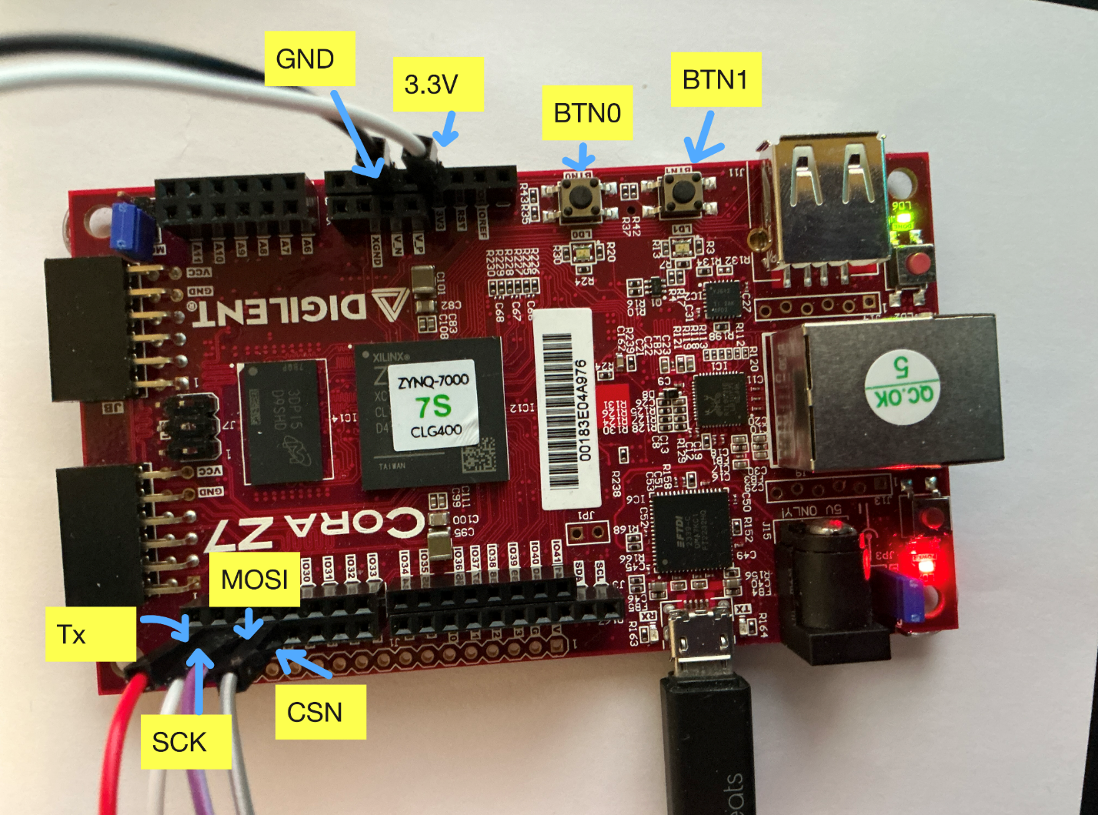
Figure 1. Labeled Cora Z7 Board
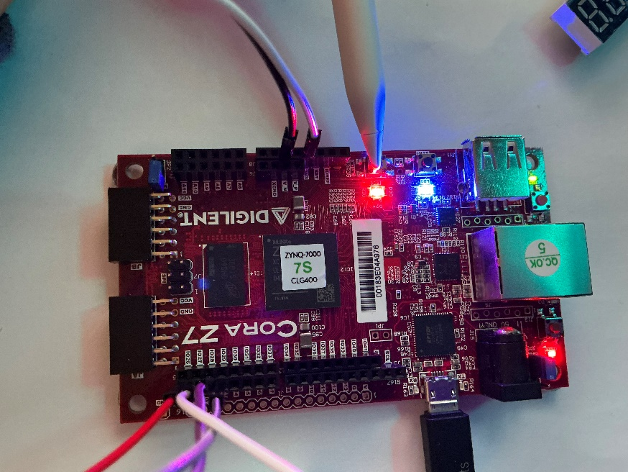
In Figure 1. We see the labeled two buttons, and the wires and voltages that are used to control the board.
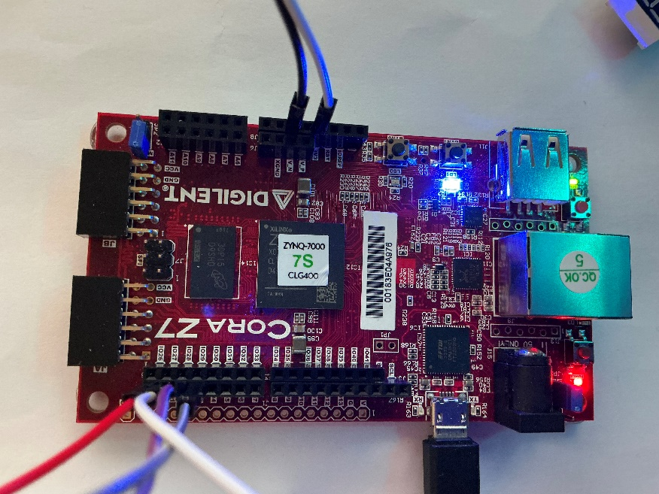
Figure 2. (Left) is showing functionality of Blue LED Figure 3. (Right) shows functionality of reset red LED.
In the figures above, Figure 2 and Figure 3 show the functionality of the blue and red LED’s on LED1 and LED0. The blue LED indicates that the counter is incrementing (in forward mode) and the red LED indicates either a start up or a reset. Whenever it is initialized it glows red, so it can be shown by pressing the reset button.
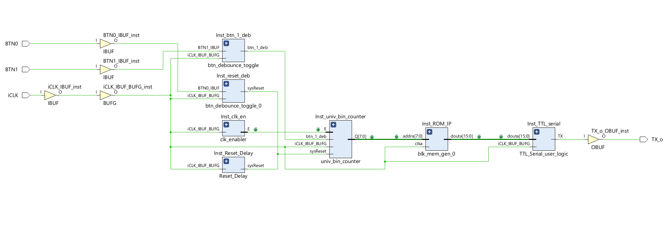
This design was divided into several functional blocks, which would integrate with each other’s signals. Figure 4. below shows the conceptual block diagram of the system, showing the flow of the data.
Figure 4. Debug Schematic created by Vivado for TTL communication (Part A)

This design was divided into several functional blocks, which would integrate with each other’s signals. Figure 5. below shows the conceptual block diagram of the system, showing the flow of the data.
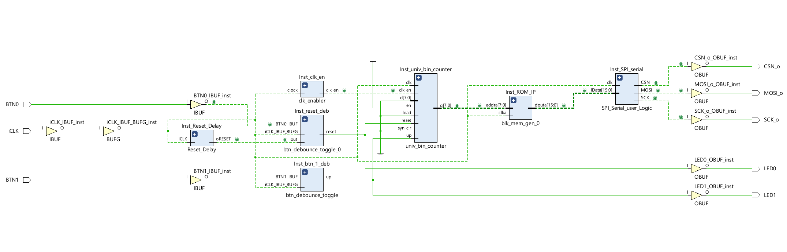
Figure 5. Debug Schematic created by Vivado for SPI SERIAL (Part B)

The Reset Delay block was there to ensure that on power-up and when the switch was pressed, the counter would reset, and ‘up’, the signal that told the counter to increment or decrement, would also reset to its default state of ‘1’.
The debouncer code block was there to debounce the raw inputs from the board and then pass the clean inputs to the ‘up’ combinational logic, and to the universal binary counter.
The universal binary counter was used to take the debounced inputs, and increment or decrement the address that is sent into the lookup table. This counter was an 8-bit binary counter, with a minimum value of 0, and a maximum value of 255, as 256 addresses were required, with the address at 0 giving the hexadecimal output of “00000000”.
The Clock Enabler is a separate code that was written to divide the 125MHz system clock down to the 1Hz so that only 1 8-bit data message will be shown on the 7 segment display at a time.
The ROM was created with Vivado, and instantiated using the IP Create block design, as specified on moodle and during class. This linked the MyROM.coe file that was provided, with all of the data. This ROM was then instantiated in the top level file, and integrated well into the project.
Part A used a TTL Serial User Logic file, which sequenced the 16 bit ROM data into a 13 byte command sequence. It instantiated the TTL Serial controller, and used a cnt_max of 13021 to ensure that each bit got 13021 clock cycles (at 125MHz), which would ensure the timings to be correct. This had a single output of Tx, which was the UART asynchronous data stream.
Part B used a SPI Serial User Logic which went through the 16 bit ROM and did a similar thing to TTL serial logic, however it used a different method to talk to the 7 segment display.
The top level code brought all of this together. Instead of using a block diagram as offered, I used regular code to ensure that I followed everything that was going on with where each signal was connected.

- Detailed Design

The Reset_Delay code was provided for this exam. Its purpose was to generate a reset pulse on power-up to ensure everything starts in a known state. It’s implemented by setting reset to ‘high’ for a short amount of time and then releasing it. Its output ‘reset’ is used with the reset switch from the DE0 Nano board to produce ‘sys_reset’ which would reset the counter on start-up or on button press. The code for this can be found in Appendix 1.
The debouncer code was provided for this exam. The purpose of the debouncer was to stabilize raw input signals from the DE0 Nano board, so that any accidental disruption or non-intended triggers wouldn’t result in any unwanted behavior. It is implemented by using a counter and confirming that the input was stable of the entirety of the counter’s duration, synchronized with the clock. In this case ‘FFFF’ was used as the counter maximum, which equates to waiting 65,353 cycles. This equates to about 1.307ms of delay, which is unnoticeable with human interaction with the board. The code for this can be found in Appendix 2.
The Universal Binary Counter code was provided for this project. The purpose of this program was to track the current address being sent to the provided ROM (read only memory), to a maximum of 256 The provided code was a universal n bit counter, so the count can easily be updated in the code. The parameters of this program were N = 8 (which is the 8-bit counter), N1 = 0, which is the minimum, and N2 = 255, which is the maximum value. Synchronized with the clock, the counter would take the 125MHz clock, ‘sysReset’, ‘btn_1_deb’ and ‘clk_en’, as inputs. The system reset would reset the clock back to 0. The ‘btn_1_deb’ was the debounced signal from the button on the physical board, which would be a pulse sent from the debouncer that caused the counter to either increment or decrement, depending on the ‘btn_1_deb’ signal. This btn_1_deb signal was a toggleable signal, from btn1. Due to the LD1 being blue when this was forward, at was easy to see what mode this was in. The code for this can be found in Appendix 3.
The ROM (Read Only Memory) module is basically the lookup table and data source. It has 256 16-bit data points. This component was instantiated using the Block Memory Generator IP, and was configured as a single-port ROM. This means that the ROM is initialized only once during compilation, and that the data sequence is permanently hardware fixed in the FPGA, meaning the file MyROM.coe is not used during actual use of the device. The ROM required an 8 bit width, and a 256 bit depth, takes a 125MHz system clock input, and outputs the full 16 bit data signal via ‘douta’. A message about this code can be found in Appendix 4.

The top-level code was the construction for the entire design, which integrated and controlled all the functional components. This provides the ports, input and output, and connects all of the other files together, to create a working machine. The only bits of code that weren’t just connecting instantiations and ports together, were a couple of logical components. The first was the initialization logic.
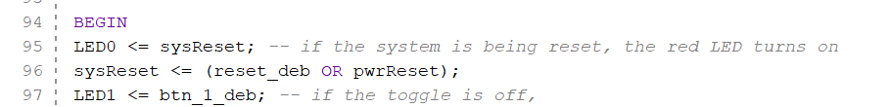
Figure 6. Shows the logical components in the top level
In Figure 6. we can see the logical components in the top level which control the ports for the LEDs, and control the logic for the reset delay. All of the other instantiations rely on sysReset, which makes sure that the system initializes correctly (and is reset upon power on, due to pwrReset), and to make sure that everything resets when one hits the reset button directly on the board.
Note that there were 2 versions of the top-level code written. The first version for part A, found in Appendix 5. and the second version for part B can be found in Appendix 6.
For part A the serial logic files were given, to make sure that it was easy to get TTL to work, after instantiating it. The code for the serial user logic can be found in Appendix 7, and the serial logic can be found in Appendix 8.
For part B, most of the serial logic files were given, however they needed some minor changes, to properly instantiate mosi, csn, and sck. MOSI, CSN, and SCK are important as they are a complex way of sending data. The code for these files can be found in Appendix 9 and 10.
MOSI – (manager out, subordinate in) makes sure that the data direction is correct. That the data is going from the manager (the Cora Z7 board) into the subordinate (the 7-segment display). This is connected to the SDI (slave data in) on the 7 segment display with a wire on a breadboard. The data is sent starting with the most significant bit first, which is important.
SCK is the serial clock, which is the clock generated by the manager/FPGA to synchronize the data transfer. This means that it controls the rate that the mosi line is sending data, and the rate that the data is read.
The CSN is a control line, which is used to start up the display.
The constraints file was used to tell the FPGA which ports to connect to which signals. This also told the FPGA which signals to mark as debug, so we could look at them in the logic analyzer (vivado’s version of Signal tap). The code for this can be found in Appendix 11.
Lastly, the clock enabler file was a short file I created to slow down the clock. This meant that the display would output at 1Hz as expected, while keeping the regular clock on the FPGA at 125MHz. The clock enabler would emit a pulse for 8ns (1 clock cycle) once every second (or 124,999,999 counts/clock cycles). The code for this can be found in Appendix 12.

- Module and Specifications Testing
PART A
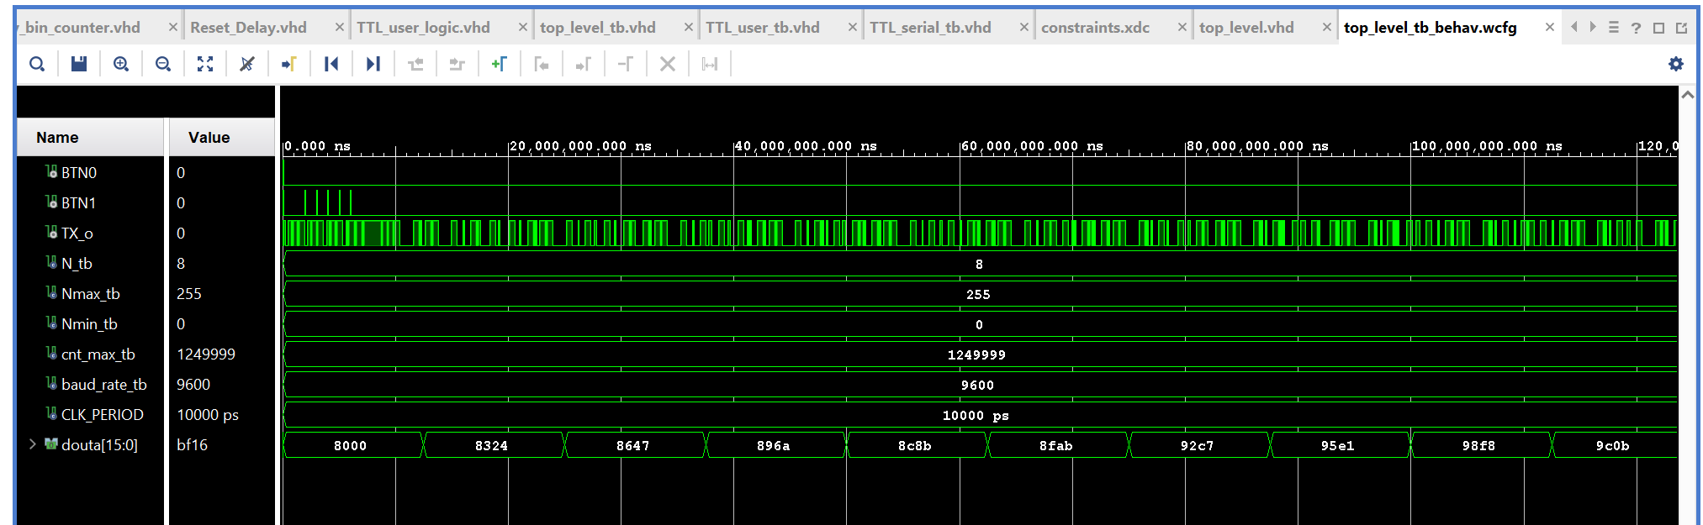
To test the functionality of each type, I used Vivado’s simulation tool, and wrote a testbench to test the code. Below in Figure 7. shows the successful functionality of the code. Using a sped up clock (from 125MHz -> 1.25MHz) for easier simulation (as seen with cnt_max_tb in the simulation) we looked at the inputs and outputs, and as expected it cycled through the data correctly, and output Tx correctly.
Figure 7. testbench in Simulation of TTL serial code
As seen in Figure 7. we can see the correct function of the TTL serial in the testbench. The clock was accelerated, so that it would spend less time processing. There were a couple of button presses in the beginning to ensure proper initialization. This ensure that after initialized (and initialization would properly set everything to 0 as expected) that the counter would count up, and go through the memory addresses and output the data as expected. This functioned correctly, and the data counted up perfectly. The testbench code can be found in Appendix 13.
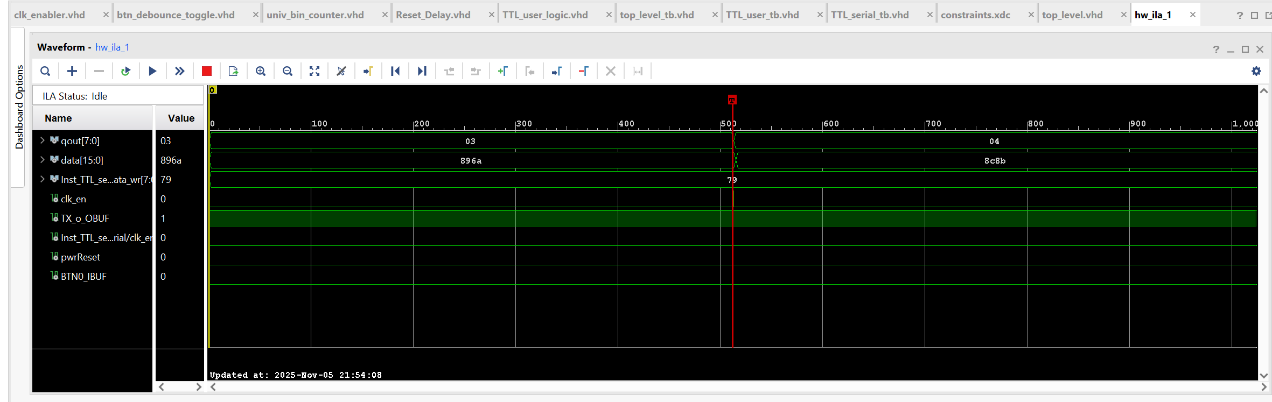
Figure 8. Logic Analyzer for TTL
As we can see in the logic analyzer, shown in Figure 8. we can see a snapshot of one of the triggers. The trigger is set to a clk_en, which happens once every second. This shows an increment of qout (the output from the universal binary counter) and the memory address changing. This shows TX as high, due to the snapshot not being able to sample over time, but instead only showing snapshots where TX will be high.
PART B
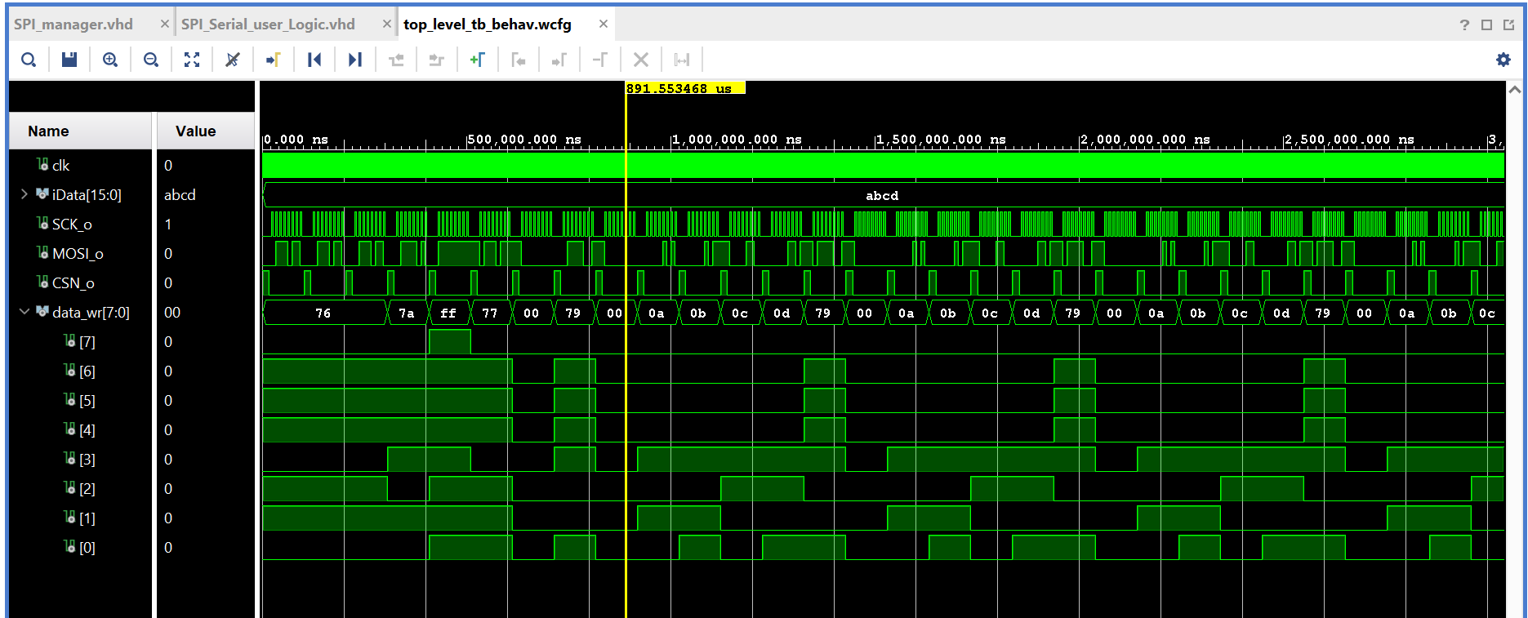
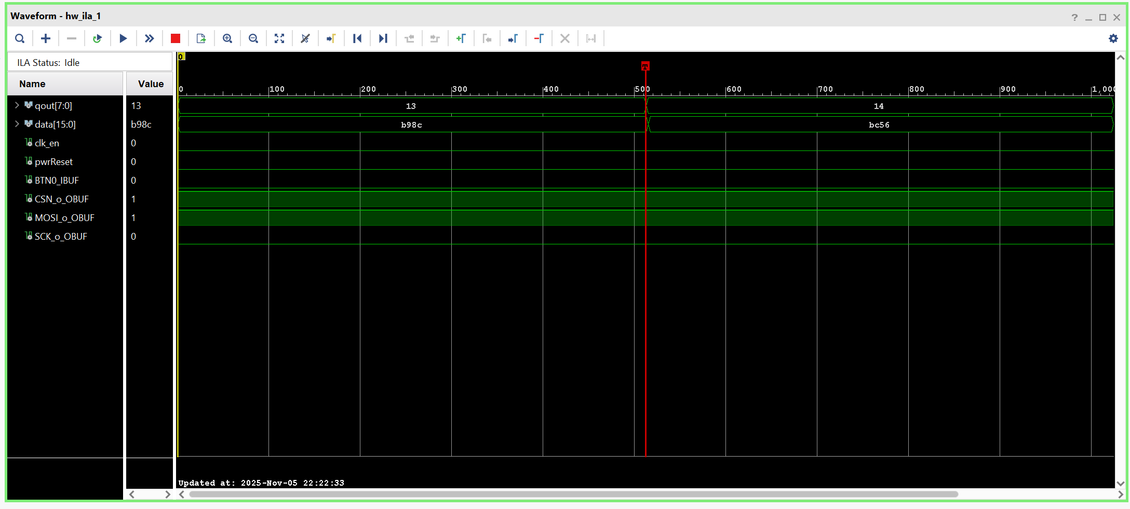
Figure 9. Testbench for Top Level SPI, showing SPI working correctly
Figure 10. Logic Analyzer showing function of SPI.

As seen in Figure 9. The testbench for the SPI top level shows the correct working of SPI. Having already thoroughly tested the logic of the design, we now only needed to test the functionality of SPI with 1 or 2 data points. As we can see, the SPI properly sends each packet of data through MOSI. The SCK is the clock, and functions when needed, whenever CSN is not on.
In Figure 10. We can also clearly see the counter incrementing up, and CSN and MOSI working to send the data. This was also then tested with the board themselves, for 100% satisfactory results. Due to the nature of the shutter speed of my camera, and the way the board cycles through having 1-2 LEDs on at a time, it is not possible to show the outputs directly. 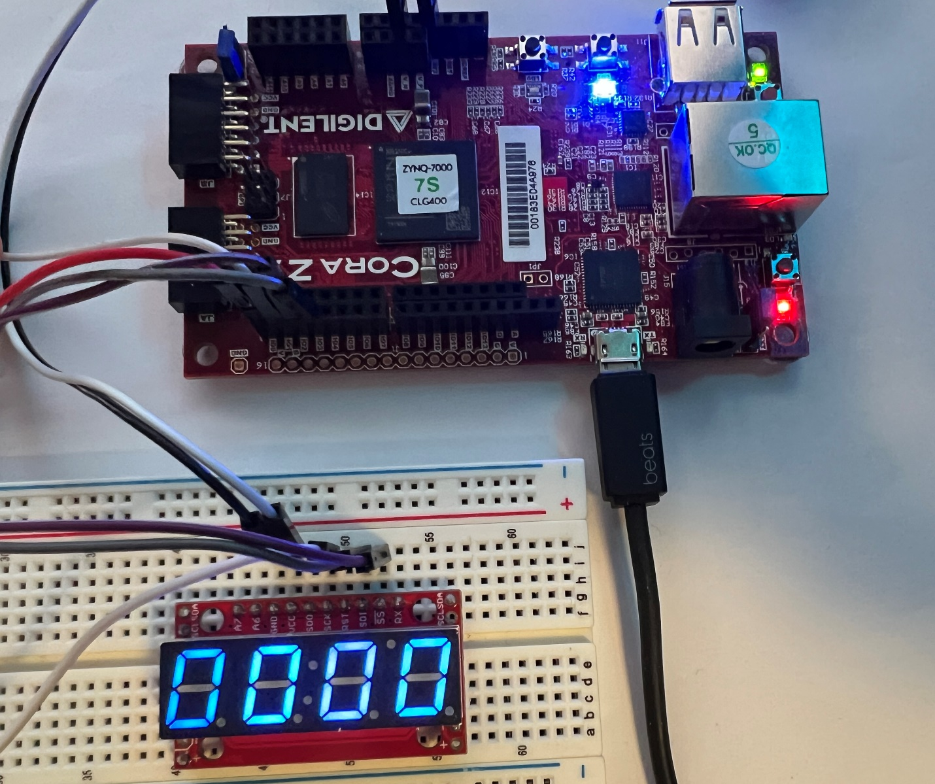
Figure 11. Shows full layout and design of the SPI communicating 7 seg display + Cora board
In Figure 11. We can see the full layout and design of the system. This is the SPI system. For the TTL system, we would just connect the red wire coming out of IO0 on the Cora z7 board, and connect it to the Rx.

- Results and Analysis
The program worked completely, and 100% adhered to specifications and assumptions made. The design operated correctly in both the simulation testing, and on the Cora Z7 board in logic analysis testing, and real world testing.
Upon first power on, the Reset_Delay module successfully initializes the system, setting the necessary signals to their respective values. The FPGA reliably goes through the provided ROM in the correct direction depending on whether the toggle is up or down (and the blue light indicates this direction). Pressing Button 1 reliably toggles the direction of traversal through the ROM. The Button 0 reset button is synchronized as specified, and resets the count, address, and the system – and is indicated by the red light turning on to show that everything is being reset. Note that the blue light is not reset by this, and the counter does continue to either increment or decrement based on the previous state, however with the blue light indication it was decided that this is purposeful design.
All timing and functional behavior matched the simulation and logic analyzer results.
No deviations from specifications were observed, and overall the project was a success, and produced a correct, complete, FPGA design system that fulfills the design goals.
All design specifications were met, and the system functioned as expected in both simulation and hardware verification.

REFERENCES
[1] SparkFun 7-Segment Serial Display Documentation https://www.sparkfun.com/sparkfun-7-segment-serial-display-blue.html
[2] SparkFun 7-Segment Serial Display tutorial https://moodle.clarkson.edu/pluginfile.php/460034/course/section/48501/SFE-0012-DS-7segmentSerial-v41.pdf
[3] Cora Z7 Board Reference Manual/Documentation https://digilent.com/reference/programmable-logic/cora-z7/reference-manual?redirect=1
[4] Reset_Delay.vhd, Univ_bin_counter.vhd, and btn_debounce.vhd, TTL_Serial_user_logic.vhd, TTL_serial.vhd on Moodle/onenote, with minimal changes made.
[5] SPI pseudocode design, given on One-Note in class
[6] MyROM.coe coefficienc file provided.
[7] A significant part of the layout of this report was taken from my Takehome Exam 1 report-OW.

APPENDIX
*Office Blocks the Opening of VHD Files if inserted as objects as icons
This appendix includes every file you would need to replicate this project, not including any of the signal tap or modelsim files. A Zip file of the entire project has been included at the bottom for convenience. Set DE0 Nano as top level.

APPENDIX 1. This file is the RESET_DELAY code provided
library IEEE;
use IEEE.STD_LOGIC_1164.ALL;

--use IEEE.numeric_std.ALL;
use IEEE.STD_LOGIC_ARITH;
use IEEE.STD_LOGIC_UNSIGNED.ALL;

ENTITY Reset_Delay IS
PORT (
SIGNAL iCLK : IN std_logic;
SIGNAL oRESET : OUT std_logic
);
END Reset_Delay;

ARCHITECTURE Arch OF Reset_Delay IS

SIGNAL Cont : std_logic_vector(19 DOWNTO 0):=X"00000";

BEGIN

PROCESS
BEGIN

WAIT UNTIL rising_edge (iCLK);
-- IF Cont /= X"FFFFF" THEN
IF Cont /= X"0000F" THEN
Cont <= Cont + '1';
oRESET <= '1';
ELSE
oRESET <= '0';
END IF;
END PROCESS;

END Arch;

APPENDIX 2. This file is the DEBOUNCER code provided
----------------------------------------------------------------------------
-- btn_debounce.vhd -- Button Debouncer
----------------------------------------------------------------------------
-- Author: Sam Bobrowicz
-- Copyright 2011 Digilent, Inc.
-- Modified: Added toggle output
----------------------------------------------------------------------------
--
----------------------------------------------------------------------------
-- This component is used to debounce signals generated by external push
-- buttons. It is designed to independently debounce a Push button signal.
-- Debouncing is done by only registering a change in a button state if
-- it remains constant for 2^16 clock cycles.
--
-- Port Descriptions:
--
-- BTN_I - The input button signals
-- CLK - Behavior is optimized for a 100 MHz clock
-- BTN_O - The debounced button signals
-- TOGGLE_O - Debounced toggle output
----------------------------------------------------------------------------
--
----------------------------------------------------------------------------
-- Revision History:
-- 08/08/2011(SamB): Created using Xilinx Tools 13.2
-- 10/06/2013 (CU): Converted to one button and added toggle output
----------------------------------------------------------------------------
library IEEE;
use IEEE.STD_LOGIC_1164.ALL;
use IEEE.std_logic_unsigned.all;

entity btn_debounce_toggle is
GENERIC (
CONSTANT CNTR_MAX : std_logic_vector(15 downto 0) := X"FFFF");
Port ( BTN_I : in STD_LOGIC;
CLK : in STD_LOGIC;
BTN_O : out STD_LOGIC;
TOGGLE_O : out STD_LOGIC;
PULSE_O : out STD_LOGIC);
end btn_debounce_toggle;

architecture Behavioral of btn_debounce_toggle is

--constant CNTR_MAX : std_logic_vector(15 downto 0) := X"FFFF";
signal btn_cntr : std_logic_vector(15 downto 0) := (others => '0');
signal btn_reg : std_logic := '0';
signal btn_toggle : std_logic := '1';
signal btn_sync : std_logic_vector(1 downto 0) := (others => '0');
signal btn_pulse : std_logic := '0';

begin

btn_debounce_process : process (CLK)
begin
if (rising_edge(CLK)) then
if (btn_cntr = CNTR_MAX) then
btn_reg <= not(btn_reg);
end if;
end if;
end process;

btn_counter_process : process (CLK)
begin
if (rising_edge(CLK)) then
if ((btn_reg = '1') xor (BTN_I = '1')) then
if (btn_cntr = CNTR_MAX) then
btn_cntr <= (others => '0');
else
btn_cntr <= btn_cntr + 1;
end if;
else
btn_cntr <= (others => '0');
end if;
end if;
end process;

btn_toggle_process : process(CLK)
begin
if (rising_edge(CLK)) then
btn_sync(0) <= btn_reg;
btn_sync(1) <= btn_sync(0);
btn_pulse <= not btn_sync(1) and btn_sync(0);
if btn_pulse = '1' then
btn_toggle <= not btn_toggle;
end if;
end if;
end process;

BTN_O <= btn_reg;
TOGGLE_O <= btn_toggle;
PULSE_O <= btn_pulse;
end Behavioral;

APPENDIX 3. This file is the altered UNIV_BIN_COUNTER code provided
-- Source: http://academic.csuohio.edu/chu_p/rtl/fpga_vhdl.html
-- Listing 4.10
-- modified: added port "clk_en", Sept 5, 2013
-- modified: added upper and lower limits of the counter, Sept 1, 2016

library ieee;
use ieee.std_logic_1164.all;
use ieee.numeric_std.all;

entity univ_bin_counter is
generic(N: integer := 8; N2: integer := 255; N1: integer := 0); -- These need to be changedD!~D!D!DSRDSN!DNTS!DTSN!NSTD!SDNT!STN!SDTN lasoercudihknsratechudbintghb
port(
clk, reset : in std_logic;
syn_clr, load, en, up : in std_logic;
clk_en : in std_logic := '1';
d : in std_logic_vector(N-1 downto 0);
max_tick, min_tick : out std_logic;
q : out std_logic_vector(N-1 downto 0)
);
end univ_bin_counter;

architecture arch of univ_bin_counter is
signal r_reg : unsigned(N-1 downto 0);
signal r_next : unsigned(N-1 downto 0);
signal r_1 : unsigned(N-1 downto 0);
signal r_2 : unsigned(N-1 downto 0);

begin
-- register
process(clk,reset)
begin
if (reset='1') then
r_reg <= (others=>'0');
elsif rising_edge(clk) and clk_en = '1' then
r_reg <= r_next;
end if;
end process;

-- next-state logic
r_next <= (others=>'0') when syn_clr='1' else
unsigned(d) when load='1' else
r_1 when en ='1' and up='1' else
r_2 when en ='1' and up='0' else
r_reg;

r_1 <= to_unsigned(N1, r_reg'length) when r_reg = to_unsigned(N2, r_reg'length) else
r_reg + 1;
r_2 <= to_unsigned(N2, r_reg'length) when r_reg = to_unsigned(N1, r_reg'length) else
r_reg - 1;

-- output logic
q <= std_logic_vector(r_reg);
max_tick <= '1' when r_reg=to_unsigned(N2, r_reg'length) else '0';
min_tick <= '1' when r_reg=to_unsigned(N1, r_reg'length) else '0';
end arch;

Appendix 4. This file is the code for the ROM (Read only memory) module
- This has instead been included in the source files on moodle.

Appendix 5. This is the Part A code for the top-level code
LIBRARY ieee;
USE ieee.std_logic_1164.all;

ENTITY top_level IS
GENERIC (
N : integer := 8; -- 8 bits becasue 256 data points
Nmax : integer := 255; -- max data
Nmin : integer := 0;
-- cnt_max : integer := 124; -- this is for debug
cnt_max : integer := 124999999; -- 1hz
baud_rate : integer := 9600); --
PORT (
iCLK : IN STD_LOGIC;
BTN0 : IN STD_LOGIC;
BTN1 : IN STD_LOGIC;
-- outputs for the 7seg display using ttl
TX_o : OUT STD_LOGIC; -- for now we only need this one, until we add spi in part b.
LED0 : OUT STD_LOGIC;
LED1 : OUT STD_LOGIC
);
END top_level;

architecture structural OF top_level IS

component univ_bin_counter is
generic(N: integer := 8; N1: integer := 255; N2: integer := 0);
port(
clk, reset : in std_logic;
syn_clr, load, en, up : in std_logic;
clk_en : in std_logic := '1';
d : in std_logic_vector(N-1 downto 0);
max_tick, min_tick : out std_logic;
q : out std_logic_vector(N-1 downto 0)
);
end component;

component clk_enabler is
GENERIC (
CONSTANT cnt_max : integer := cnt_max); --1 hz
PORT(
clock : in std_logic;
clk_en : out std_logic
);

end component;

component Reset_Delay IS
PORT (
iCLK : IN std_logic;
oRESET : OUT std_logic
);
end component;

component btn_debounce_toggle is
GENERIC (CONSTANT CNTR_MAX : std_logic_vector(15 downto 0) := X"FFFF");
Port ( BTN_I : in STD_LOGIC;
CLK : in STD_LOGIC;
BTN_O : out STD_LOGIC;
TOGGLE_O : out STD_LOGIC;
PULSE_O : out STD_LOGIC);
end component;

component TTL_Serial_user_logic is
GENERIC (CONSTANT cnt_max : integer := 13021);
PORT(
clk : IN STD_LOGIC;
iData : IN STD_LOGIC_VECTOR(15 DOWNTO 0);
TX : OUT STD_LOGIC);
end component TTL_Serial_user_logic;

component blk_mem_gen_0 is
port(
clka : in std_logic; -- clk
addra : in std_logic_vector(7 downto 0); -- addy input 8 bit
douta : out std_logic_vector(15 downto 0) -- data out, 16bits
);
end component;

signal btn_1_deb : std_LOGIC; -- this is the debouncde forwards/backwards for data
signal reset_deb : std_LOGIC;
signal clk_en : std_logic;
signal sysReset : std_logic;
signal qout : std_logic_vector(7 downto 0); -- output from univ bin counter
signal data : std_logic_vector(15 downto 0); -- output data from the ROM

signal pwrReset : std_logic;

BEGIN
LED0 <= sysReset; -- if the system is being reset, the red LED turns on
sysReset <= (reset_deb OR pwrReset);
LED1 <= btn_1_deb; -- if the toggle is off,
Inst_clk_en: clk_enabler
generic map(cnt_max => cnt_max)
port map(
clock => iCLK,
clk_en => clk_en -- 1hz pulse
);

Inst_Reset_Delay: Reset_Delay
port map(
iClk => iCLK,
oRESET => pwrReset
);

Inst_univ_bin_counter: univ_bin_counter
generic map(N => N, N2 => Nmax, N1 => Nmin)
port map(
clk => iClk,
reset => sysReset,
syn_clr => '0',
load => '0',
d => (others => '0'),
en => '1', -- this should be the 1Hz clock enabler to slow it
up => btn_1_deb, -- reset this to btn_1_deb toggle so that it counts up and down
clk_en => clk_en,
max_tick => open,
min_tick => open,
q => qout
);
Inst_ROM_IP: blk_mem_gen_0
port map(
clka => iCLK,
addra => qout,
douta => data
);

Inst_btn_1_deb : btn_debounce_toggle
GENERIC MAP(CNTR_MAX => X"FFFF")
PORT MAP(BTN_I => BTN1,
CLK => iClk,
TOGGLE_O => btn_1_deb);

Inst_reset_deb : btn_debounce_toggle
GENERIC MAP(CNTR_MAX => X"FFFF")
PORT MAP(BTN_I => BTN0,
CLK => iClk,
BTN_O => reset_deb);

Inst_TTL_serial: TTL_Serial_user_Logic
generic map(cnt_max => 13021)
port map(
clk => iCLK,
iData => data,
TX => TX_o
);

END structural;

Appendix 6. This is the Part B code for the top-level code
LIBRARY ieee;
USE ieee.std_logic_1164.all;

ENTITY top_level IS
GENERIC (
N : integer := 8; -- 8 bits becasue 256 data points
Nmax : integer := 255; -- max data
Nmin : integer := 0;
-- cnt_max : integer := 124; -- this is for debug
cnt_max : integer := 124999999; -- 1hz
baud_rate : integer := 9600); --
PORT (
iCLK : IN STD_LOGIC;
BTN0 : IN STD_LOGIC;
BTN1 : IN STD_LOGIC;
-- outputs for the 7seg display using ttl
--TX_o : OUT STD_LOGIC; -- add spi in part b.
SCK_o : OUT STD_LOGIC;
MOSI_o : OUT STD_LOGIC;
CSN_o : OUT STD_LOGIC;
LED0 : OUT STD_LOGIC;
LED1 : OUT STD_LOGIC
);
END top_level;

architecture structural OF top_level IS

component univ_bin_counter is
generic(N: integer := 8; N1: integer := 255; N2: integer := 0);
port(
clk, reset : in std_logic;
syn_clr, load, en, up : in std_logic;
clk_en : in std_logic := '1';
d : in std_logic_vector(N-1 downto 0);
max_tick, min_tick : out std_logic;
q : out std_logic_vector(N-1 downto 0)
);
end component;
component SPI_Serial_user_Logic is
GENERIC (CONSTANT cnt_max : integer := 624); --- 125mhz/200khz -1 = 624
PORT(
clk : IN STD_LOGIC;
iData : IN STD_LOGIC_VECTOR(15 DOWNTO 0);
SCK : OUT STD_LOGIC;
MOSI : OUT STD_LOGIC;
CSN : OUT STD_LOGIC
);
end component SPI_Serial_user_Logic;

component clk_enabler is
GENERIC (
CONSTANT cnt_max : integer := cnt_max); --1 hz
PORT(
clock : in std_logic;
clk_en : out std_logic
);

end component;

component Reset_Delay IS
PORT (
iCLK : IN std_logic;
oRESET : OUT std_logic
);
end component;

component btn_debounce_toggle is
GENERIC (CONSTANT CNTR_MAX : std_logic_vector(15 downto 0) := X"FFFF");
Port ( BTN_I : in STD_LOGIC;
CLK : in STD_LOGIC;
BTN_O : out STD_LOGIC;
TOGGLE_O : out STD_LOGIC;
PULSE_O : out STD_LOGIC);
end component;

component TTL_Serial_user_logic is
GENERIC (CONSTANT cnt_max : integer := 13021);
PORT(
clk : IN STD_LOGIC;
iData : IN STD_LOGIC_VECTOR(15 DOWNTO 0);
TX : OUT STD_LOGIC);
end component TTL_Serial_user_logic;

component blk_mem_gen_0 is
port(
clka : in std_logic; -- clk
addra : in std_logic_vector(7 downto 0); -- addy input 8 bit
douta : out std_logic_vector(15 downto 0) -- data out, 16bits
);
end component;

signal btn_1_deb : std_LOGIC; -- this is the debouncde forwards/backwards for data
signal reset_deb : std_LOGIC;
signal clk_en : std_logic;
signal sysReset : std_logic;
signal qout : std_logic_vector(7 downto 0); -- output from univ bin counter
signal data : std_logic_vector(15 downto 0); -- output data from the ROM

signal pwrReset : std_logic;

BEGIN
LED0 <= sysReset; -- if the system is being reset, the red LED turns on
sysReset <= (reset_deb OR pwrReset);
LED1 <= btn_1_deb; -- if the toggle is off,
Inst_clk_en: clk_enabler
generic map(cnt_max => cnt_max)
port map(
clock => iCLK,
clk_en => clk_en -- 1hz pulse
);

Inst_Reset_Delay: Reset_Delay
port map(
iClk => iCLK,
oRESET => pwrReset
);

Inst_univ_bin_counter: univ_bin_counter
generic map(N => N, N2 => Nmax, N1 => Nmin)
port map(
clk => iClk,
reset => sysReset,
syn_clr => '0',
load => '0',
d => (others => '0'),
en => '1', -- this should be the 1Hz clock enabler to slow it
up => btn_1_deb, -- reset this to btn_1_deb toggle so that it counts up and down
clk_en => clk_en,
max_tick => open,
min_tick => open,
q => qout
);
Inst_ROM_IP: blk_mem_gen_0
port map(
clka => iCLK,
addra => qout,
douta => data
);

Inst_btn_1_deb : btn_debounce_toggle
GENERIC MAP(CNTR_MAX => X"FFFF")
PORT MAP(BTN_I => BTN1,
CLK => iClk,
TOGGLE_O => btn_1_deb);

Inst_reset_deb : btn_debounce_toggle
GENERIC MAP(CNTR_MAX => X"FFFF")
PORT MAP(BTN_I => BTN0,
CLK => iClk,
BTN_O => reset_deb);

--Inst_TTL_serial: TTL_Serial_user_Logic -- THIS IS FOR TTL, PUT BACK FOR MORE TESTING???@
--generic map(cnt_max => 13021)
--port map(
-- clk => iCLK,
-- iData => data,
-- TX => TX_o
--);

Inst_SPI_serial: SPI_Serial_user_Logic
generic map(cnt_max => 624)
port map(
clk => iCLK,
iData => data,
SCK => SCK_o,
MOSI => MOSI_o,
CSN => CSN_o
);

END structural;

Appendix 7. This is the code for the TTL Serial user logic file provided.
LIBRARY ieee;
USE ieee.std_logic_1164.all;
use IEEE.numeric_std.all;
--USE ieee.std_logic_unsigned.all;

ENTITY TTL_Serial_user_logic IS
GENERIC (
CONSTANT cnt_max : integer := 13021); -- For 9600 Baud rate with a 125 MHz clock
PORT(
clk : IN STD_LOGIC; --system clock
iData : IN STD_LOGIC_VECTOR(15 DOWNTO 0); --input data
TX : OUT STD_LOGIC); --serial data output
END TTL_Serial_user_logic;

ARCHITECTURE user_logic OF TTL_Serial_user_logic IS

TYPE state_type IS(start, ready, data_valid, busy_high, repeat); --needed states
signal state : state_type; --state machine
signal reset_n : STD_LOGIC; --active low reset
signal ena : STD_LOGIC; --latch in data
signal data : STD_LOGIC_VECTOR(7 DOWNTO 0); --data to write
signal data_wr : STD_LOGIC_VECTOR(7 DOWNTO 0); --data to write
signal busy : STD_LOGIC; --indicates transaction in
signal count : unsigned(27 DOWNTO 0):=X"00000FF";
signal byteSel : integer range 0 to 12:=0;
signal sig_TX : std_logic;

--attribute keep : string ;
--attribute keep of data_wr : signal is "true";
attribute mark_debug : string;
attribute mark_debug of data_wr : signal is "TRUE";

COMPONENT TTL_serial is
GENERIC (
CONSTANT cnt_max : integer := 13021);
port (
reset_n : in std_logic;
clk : in std_logic;
ena : in std_logic;
idata : in std_logic_vector(7 downto 0);
busy : out std_logic;
TX : out std_logic
);
end COMPONENT;

BEGIN

TX <= Sig_TX;

process(byteSel, iData)
begin
case byteSel is
when 0 => data <= X"76";
when 1 => data <= X"76";
when 2 => data <= X"76";
when 3 => data <= X"7A";
when 4 => data <= X"FF";
when 5 => data <= X"77";
when 6 => data <= X"00";
when 7 => data <= X"79";
when 8 => data <= X"00";
when 9 => data <= X"0"&iData(15 downto 12);
when 10 => data <= X"0"&iData(11 downto 8);
when 11 => data <= X"0"&iData(7 downto 4);
when 12 => data <= X"0"&iData(3 downto 0);
when others => data <= X"76";
end case;
end process;

Inst_TTL_serial: TTL_serial
GENERIC map(
cnt_max => cnt_max)
port map(
reset_n => reset_n,
clk => clk,
ena => ena,
idata => data_wr,
busy => busy,
TX => Sig_TX
);

process(clk)
begin
if(clk'event and clk = '1') then
case state is
when start =>
if count /= X"0000000" then
count <= count - 1;
reset_n <= '0';
state <= start;
ena <= '0';
else
reset_n <= '1';
state <= ready;
data_wr <= data; --data to be written
end if;

when ready =>
if busy = '0' then
ena <= '1';
state <= data_valid;
end if;

when data_valid => --state for conducting this transaction
if busy = '1' then
ena <= '0';
state <= busy_high;
end if;

when busy_high =>
if(busy = '0') then -- busy just went low
state <= repeat;
end if;
when repeat =>
if byteSel < 12 then
byteSel <= byteSel + 1;
else
byteSel <= 7;
end if;
count <= X"00000FF";
state <= start;
when others => null;

end case;
end if;
end process;
end user_logic;

Appendix 8. This is the code for the TTL Serial logic (state machine)
LIBRARY ieee;
USE ieee.std_logic_1164.all;

use IEEE.NUMERIC_STD.ALL;
-- use IEEE.STD_LOGIC_ARITH;
-- use IEEE.STD_LOGIC_UNSIGNED.ALL;

entity TTL_serial is
GENERIC (
CONSTANT cnt_max : integer := 13021);
port (
reset_n : in std_logic;
clk : in std_logic;
ena : in std_logic;
idata : in std_logic_vector(7 downto 0);
busy : out std_logic;
TX : out std_logic
);
end TTL_serial;

architecture state_machine of TTL_serial is

type stateType is (ready, Start, Send, Stop);
signal state : stateType;
signal bit_cnt : integer;
signal data : std_logic_vector(7 downto 0);
signal clk_cnt : integer range 0 to cnt_max;
signal clk_en : std_logic;

attribute mark_debug : string;
attribute mark_debug of clk_en : signal is "TRUE";

begin

clk_en_inst: process(clk)
begin
if rising_edge(clk) then
if (clk_cnt = cnt_max) then
clk_cnt <= 0;
clk_en <= '1';
else
clk_cnt <= clk_cnt + 1;
clk_en <= '0';
end if;
end if;
end process;

process(clk, reset_n, ena)
begin
if reset_n = '0' then
state <= ready;
busy <= '1';
bit_cnt <= 0;
TX <= '1'; -- Don't need it if the output is pulled high

elsif rising_edge(clk) and clk_en = '1' then

case state is
when ready =>
if ena = '0' then
busy <= '0';
state <= ready;
else
busy <= '1';
data <= iData;
state <= start;
TX <= '0';
end if;

when start =>
TX <= data(bit_cnt);
state <= Send;

when Send =>
if bit_cnt < 7 then
TX <= data(bit_cnt + 1);
bit_cnt <= bit_cnt + 1;
state <= Send;
else
state <= Stop;
bit_cnt <= 0;
TX <= '1';
end if;

when Stop =>
state <= ready;
--busy <= '0';
end case;
end if;
end process;

end state_machine;

Appendix 9. This is the code for the SPI serial user logic file with minor changes
LIBRARY ieee;
USE ieee.std_logic_1164.all;
use IEEE.numeric_std.all;

ENTITY SPI_Serial_user_Logic IS
GENERIC ( CONSTANT cnt_max : integer := 624);
PORT(
clk : IN STD_LOGIC;
iData : IN STD_LOGIC_VECTOR(15 DOWNTO 0);
SCK : OUT STD_LOGIC;
MOSI : OUT STD_LOGIC;
CSN : OUT STD_LOGIC
);
END SPI_Serial_user_Logic;

ARCHITECTURE user_logic OF SPI_Serial_user_Logic IS

TYPE state_type IS(start, ready, data_valid, busy_high, repeat);
signal state : state_type;
signal reset_n : STD_LOGIC;
signal ena : STD_LOGIC;
signal data_wr : STD_LOGIC_VECTOR(7 DOWNTO 0);
signal busy : STD_LOGIC;
signal count : unsigned(27 DOWNTO 0):=X"00000FF";
signal byteSel : integer range 0 to 12:=0;
signal sig_SCK : std_logic;
signal sig_MOSI : std_logic;
signal sig_CSN : std_logic;

COMPONENT SPI_manager is
GENERIC ( CONSTANT cnt_max : integer := 624);
PORT (
reset_n : in std_logic;
clk : in std_logic;
ena : in std_logic;
idata : in std_logic_vector(7 downto 0);
busy : out std_logic;
SCK : out std_logic;
MOSI : out std_logic;
CSN : out std_logic
);
END COMPONENT;

BEGIN

SCK <= sig_SCK;
MOSI <= sig_MOSI;
CSN <= sig_CSN;

Inst_SPI_serial: SPI_manager
GENERIC map( cnt_max => cnt_max)
port map(
reset_n => reset_n,
clk => clk,
ena => ena,
idata => data_wr,
busy => busy,
SCK => sig_SCK,
MOSI => sig_MOSI,
CSN => sig_CSN
);

-- basically same as TTL logic
process(byteSel, iData)
begin
case byteSel is
when 0 => data_wr <= X"76";
when 1 => data_wr <= X"76";
when 2 => data_wr <= X"76";
when 3 => data_wr <= X"7A";
when 4 => data_wr <= X"FF";
when 5 => data_wr <= X"77";
when 6 => data_wr <= X"00";
when 7 => data_wr <= X"79";
when 8 => data_wr <= X"00";
when 9 => data_wr <= X"0"&iData(15 downto 12);
when 10 => data_wr <= X"0"&iData(11 downto 8);
when 11 => data_wr <= X"0"&iData(7 downto 4);
when 12 => data_wr <= X"0"&iData(3 downto 0);
when others => data_wr <= X"76";
end case;
end process;

process(clk) begin
if(rising_edge(clk)) then
case state is
when start =>

if count /= X"0000000" then
count <= count - 1;
reset_n <= '0';
state <= start;
ena <= '0';
else
reset_n <= '1';
state <= ready;

end if;

when ready =>
if busy = '0' then
ena <= '1';
state <= data_valid;
end if;

when data_valid =>
if busy = '1' then
state <= busy_high;
end if;

when busy_high =>
if(busy = '0') then
state <= repeat;
end if;

when repeat =>
if byteSel < 12 then
byteSel <= byteSel + 1;
else
byteSel <= 7;
end if;
count <= X"00000FF";
state <= start;

when others => null;
end case;
end if;
end process;

END user_logic;

Appendix 10. This is the code for the SPI Manager file which needed minor changes
LIBRARY ieee;
USE ieee.std_logic_1164.all;
use IEEE.numeric_std.all;

--this is basically same as TTL_Serial
ENTITY SPI_manager IS
GENERIC (CONSTANT cnt_max : integer := 624);
PORT (
reset_n : IN STD_LOGIC;
clk : IN STD_LOGIC;
ena : IN STD_LOGIC;
idata : IN STD_LOGIC_VECTOR(7 DOWNTO 0);
busy : OUT STD_LOGIC;
SCK : OUT STD_LOGIC;
MOSI : OUT STD_LOGIC;
CSN : OUT STD_LOGIC
);
END SPI_manager;

ARCHITECTURE behavioral OF SPI_manager IS

TYPE stateType IS (ready, prepare, write, done);
SIGNAL state : stateType := ready;

SIGNAL clk_cnt : INTEGER RANGE 0 TO cnt_max := 0;
SIGNAL clk_en : STD_LOGIC := '0';

SIGNAL bit_count : INTEGER RANGE 0 TO 7 := 0;
SIGNAL data_to_send: STD_LOGIC_VECTOR(7 DOWNTO 0);
SIGNAL s_SCK : STD_LOGIC := '0';
SIGNAL s_MOSI : STD_LOGIC := '0';
SIGNAL s_CSN : STD_LOGIC := '1';

BEGIN

SCK <= s_SCK;
MOSI <= s_MOSI;
CSN <= s_CSN;

clk_en_inst: PROCESS(clk)
BEGIN
IF rising_edge(clk) THEN
IF reset_n = '0' THEN
clk_cnt <= 0;
clk_en <= '0';
ELSIF (clk_cnt = cnt_max) THEN
clk_cnt <= 0;
clk_en <= '1';
ELSE
clk_cnt <= clk_cnt + 1;
clk_en <= '0';
END IF;
END IF;
END PROCESS clk_en_inst;

PROCESS (clk, reset_n)
BEGIN
IF reset_n = '0' THEN

state <= ready;
s_SCK <= '0';
s_CSN <= '1';
busy <= '1';
bit_count <= 0;

ELSIF rising_edge(clk) AND clk_en = '1' THEN

CASE state IS

WHEN ready =>
s_SCK <= '0';
s_CSN <= '1';
busy <= '0';

IF ena = '1' THEN
data_to_send <= idata;
bit_count <= 0;
state <= prepare;
ELSE
state <= ready;
END IF;

WHEN prepare =>
s_CSN <= '0';
s_SCK <= '0';
busy <= '1';
state <= write;

WHEN write =>

IF bit_count < 8 THEN

s_MOSI <= data_to_send(7 - bit_count);

s_SCK <= NOT s_SCK;

IF s_SCK = '1' THEN
bit_count <= bit_count + 1;
END IF;

IF bit_count = 7 AND s_SCK = '1' THEN
state <= done;
ELSE
state <= write;
END IF;

ELSE
state <= done;
END IF;

WHEN done =>
s_SCK <= '0';
s_CSN <= '1';
bit_count <= 0;
busy <= '0';
state <= ready;

WHEN OTHERS =>
state <= ready;
END CASE;
END IF;
END PROCESS;

END behavioral;

Appendix 11. This is the code for the constraints file, constraints.xdc. APPENDIX 11 PART A is PART A of the project’s constraints file:
## This file is a general .xdc for the Cora Z7-07S Rev. B
## To use it in a project:
## - uncomment the lines corresponding to used pins
## - rename the used ports (in each line, after get_ports) according to the top level signal names in the project

## PL System Clock
set_property -dict {PACKAGE_PIN H16 IOSTANDARD LVCMOS33} [get_ports iCLK]
create_clock -period 8.000 -name sys_clk_pin -waveform {0.000 4.000} -add [get_ports iCLK]

## RGB LEDs
#set_property -dict { PACKAGE_PIN L15 IOSTANDARD LVCMOS33 } [get_ports { led0_b }]; #IO_L22N_T3_AD7N_35 Sch=led0_b
#set_property -dict { PACKAGE_PIN G17 IOSTANDARD LVCMOS33 } [get_ports { led0_g }]; #IO_L16P_T2_35 Sch=led0_g
set_property -dict {PACKAGE_PIN N15 IOSTANDARD LVCMOS33} [get_ports LED0]
set_property -dict {PACKAGE_PIN G14 IOSTANDARD LVCMOS33} [get_ports LED1]
#set_property -dict { PACKAGE_PIN L14 IOSTANDARD LVCMOS33 } [get_ports { led1_g }]; #IO_L22P_T3_AD7P_35 Sch=led1_g
#set_property -dict { PACKAGE_PIN M15 IOSTANDARD LVCMOS33 } [get_ports { led1_r }]; #IO_L23N_T3_35 Sch=led1_r

## Buttons
set_property -dict {PACKAGE_PIN D20 IOSTANDARD LVCMOS33} [get_ports BTN0]
set_property -dict {PACKAGE_PIN D19 IOSTANDARD LVCMOS33} [get_ports BTN1]

## Pmod Header JA
set_property -dict {PACKAGE_PIN Y18 IOSTANDARD LVCMOS33} [get_ports TX_o]
#set_property -dict { PACKAGE_PIN Y19 IOSTANDARD LVCMOS33 } [get_ports { ja[1] }]; #IO_L17N_T2_34 Sch=ja_n[1]
#set_property -dict { PACKAGE_PIN Y16 IOSTANDARD LVCMOS33 } [get_ports { ja[2] }]; #IO_L7P_T1_34 Sch=ja_p[2]
#set_property -dict { PACKAGE_PIN Y17 IOSTANDARD LVCMOS33 } [get_ports { ja[3] }]; #IO_L7N_T1_34 Sch=ja_n[2]
#set_property -dict { PACKAGE_PIN U18 IOSTANDARD LVCMOS33 } [get_ports { ja[4] }]; #IO_L12P_T1_MRCC_34 Sch=ja_p[3]
#set_property -dict { PACKAGE_PIN U19 IOSTANDARD LVCMOS33 } [get_ports { ja[5] }]; #IO_L12N_T1_MRCC_34 Sch=ja_n[3]
#set_property -dict { PACKAGE_PIN W18 IOSTANDARD LVCMOS33 } [get_ports { ja[6] }]; #IO_L22P_T3_34 Sch=ja_p[4]
#set_property -dict { PACKAGE_PIN W19 IOSTANDARD LVCMOS33 } [get_ports { ja[7] }]; #IO_L22N_T3_34 Sch=ja_n[4]

## Pmod Header JB
#set_property -dict { PACKAGE_PIN W14 IOSTANDARD LVCMOS33 } [get_ports { TX_o }]; #IO_L8P_T1_34 Sch=jb_p[1]
#set_property -dict { PACKAGE_PIN Y14 IOSTANDARD LVCMOS33 } [get_ports { jb[1] }]; #IO_L8N_T1_34 Sch=jb_n[1]
#set_property -dict { PACKAGE_PIN T11 IOSTANDARD LVCMOS33 } [get_ports { jb[2] }]; #IO_L1P_T0_34 Sch=jb_p[2]
#set_property -dict { PACKAGE_PIN T10 IOSTANDARD LVCMOS33 } [get_ports { jb[3] }]; #IO_L1N_T0_34 Sch=jb_n[2]
#set_property -dict { PACKAGE_PIN V16 IOSTANDARD LVCMOS33 } [get_ports { jb[4] }]; #IO_L18P_T2_34 Sch=jb_p[3]
#set_property -dict { PACKAGE_PIN W16 IOSTANDARD LVCMOS33 } [get_ports { jb[5] }]; #IO_L18N_T2_34 Sch=jb_n[3]
#set_property -dict { PACKAGE_PIN V12 IOSTANDARD LVCMOS33 } [get_ports { jb[6] }]; #IO_L4P_T0_34 Sch=jb_p[4]
#set_property -dict { PACKAGE_PIN W13 IOSTANDARD LVCMOS33 } [get_ports { jb[7] }]; #IO_L4N_T0_34 Sch=jb_n[4]

## Crypto SDA
#set_property -dict { PACKAGE_PIN J15 IOSTANDARD LVCMOS33 } [get_ports { crypto_sda }];

## Dedicated Analog Inputs
#set_property -dict { PACKAGE_PIN K9 IOSTANDARD LVCMOS33 } [get_ports { v_p }]; #VP_0 Sch=xadc_v_p
#set_property -dict { PACKAGE_PIN L10 IOSTANDARD LVCMOS33 } [get_ports { v_n }]; #VN_0 Sch=xadc_v_n

## ChipKit Outer Analog Header - as Single-Ended Analog Inputs
## NOTE: These ports can be used as single-ended analog inputs with voltages from 0-3.3V (ChipKit analog pins A0-A5) or as digital I/O.
## WARNING: Do not use both sets of constraints at the same time!
#set_property -dict { PACKAGE_PIN E17 IOSTANDARD LVCMOS33 } [get_ports { vaux1_p }]; #IO_L3P_T0_DQS_AD1P_35 Sch=ck_an_p[0]
#set_property -dict { PACKAGE_PIN D18 IOSTANDARD LVCMOS33 } [get_ports { vaux1_n }]; #IO_L3N_T0_DQS_AD1N_35 Sch=ck_an_n[0]
#set_property -dict { PACKAGE_PIN E18 IOSTANDARD LVCMOS33 } [get_ports { vaux9_p }]; #IO_L5P_T0_AD9P_35 Sch=ck_an_p[1]
#set_property -dict { PACKAGE_PIN E19 IOSTANDARD LVCMOS33 } [get_ports { vaux9_n }]; #IO_L5N_T0_AD9N_35 Sch=ck_an_n[1]
#set_property -dict { PACKAGE_PIN K14 IOSTANDARD LVCMOS33 } [get_ports { vaux6_p }]; #IO_L20P_T3_AD6P_35 Sch=ck_an_p[2]
#set_property -dict { PACKAGE_PIN J14 IOSTANDARD LVCMOS33 } [get_ports { vaux6_n }]; #IO_L20N_T3_AD6N_35 Sch=ck_an_n[2]
#set_property -dict { PACKAGE_PIN K16 IOSTANDARD LVCMOS33 } [get_ports { vaux15_p }]; #IO_L24P_T3_AD15P_35 Sch=ck_an_p[3]
#set_property -dict { PACKAGE_PIN J16 IOSTANDARD LVCMOS33 } [get_ports { vaux15_n }]; #IO_L24N_T3_AD15N_35 Sch=ck_an_n[3]
#set_property -dict { PACKAGE_PIN J20 IOSTANDARD LVCMOS33 } [get_ports { vaux5_p }]; #IO_L17P_T2_AD5P_35 Sch=ck_an_p[4]
#set_property -dict { PACKAGE_PIN H20 IOSTANDARD LVCMOS33 } [get_ports { vaux5_n }]; #IO_L17N_T2_AD5N_35 Sch=ck_an_n[4]
#set_property -dict { PACKAGE_PIN G19 IOSTANDARD LVCMOS33 } [get_ports { vaux13_p }]; #IO_L18P_T2_AD13P_35 Sch=ck_an_p[5]
#set_property -dict { PACKAGE_PIN G20 IOSTANDARD LVCMOS33 } [get_ports { vaux13_n }]; #IO_L18N_T2_AD13N_35 Sch=ck_an_n[5]
## ChipKit Outer Analog Header - as Digital I/O
## NOTE: The following constraints should be used when using these ports as digital I/O.
#set_property -dict { PACKAGE_PIN F17 IOSTANDARD LVCMOS33 } [get_ports { ck_a0 }]; #IO_L6N_T0_VREF_35 Sch=ck_a[0]
#set_property -dict { PACKAGE_PIN J19 IOSTANDARD LVCMOS33 } [get_ports { ck_a1 }]; #IO_L10N_T1_AD11N_35 Sch=ck_a[1]
#set_property -dict { PACKAGE_PIN K17 IOSTANDARD LVCMOS33 } [get_ports { ck_a2 }]; #IO_L12P_T1_MRCC_35 Sch=ck_a[2]
#set_property -dict { PACKAGE_PIN L16 IOSTANDARD LVCMOS33 } [get_ports { ck_a3 }]; #IO_L11P_T1_SRCC_35 Sch=ck_a[3]
#set_property -dict { PACKAGE_PIN N16 IOSTANDARD LVCMOS33 } [get_ports { ck_a4 }]; #IO_L21N_T3_DQS_AD14N_35 Sch=ck_a[4]
#set_property -dict { PACKAGE_PIN P14 IOSTANDARD LVCMOS33 } [get_ports { ck_a5 }]; #IO_L6P_T0_34 Sch=ck_a[5]

## ChipKit Inner Analog Header - as Differential Analog Inputs
## NOTE: These ports can be used as differential analog inputs with voltages from 0-1.0V (ChipKit analog pins A6-A11) or as digital I/O.
## WARNING: Do not use both sets of constraints at the same time!
#set_property -dict { PACKAGE_PIN C20 IOSTANDARD LVCMOS33 } [get_ports { vaux0_p }]; #IO_L1P_T0_AD0P_35 Sch=ad_p[0]
#set_property -dict { PACKAGE_PIN B20 IOSTANDARD LVCMOS33 } [get_ports { vaux0_n }]; #IO_L1N_T0_AD0N_35 Sch=ad_n[0]
#set_property -dict { PACKAGE_PIN F19 IOSTANDARD LVCMOS33 } [get_ports { vaux12_p }]; #IO_L15P_T2_DQS_AD12P_35 Sch=ad_p[12]
#set_property -dict { PACKAGE_PIN F20 IOSTANDARD LVCMOS33 } [get_ports { vaux12_n }]; #IO_L15N_T2_DQS_AD12N_35 Sch=ad_n[12]
#set_property -dict { PACKAGE_PIN B19 IOSTANDARD LVCMOS33 } [get_ports { vaux8_p }]; #IO_L2P_T0_AD8P_35 Sch=ad_p[8]
#set_property -dict { PACKAGE_PIN A20 IOSTANDARD LVCMOS33 } [get_ports { vaux8_n }]; #IO_L2N_T0_AD8N_35 Sch=ad_n[8]
## ChipKit Inner Analog Header - as Digital I/O
## NOTE: The following constraints should be used when using the inner analog header ports as digital I/O.
#set_property -dict { PACKAGE_PIN C20 IOSTANDARD LVCMOS33 } [get_ports { ck_a6 }]; #IO_L1P_T0_AD0P_35 Sch=ad_p[0]
#set_property -dict { PACKAGE_PIN B20 IOSTANDARD LVCMOS33 } [get_ports { ck_a7 }]; #IO_L1N_T0_AD0N_35 Sch=ad_n[0]
#set_property -dict { PACKAGE_PIN F19 IOSTANDARD LVCMOS33 } [get_ports { ck_a8 }]; #IO_L15P_T2_DQS_AD12P_35 Sch=ad_p[12]
#set_property -dict { PACKAGE_PIN F20 IOSTANDARD LVCMOS33 } [get_ports { ck_a9 }]; #IO_L15N_T2_DQS_AD12N_35 Sch=ad_n[12]
#set_property -dict { PACKAGE_PIN B19 IOSTANDARD LVCMOS33 } [get_ports { ck_a10 }]; #IO_L2P_T0_AD8P_35 Sch=ad_p[8]
#set_property -dict { PACKAGE_PIN A20 IOSTANDARD LVCMOS33 } [get_ports { ck_a11 }]; #IO_L2N_T0_AD8N_35 Sch=ad_n[8]

## ChipKit Outer Digital Header
set_property -dict { PACKAGE_PIN U14 IOSTANDARD LVCMOS33 } [get_ports { Tx_o }]; #IO_L11P_T1_SRCC_34 Sch=ck_io[0]
#set_property -dict { PACKAGE_PIN V13 IOSTANDARD LVCMOS33 } [get_ports { ck_io1 }]; #IO_L3N_T0_DQS_34 Sch=ck_io[1]
#set_property -dict { PACKAGE_PIN T14 IOSTANDARD LVCMOS33 } [get_ports { ck_io2 }]; #IO_L5P_T0_34 Sch=ck_io[2]
#set_property -dict { PACKAGE_PIN T15 IOSTANDARD LVCMOS33 } [get_ports { ck_io3 }]; #IO_L5N_T0_34 Sch=ck_io[3]
#set_property -dict { PACKAGE_PIN V17 IOSTANDARD LVCMOS33 } [get_ports { ck_io4 }]; #IO_L21P_T3_DQS_34 Sch=ck_io[4]
#set_property -dict { PACKAGE_PIN V18 IOSTANDARD LVCMOS33 } [get_ports { ck_io5 }]; #IO_L21N_T3_DQS_34 Sch=ck_io[5]
#set_property -dict { PACKAGE_PIN R17 IOSTANDARD LVCMOS33 } [get_ports { ck_io6 }]; #IO_L19N_T3_VREF_34 Sch=ck_io[6]
#set_property -dict { PACKAGE_PIN R14 IOSTANDARD LVCMOS33 } [get_ports { ck_io7 }]; #IO_L6N_T0_VREF_34 Sch=ck_io[7]
#set_property -dict { PACKAGE_PIN N18 IOSTANDARD LVCMOS33 } [get_ports { ck_io8 }]; #IO_L13P_T2_MRCC_34 Sch=ck_io[8]
#set_property -dict { PACKAGE_PIN M18 IOSTANDARD LVCMOS33 } [get_ports { ck_io9 }]; #IO_L8N_T1_AD10N_35 Sch=ck_io[9]
#set_property -dict { PACKAGE_PIN U15 IOSTANDARD LVCMOS33 } [get_ports { ck_io10 }]; #IO_L11N_T1_SRCC_34 Sch=ck_io[10]
#set_property -dict { PACKAGE_PIN K18 IOSTANDARD LVCMOS33 } [get_ports { ck_io11 }]; #IO_L12N_T1_MRCC_35 Sch=ck_io[11]
#set_property -dict { PACKAGE_PIN J18 IOSTANDARD LVCMOS33 } [get_ports { ck_io12 }]; #IO_L14P_T2_AD4P_SRCC_35 Sch=ck_io[12]
#set_property -dict { PACKAGE_PIN G15 IOSTANDARD LVCMOS33 } [get_ports { ck_io13 }]; #IO_L19N_T3_VREF_35 Sch=ck_io[13]

## ChipKit Inner Digital Header
#set_property -dict { PACKAGE_PIN R16 IOSTANDARD LVCMOS33 } [get_ports { ck_io26 }]; #IO_L19P_T3_34 Sch=ck_io[26]
#set_property -dict { PACKAGE_PIN U12 IOSTANDARD LVCMOS33 } [get_ports { ck_io27 }]; #IO_L2N_T0_34 Sch=ck_io[27]
#set_property -dict { PACKAGE_PIN U13 IOSTANDARD LVCMOS33 } [get_ports { ck_io28 }]; #IO_L3P_T0_DQS_PUDC_B_34 Sch=ck_io[28]
#set_property -dict { PACKAGE_PIN V15 IOSTANDARD LVCMOS33 } [get_ports { ck_io29 }]; #IO_L10P_T1_34 Sch=ck_io[29]
#set_property -dict { PACKAGE_PIN T16 IOSTANDARD LVCMOS33 } [get_ports { ck_io30 }]; #IO_L9P_T1_DQS_34 Sch=ck_io[30]
#set_property -dict { PACKAGE_PIN U17 IOSTANDARD LVCMOS33 } [get_ports { ck_io31 }]; #IO_L9N_T1_DQS_34 Sch=ck_io[31]
#set_property -dict { PACKAGE_PIN T17 IOSTANDARD LVCMOS33 } [get_ports { ck_io32 }]; #IO_L20P_T3_34 Sch=ck_io[32]
#set_property -dict { PACKAGE_PIN R18 IOSTANDARD LVCMOS33 } [get_ports { ck_io33 }]; #IO_L20N_T3_34 Sch=ck_io[33]
#set_property -dict { PACKAGE_PIN P18 IOSTANDARD LVCMOS33 } [get_ports { ck_io34 }]; #IO_L23N_T3_34 Sch=ck_io[34]
#set_property -dict { PACKAGE_PIN N17 IOSTANDARD LVCMOS33 } [get_ports { ck_io35 }]; #IO_L23P_T3_34 Sch=ck_io[35]
#set_property -dict { PACKAGE_PIN M17 IOSTANDARD LVCMOS33 } [get_ports { ck_io36 }]; #IO_L8P_T1_AD10P_35 Sch=ck_io[36]
#set_property -dict { PACKAGE_PIN L17 IOSTANDARD LVCMOS33 } [get_ports { ck_io37 }]; #IO_L11N_T1_SRCC_35 Sch=ck_io[37]
#set_property -dict { PACKAGE_PIN H17 IOSTANDARD LVCMOS33 } [get_ports { ck_io38 }]; #IO_L13N_T2_MRCC_35 Sch=ck_io[38]
#set_property -dict { PACKAGE_PIN H18 IOSTANDARD LVCMOS33 } [get_ports { ck_io39 }]; #IO_L14N_T2_AD4N_SRCC_35 Sch=ck_io[39]
#set_property -dict { PACKAGE_PIN G18 IOSTANDARD LVCMOS33 } [get_ports { ck_io40 }]; #IO_L16N_T2_35 Sch=ck_io[40]
#set_property -dict { PACKAGE_PIN L20 IOSTANDARD LVCMOS33 } [get_ports { ck_io41 }]; #IO_L9N_T1_DQS_AD3N_35 Sch=ck_io[41]

## ChipKit SPI
#set_property -dict { PACKAGE_PIN W15 IOSTANDARD LVCMOS33 } [get_ports { ck_miso }]; #IO_L10N_T1_34 Sch=ck_miso
#set_property -dict { PACKAGE_PIN T12 IOSTANDARD LVCMOS33 } [get_ports { ck_mosi }]; #IO_L2P_T0_34 Sch=ck_mosi
#set_property -dict { PACKAGE_PIN H15 IOSTANDARD LVCMOS33 } [get_ports { ck_sck }]; #IO_L19P_T3_35 Sch=ck_sck
#set_property -dict { PACKAGE_PIN F16 IOSTANDARD LVCMOS33 } [get_ports { ck_ss }]; #IO_L6P_T0_35 Sch=ck_ss

## ChipKit I2C
#set_property -dict { PACKAGE_PIN P16 IOSTANDARD LVCMOS33 } [get_ports { ck_scl }]; #IO_L24N_T3_34 Sch=ck_scl
#set_property -dict { PACKAGE_PIN P15 IOSTANDARD LVCMOS33 } [get_ports { ck_sda }]; #IO_L24P_T3_34 Sch=ck_sda

##Misc. ChipKit signals
#set_property -dict { PACKAGE_PIN M20 IOSTANDARD LVCMOS33 } [get_ports { ck_ioa }]; #IO_L7N_T1_AD2N_35 Sch=ck_ioa

## User Digital I/O Header J1
#set_property -dict { PACKAGE_PIN L19 IOSTANDARD LVCMOS33 } [get_ports { user_dio[1] }]; #IO_L9P_T1_DQS_AD3P_35 Sch=user_dio[1]
#set_property -dict { PACKAGE_PIN M19 IOSTANDARD LVCMOS33 } [get_ports { user_dio[2] }]; #IO_L7P_T1_AD2P_35 Sch=user_dio[2]
#set_property -dict { PACKAGE_PIN N20 IOSTANDARD LVCMOS33 } [get_ports { user_dio[3] }]; #IO_L14P_T2_SRCC_34 Sch=user_dio[3]
#set_property -dict { PACKAGE_PIN P20 IOSTANDARD LVCMOS33 } [get_ports { user_dio[4] }]; #IO_L14N_T2_SRCC_34 Sch=user_dio[4]
#set_property -dict { PACKAGE_PIN P19 IOSTANDARD LVCMOS33 } [get_ports { user_dio[5] }]; #IO_L13N_T2_MRCC_34 Sch=user_dio[5]
#set_property -dict { PACKAGE_PIN R19 IOSTANDARD LVCMOS33 } [get_ports { user_dio[6] }]; #IO_0_34 Sch=user_dio[6]
#set_property -dict { PACKAGE_PIN T20 IOSTANDARD LVCMOS33 } [get_ports { user_dio[7] }]; #IO_L15P_T2_DQS_34 Sch=user_dio[7]
#set_property -dict { PACKAGE_PIN T19 IOSTANDARD LVCMOS33 } [get_ports { user_dio[8] }]; #IO_25_34 Sch=user_dio[8]
#set_property -dict { PACKAGE_PIN U20 IOSTANDARD LVCMOS33 } [get_ports { user_dio[9] }]; #IO_L15N_T2_DQS_34 Sch=user_dio[9]
#set_property -dict { PACKAGE_PIN V20 IOSTANDARD LVCMOS33 } [get_ports { user_dio[10] }]; #IO_L16P_T2_34 Sch=user_dio[10]
#set_property -dict { PACKAGE_PIN W20 IOSTANDARD LVCMOS33 } [get_ports { user_dio[11] }]; #IO_L16N_T2_34 Sch=user_dio[11]
#set_property -dict { PACKAGE_PIN K19 IOSTANDARD LVCMOS33 } [get_ports { user_dio[12] }]; #IO_L10P_T1_AD11P_35 Sch=user_dio[12]

set_property MARK_DEBUG true [get_nets {data[1]}]
set_property MARK_DEBUG true [get_nets {data[2]}]
set_property MARK_DEBUG true [get_nets {data[4]}]
set_property MARK_DEBUG true [get_nets {data[7]}]
set_property MARK_DEBUG true [get_nets {data[13]}]
set_property MARK_DEBUG true [get_nets {data[0]}]
set_property MARK_DEBUG true [get_nets {data[3]}]
set_property MARK_DEBUG true [get_nets {data[6]}]
set_property MARK_DEBUG true [get_nets {data[5]}]
set_property MARK_DEBUG true [get_nets {data[8]}]
set_property MARK_DEBUG true [get_nets {data[9]}]
set_property MARK_DEBUG true [get_nets {data[10]}]
set_property MARK_DEBUG true [get_nets {data[14]}]
set_property MARK_DEBUG true [get_nets {data[11]}]
set_property MARK_DEBUG true [get_nets {data[12]}]
set_property MARK_DEBUG true [get_nets {data[15]}]
set_property MARK_DEBUG true [get_nets {qout[0]}]
set_property MARK_DEBUG true [get_nets {qout[1]}]
set_property MARK_DEBUG true [get_nets {qout[2]}]
set_property MARK_DEBUG true [get_nets {qout[3]}]
set_property MARK_DEBUG true [get_nets {qout[4]}]
set_property MARK_DEBUG true [get_nets {qout[5]}]
set_property MARK_DEBUG true [get_nets {qout[6]}]
set_property MARK_DEBUG true [get_nets {qout[7]}]
set_property MARK_DEBUG true [get_nets clk_en]

set_property MARK_DEBUG true [get_nets TX_o_OBUF]

set_property MARK_DEBUG true [get_nets reset]
set_property MARK_DEBUG true [get_nets oRESET]
connect_debug_port u_ila_0/probe5 [get_nets [list oRESET]]

set_property MARK_DEBUG true [get_nets BTN0_IBUF]
connect_debug_port u_ila_0/probe7 [get_nets [list reset]]

create_debug_core u_ila_0 ila
set_property ALL_PROBE_SAME_MU true [get_debug_cores u_ila_0]
set_property ALL_PROBE_SAME_MU_CNT 4 [get_debug_cores u_ila_0]
set_property C_ADV_TRIGGER true [get_debug_cores u_ila_0]
set_property C_DATA_DEPTH 1024 [get_debug_cores u_ila_0]
set_property C_EN_STRG_QUAL true [get_debug_cores u_ila_0]
set_property C_INPUT_PIPE_STAGES 0 [get_debug_cores u_ila_0]
set_property C_TRIGIN_EN false [get_debug_cores u_ila_0]
set_property C_TRIGOUT_EN false [get_debug_cores u_ila_0]
set_property port_width 1 [get_debug_ports u_ila_0/clk]
connect_debug_port u_ila_0/clk [get_nets [list iCLK_IBUF_BUFG]]
set_property PROBE_TYPE DATA_AND_TRIGGER [get_debug_ports u_ila_0/probe0]
set_property port_width 8 [get_debug_ports u_ila_0/probe0]
connect_debug_port u_ila_0/probe0 [get_nets [list {Inst_TTL_serial/data_wr[0]} {Inst_TTL_serial/data_wr[1]} {Inst_TTL_serial/data_wr[2]} {Inst_TTL_serial/data_wr[3]} {Inst_TTL_serial/data_wr[4]} {Inst_TTL_serial/data_wr[5]} {Inst_TTL_serial/data_wr[6]} {Inst_TTL_serial/data_wr[7]}]]
create_debug_port u_ila_0 probe
set_property PROBE_TYPE DATA_AND_TRIGGER [get_debug_ports u_ila_0/probe1]
set_property port_width 8 [get_debug_ports u_ila_0/probe1]
connect_debug_port u_ila_0/probe1 [get_nets [list {qout[0]} {qout[1]} {qout[2]} {qout[3]} {qout[4]} {qout[5]} {qout[6]} {qout[7]}]]
create_debug_port u_ila_0 probe
set_property PROBE_TYPE DATA_AND_TRIGGER [get_debug_ports u_ila_0/probe2]
set_property port_width 16 [get_debug_ports u_ila_0/probe2]
connect_debug_port u_ila_0/probe2 [get_nets [list {data[0]} {data[1]} {data[2]} {data[3]} {data[4]} {data[5]} {data[6]} {data[7]} {data[8]} {data[9]} {data[10]} {data[11]} {data[12]} {data[13]} {data[14]} {data[15]}]]
create_debug_port u_ila_0 probe
set_property PROBE_TYPE DATA_AND_TRIGGER [get_debug_ports u_ila_0/probe3]
set_property port_width 1 [get_debug_ports u_ila_0/probe3]
connect_debug_port u_ila_0/probe3 [get_nets [list BTN0_IBUF]]
create_debug_port u_ila_0 probe
set_property PROBE_TYPE DATA_AND_TRIGGER [get_debug_ports u_ila_0/probe4]
set_property port_width 1 [get_debug_ports u_ila_0/probe4]
connect_debug_port u_ila_0/probe4 [get_nets [list Inst_TTL_serial/Inst_TTL_serial/clk_en]]
create_debug_port u_ila_0 probe
set_property PROBE_TYPE DATA_AND_TRIGGER [get_debug_ports u_ila_0/probe5]
set_property port_width 1 [get_debug_ports u_ila_0/probe5]
connect_debug_port u_ila_0/probe5 [get_nets [list clk_en]]
create_debug_port u_ila_0 probe
set_property PROBE_TYPE DATA_AND_TRIGGER [get_debug_ports u_ila_0/probe6]
set_property port_width 1 [get_debug_ports u_ila_0/probe6]
connect_debug_port u_ila_0/probe6 [get_nets [list pwrReset]]
create_debug_port u_ila_0 probe
set_property PROBE_TYPE DATA_AND_TRIGGER [get_debug_ports u_ila_0/probe7]
set_property port_width 1 [get_debug_ports u_ila_0/probe7]
connect_debug_port u_ila_0/probe7 [get_nets [list TX_o_OBUF]]
set_property C_CLK_INPUT_FREQ_HZ 300000000 [get_debug_cores dbg_hub]
set_property C_ENABLE_CLK_DIVIDER false [get_debug_cores dbg_hub]
set_property C_USER_SCAN_CHAIN 1 [get_debug_cores dbg_hub]
connect_debug_port dbg_hub/clk [get_nets iCLK_IBUF_BUFG]

APPENDIX 11 PART B IS THE CONSTRAINTS FILE FOR PART B
## This file is a general .xdc for the Cora Z7-07S Rev. B
## To use it in a project:
## - uncomment the lines corresponding to used pins
## - rename the used ports (in each line, after get_ports) according to the top level signal names in the project

## PL System Clock
set_property -dict {PACKAGE_PIN H16 IOSTANDARD LVCMOS33} [get_ports iCLK]
create_clock -period 8.000 -name sys_clk_pin -waveform {0.000 4.000} -add [get_ports iCLK]

## RGB LEDs
#set_property -dict { PACKAGE_PIN L15 IOSTANDARD LVCMOS33 } [get_ports { led0_b }]; #IO_L22N_T3_AD7N_35 Sch=led0_b
#set_property -dict { PACKAGE_PIN G17 IOSTANDARD LVCMOS33 } [get_ports { led0_g }]; #IO_L16P_T2_35 Sch=led0_g
set_property -dict {PACKAGE_PIN N15 IOSTANDARD LVCMOS33} [get_ports LED0]
set_property -dict {PACKAGE_PIN G14 IOSTANDARD LVCMOS33} [get_ports LED1]
#set_property -dict { PACKAGE_PIN L14 IOSTANDARD LVCMOS33 } [get_ports { led1_g }]; #IO_L22P_T3_AD7P_35 Sch=led1_g
#set_property -dict { PACKAGE_PIN M15 IOSTANDARD LVCMOS33 } [get_ports { led1_r }]; #IO_L23N_T3_35 Sch=led1_r

## Buttons
set_property -dict {PACKAGE_PIN D20 IOSTANDARD LVCMOS33} [get_ports BTN0]
set_property -dict {PACKAGE_PIN D19 IOSTANDARD LVCMOS33} [get_ports BTN1]

### Pmod Header JA
#set_property -dict {PACKAGE_PIN Y18 IOSTANDARD LVCMOS33} [get_ports TX_o]
#set_property -dict {PACKAGE_PIN Y19 IOSTANDARD LVCMOS33} [get_ports SCK_o]
#set_property -dict {PACKAGE_PIN Y16 IOSTANDARD LVCMOS33} [get_ports MOSI_o]
#set_property -dict {PACKAGE_PIN Y17 IOSTANDARD LVCMOS33} [get_ports CSN_o]
#set_property -dict { PACKAGE_PIN U18 IOSTANDARD LVCMOS33 } [get_ports { ja[4] }]; #IO_L12P_T1_MRCC_34 Sch=ja_p[3]
#set_property -dict { PACKAGE_PIN U19 IOSTANDARD LVCMOS33 } [get_ports { ja[5] }]; #IO_L12N_T1_MRCC_34 Sch=ja_n[3]
#set_property -dict { PACKAGE_PIN W18 IOSTANDARD LVCMOS33 } [get_ports { ja[6] }]; #IO_L22P_T3_34 Sch=ja_p[4]
#set_property -dict { PACKAGE_PIN W19 IOSTANDARD LVCMOS33 } [get_ports { ja[7] }]; #IO_L22N_T3_34 Sch=ja_n[4]

## Pmod Header JB
#set_property -dict { PACKAGE_PIN W14 IOSTANDARD LVCMOS33 } [get_ports { TX_o }]; #IO_L8P_T1_34 Sch=jb_p[1]
#set_property -dict { PACKAGE_PIN Y14 IOSTANDARD LVCMOS33 } [get_ports { jb[1] }]; #IO_L8N_T1_34 Sch=jb_n[1]
#set_property -dict { PACKAGE_PIN T11 IOSTANDARD LVCMOS33 } [get_ports { jb[2] }]; #IO_L1P_T0_34 Sch=jb_p[2]
#set_property -dict { PACKAGE_PIN T10 IOSTANDARD LVCMOS33 } [get_ports { jb[3] }]; #IO_L1N_T0_34 Sch=jb_n[2]
#set_property -dict { PACKAGE_PIN V16 IOSTANDARD LVCMOS33 } [get_ports { jb[4] }]; #IO_L18P_T2_34 Sch=jb_p[3]
#set_property -dict { PACKAGE_PIN W16 IOSTANDARD LVCMOS33 } [get_ports { jb[5] }]; #IO_L18N_T2_34 Sch=jb_n[3]
#set_property -dict { PACKAGE_PIN V12 IOSTANDARD LVCMOS33 } [get_ports { jb[6] }]; #IO_L4P_T0_34 Sch=jb_p[4]
#set_property -dict { PACKAGE_PIN W13 IOSTANDARD LVCMOS33 } [get_ports { jb[7] }]; #IO_L4N_T0_34 Sch=jb_n[4]

## Crypto SDA
#set_property -dict { PACKAGE_PIN J15 IOSTANDARD LVCMOS33 } [get_ports { crypto_sda }];

## Dedicated Analog Inputs
#set_property -dict { PACKAGE_PIN K9 IOSTANDARD LVCMOS33 } [get_ports { v_p }]; #VP_0 Sch=xadc_v_p
#set_property -dict { PACKAGE_PIN L10 IOSTANDARD LVCMOS33 } [get_ports { v_n }]; #VN_0 Sch=xadc_v_n

## ChipKit Outer Analog Header - as Single-Ended Analog Inputs
## NOTE: These ports can be used as single-ended analog inputs with voltages from 0-3.3V (ChipKit analog pins A0-A5) or as digital I/O.
## WARNING: Do not use both sets of constraints at the same time!
#set_property -dict { PACKAGE_PIN E17 IOSTANDARD LVCMOS33 } [get_ports { vaux1_p }]; #IO_L3P_T0_DQS_AD1P_35 Sch=ck_an_p[0]
#set_property -dict { PACKAGE_PIN D18 IOSTANDARD LVCMOS33 } [get_ports { vaux1_n }]; #IO_L3N_T0_DQS_AD1N_35 Sch=ck_an_n[0]
#set_property -dict { PACKAGE_PIN E18 IOSTANDARD LVCMOS33 } [get_ports { vaux9_p }]; #IO_L5P_T0_AD9P_35 Sch=ck_an_p[1]
#set_property -dict { PACKAGE_PIN E19 IOSTANDARD LVCMOS33 } [get_ports { vaux9_n }]; #IO_L5N_T0_AD9N_35 Sch=ck_an_n[1]
#set_property -dict { PACKAGE_PIN K14 IOSTANDARD LVCMOS33 } [get_ports { vaux6_p }]; #IO_L20P_T3_AD6P_35 Sch=ck_an_p[2]
#set_property -dict { PACKAGE_PIN J14 IOSTANDARD LVCMOS33 } [get_ports { vaux6_n }]; #IO_L20N_T3_AD6N_35 Sch=ck_an_n[2]
#set_property -dict { PACKAGE_PIN K16 IOSTANDARD LVCMOS33 } [get_ports { vaux15_p }]; #IO_L24P_T3_AD15P_35 Sch=ck_an_p[3]
#set_property -dict { PACKAGE_PIN J16 IOSTANDARD LVCMOS33 } [get_ports { vaux15_n }]; #IO_L24N_T3_AD15N_35 Sch=ck_an_n[3]
#set_property -dict { PACKAGE_PIN J20 IOSTANDARD LVCMOS33 } [get_ports { vaux5_p }]; #IO_L17P_T2_AD5P_35 Sch=ck_an_p[4]
#set_property -dict { PACKAGE_PIN H20 IOSTANDARD LVCMOS33 } [get_ports { vaux5_n }]; #IO_L17N_T2_AD5N_35 Sch=ck_an_n[4]
#set_property -dict { PACKAGE_PIN G19 IOSTANDARD LVCMOS33 } [get_ports { vaux13_p }]; #IO_L18P_T2_AD13P_35 Sch=ck_an_p[5]
#set_property -dict { PACKAGE_PIN G20 IOSTANDARD LVCMOS33 } [get_ports { vaux13_n }]; #IO_L18N_T2_AD13N_35 Sch=ck_an_n[5]
## ChipKit Outer Analog Header - as Digital I/O
## NOTE: The following constraints should be used when using these ports as digital I/O.
#set_property -dict { PACKAGE_PIN F17 IOSTANDARD LVCMOS33 } [get_ports { ck_a0 }]; #IO_L6N_T0_VREF_35 Sch=ck_a[0]
#set_property -dict { PACKAGE_PIN J19 IOSTANDARD LVCMOS33 } [get_ports { ck_a1 }]; #IO_L10N_T1_AD11N_35 Sch=ck_a[1]
#set_property -dict { PACKAGE_PIN K17 IOSTANDARD LVCMOS33 } [get_ports { ck_a2 }]; #IO_L12P_T1_MRCC_35 Sch=ck_a[2]
#set_property -dict { PACKAGE_PIN L16 IOSTANDARD LVCMOS33 } [get_ports { ck_a3 }]; #IO_L11P_T1_SRCC_35 Sch=ck_a[3]
#set_property -dict { PACKAGE_PIN N16 IOSTANDARD LVCMOS33 } [get_ports { ck_a4 }]; #IO_L21N_T3_DQS_AD14N_35 Sch=ck_a[4]
#set_property -dict { PACKAGE_PIN P14 IOSTANDARD LVCMOS33 } [get_ports { ck_a5 }]; #IO_L6P_T0_34 Sch=ck_a[5]

## ChipKit Inner Analog Header - as Differential Analog Inputs
## NOTE: These ports can be used as differential analog inputs with voltages from 0-1.0V (ChipKit analog pins A6-A11) or as digital I/O.
## WARNING: Do not use both sets of constraints at the same time!
#set_property -dict { PACKAGE_PIN C20 IOSTANDARD LVCMOS33 } [get_ports { vaux0_p }]; #IO_L1P_T0_AD0P_35 Sch=ad_p[0]
#set_property -dict { PACKAGE_PIN B20 IOSTANDARD LVCMOS33 } [get_ports { vaux0_n }]; #IO_L1N_T0_AD0N_35 Sch=ad_n[0]
#set_property -dict { PACKAGE_PIN F19 IOSTANDARD LVCMOS33 } [get_ports { vaux12_p }]; #IO_L15P_T2_DQS_AD12P_35 Sch=ad_p[12]
#set_property -dict { PACKAGE_PIN F20 IOSTANDARD LVCMOS33 } [get_ports { vaux12_n }]; #IO_L15N_T2_DQS_AD12N_35 Sch=ad_n[12]
#set_property -dict { PACKAGE_PIN B19 IOSTANDARD LVCMOS33 } [get_ports { vaux8_p }]; #IO_L2P_T0_AD8P_35 Sch=ad_p[8]
#set_property -dict { PACKAGE_PIN A20 IOSTANDARD LVCMOS33 } [get_ports { vaux8_n }]; #IO_L2N_T0_AD8N_35 Sch=ad_n[8]
## ChipKit Inner Analog Header - as Digital I/O
## NOTE: The following constraints should be used when using the inner analog header ports as digital I/O.
#set_property -dict { PACKAGE_PIN C20 IOSTANDARD LVCMOS33 } [get_ports { ck_a6 }]; #IO_L1P_T0_AD0P_35 Sch=ad_p[0]
#set_property -dict { PACKAGE_PIN B20 IOSTANDARD LVCMOS33 } [get_ports { ck_a7 }]; #IO_L1N_T0_AD0N_35 Sch=ad_n[0]
#set_property -dict { PACKAGE_PIN F19 IOSTANDARD LVCMOS33 } [get_ports { ck_a8 }]; #IO_L15P_T2_DQS_AD12P_35 Sch=ad_p[12]
#set_property -dict { PACKAGE_PIN F20 IOSTANDARD LVCMOS33 } [get_ports { ck_a9 }]; #IO_L15N_T2_DQS_AD12N_35 Sch=ad_n[12]
#set_property -dict { PACKAGE_PIN B19 IOSTANDARD LVCMOS33 } [get_ports { ck_a10 }]; #IO_L2P_T0_AD8P_35 Sch=ad_p[8]
#set_property -dict { PACKAGE_PIN A20 IOSTANDARD LVCMOS33 } [get_ports { ck_a11 }]; #IO_L2N_T0_AD8N_35 Sch=ad_n[8]

## ChipKit Outer Digital Header
#set_property -dict { PACKAGE_PIN U14 IOSTANDARD LVCMOS33 } [get_ports { TX_o }]; #IO_L11P_T1_SRCC_34 Sch=ck_io[0]
set_property -dict {PACKAGE_PIN V13 IOSTANDARD LVCMOS33} [get_ports SCK_o]
set_property -dict {PACKAGE_PIN T14 IOSTANDARD LVCMOS33} [get_ports MOSI_o]
set_property -dict {PACKAGE_PIN T15 IOSTANDARD LVCMOS33} [get_ports CSN_o]
#set_property -dict { PACKAGE_PIN V17 IOSTANDARD LVCMOS33 } [get_ports { ck_io4 }]; #IO_L21P_T3_DQS_34 Sch=ck_io[4]
#set_property -dict { PACKAGE_PIN V18 IOSTANDARD LVCMOS33 } [get_ports { ck_io5 }]; #IO_L21N_T3_DQS_34 Sch=ck_io[5]
#set_property -dict { PACKAGE_PIN R17 IOSTANDARD LVCMOS33 } [get_ports { ck_io6 }]; #IO_L19N_T3_VREF_34 Sch=ck_io[6]
#set_property -dict { PACKAGE_PIN R14 IOSTANDARD LVCMOS33 } [get_ports { ck_io7 }]; #IO_L6N_T0_VREF_34 Sch=ck_io[7]
#set_property -dict { PACKAGE_PIN N18 IOSTANDARD LVCMOS33 } [get_ports { ck_io8 }]; #IO_L13P_T2_MRCC_34 Sch=ck_io[8]
#set_property -dict { PACKAGE_PIN M18 IOSTANDARD LVCMOS33 } [get_ports { ck_io9 }]; #IO_L8N_T1_AD10N_35 Sch=ck_io[9]
#set_property -dict { PACKAGE_PIN U15 IOSTANDARD LVCMOS33 } [get_ports { ck_io10 }]; #IO_L11N_T1_SRCC_34 Sch=ck_io[10]
#set_property -dict { PACKAGE_PIN K18 IOSTANDARD LVCMOS33 } [get_ports { ck_io11 }]; #IO_L12N_T1_MRCC_35 Sch=ck_io[11]
#set_property -dict { PACKAGE_PIN J18 IOSTANDARD LVCMOS33 } [get_ports { ck_io12 }]; #IO_L14P_T2_AD4P_SRCC_35 Sch=ck_io[12]
#set_property -dict { PACKAGE_PIN G15 IOSTANDARD LVCMOS33 } [get_ports { ck_io13 }]; #IO_L19N_T3_VREF_35 Sch=ck_io[13]

## ChipKit Inner Digital Header
#set_property -dict { PACKAGE_PIN R16 IOSTANDARD LVCMOS33 } [get_ports { ck_io26 }]; #IO_L19P_T3_34 Sch=ck_io[26]
#set_property -dict { PACKAGE_PIN U12 IOSTANDARD LVCMOS33 } [get_ports { ck_io27 }]; #IO_L2N_T0_34 Sch=ck_io[27]
#set_property -dict { PACKAGE_PIN U13 IOSTANDARD LVCMOS33 } [get_ports { ck_io28 }]; #IO_L3P_T0_DQS_PUDC_B_34 Sch=ck_io[28]
#set_property -dict { PACKAGE_PIN V15 IOSTANDARD LVCMOS33 } [get_ports { ck_io29 }]; #IO_L10P_T1_34 Sch=ck_io[29]
#set_property -dict { PACKAGE_PIN T16 IOSTANDARD LVCMOS33 } [get_ports { ck_io30 }]; #IO_L9P_T1_DQS_34 Sch=ck_io[30]
#set_property -dict { PACKAGE_PIN U17 IOSTANDARD LVCMOS33 } [get_ports { ck_io31 }]; #IO_L9N_T1_DQS_34 Sch=ck_io[31]
#set_property -dict { PACKAGE_PIN T17 IOSTANDARD LVCMOS33 } [get_ports { ck_io32 }]; #IO_L20P_T3_34 Sch=ck_io[32]
#set_property -dict { PACKAGE_PIN R18 IOSTANDARD LVCMOS33 } [get_ports { ck_io33 }]; #IO_L20N_T3_34 Sch=ck_io[33]
#set_property -dict { PACKAGE_PIN P18 IOSTANDARD LVCMOS33 } [get_ports { ck_io34 }]; #IO_L23N_T3_34 Sch=ck_io[34]
#set_property -dict { PACKAGE_PIN N17 IOSTANDARD LVCMOS33 } [get_ports { ck_io35 }]; #IO_L23P_T3_34 Sch=ck_io[35]
#set_property -dict { PACKAGE_PIN M17 IOSTANDARD LVCMOS33 } [get_ports { ck_io36 }]; #IO_L8P_T1_AD10P_35 Sch=ck_io[36]
#set_property -dict { PACKAGE_PIN L17 IOSTANDARD LVCMOS33 } [get_ports { ck_io37 }]; #IO_L11N_T1_SRCC_35 Sch=ck_io[37]
#set_property -dict { PACKAGE_PIN H17 IOSTANDARD LVCMOS33 } [get_ports { ck_io38 }]; #IO_L13N_T2_MRCC_35 Sch=ck_io[38]
#set_property -dict { PACKAGE_PIN H18 IOSTANDARD LVCMOS33 } [get_ports { ck_io39 }]; #IO_L14N_T2_AD4N_SRCC_35 Sch=ck_io[39]
#set_property -dict { PACKAGE_PIN G18 IOSTANDARD LVCMOS33 } [get_ports { ck_io40 }]; #IO_L16N_T2_35 Sch=ck_io[40]
#set_property -dict { PACKAGE_PIN L20 IOSTANDARD LVCMOS33 } [get_ports { ck_io41 }]; #IO_L9N_T1_DQS_AD3N_35 Sch=ck_io[41]

## ChipKit SPI
#set_property -dict { PACKAGE_PIN W15 IOSTANDARD LVCMOS33 } [get_ports { ck_miso }]; #IO_L10N_T1_34 Sch=ck_miso
#set_property -dict { PACKAGE_PIN T12 IOSTANDARD LVCMOS33 } [get_ports { ck_mosi }]; #IO_L2P_T0_34 Sch=ck_mosi
#set_property -dict { PACKAGE_PIN H15 IOSTANDARD LVCMOS33 } [get_ports { ck_sck }]; #IO_L19P_T3_35 Sch=ck_sck
#set_property -dict { PACKAGE_PIN F16 IOSTANDARD LVCMOS33 } [get_ports { ck_ss }]; #IO_L6P_T0_35 Sch=ck_ss

## ChipKit I2C
#set_property -dict { PACKAGE_PIN P16 IOSTANDARD LVCMOS33 } [get_ports { ck_scl }]; #IO_L24N_T3_34 Sch=ck_scl
#set_property -dict { PACKAGE_PIN P15 IOSTANDARD LVCMOS33 } [get_ports { ck_sda }]; #IO_L24P_T3_34 Sch=ck_sda

##Misc. ChipKit signals
#set_property -dict { PACKAGE_PIN M20 IOSTANDARD LVCMOS33 } [get_ports { ck_ioa }]; #IO_L7N_T1_AD2N_35 Sch=ck_ioa

## User Digital I/O Header J1
#set_property -dict { PACKAGE_PIN L19 IOSTANDARD LVCMOS33 } [get_ports { user_dio[1] }]; #IO_L9P_T1_DQS_AD3P_35 Sch=user_dio[1]
#set_property -dict { PACKAGE_PIN M19 IOSTANDARD LVCMOS33 } [get_ports { user_dio[2] }]; #IO_L7P_T1_AD2P_35 Sch=user_dio[2]
#set_property -dict { PACKAGE_PIN N20 IOSTANDARD LVCMOS33 } [get_ports { user_dio[3] }]; #IO_L14P_T2_SRCC_34 Sch=user_dio[3]
#set_property -dict { PACKAGE_PIN P20 IOSTANDARD LVCMOS33 } [get_ports { user_dio[4] }]; #IO_L14N_T2_SRCC_34 Sch=user_dio[4]
#set_property -dict { PACKAGE_PIN P19 IOSTANDARD LVCMOS33 } [get_ports { user_dio[5] }]; #IO_L13N_T2_MRCC_34 Sch=user_dio[5]
#set_property -dict { PACKAGE_PIN R19 IOSTANDARD LVCMOS33 } [get_ports { user_dio[6] }]; #IO_0_34 Sch=user_dio[6]
#set_property -dict { PACKAGE_PIN T20 IOSTANDARD LVCMOS33 } [get_ports { user_dio[7] }]; #IO_L15P_T2_DQS_34 Sch=user_dio[7]
#set_property -dict { PACKAGE_PIN T19 IOSTANDARD LVCMOS33 } [get_ports { user_dio[8] }]; #IO_25_34 Sch=user_dio[8]
#set_property -dict { PACKAGE_PIN U20 IOSTANDARD LVCMOS33 } [get_ports { user_dio[9] }]; #IO_L15N_T2_DQS_34 Sch=user_dio[9]
#set_property -dict { PACKAGE_PIN V20 IOSTANDARD LVCMOS33 } [get_ports { user_dio[10] }]; #IO_L16P_T2_34 Sch=user_dio[10]
#set_property -dict { PACKAGE_PIN W20 IOSTANDARD LVCMOS33 } [get_ports { user_dio[11] }]; #IO_L16N_T2_34 Sch=user_dio[11]
#set_property -dict { PACKAGE_PIN K19 IOSTANDARD LVCMOS33 } [get_ports { user_dio[12] }]; #IO_L10P_T1_AD11P_35 Sch=user_dio[12]

set_property MARK_DEBUG true [get_nets {data[1]}]
set_property MARK_DEBUG true [get_nets {data[2]}]
set_property MARK_DEBUG true [get_nets {data[4]}]
set_property MARK_DEBUG true [get_nets {data[7]}]
set_property MARK_DEBUG true [get_nets {data[13]}]
set_property MARK_DEBUG true [get_nets {data[0]}]
set_property MARK_DEBUG true [get_nets {data[3]}]
set_property MARK_DEBUG true [get_nets {data[6]}]
set_property MARK_DEBUG true [get_nets {data[5]}]
set_property MARK_DEBUG true [get_nets {data[8]}]
set_property MARK_DEBUG true [get_nets {data[9]}]
set_property MARK_DEBUG true [get_nets {data[10]}]
set_property MARK_DEBUG true [get_nets {data[14]}]
set_property MARK_DEBUG true [get_nets {data[11]}]
set_property MARK_DEBUG true [get_nets {data[12]}]
set_property MARK_DEBUG true [get_nets {data[15]}]
set_property MARK_DEBUG true [get_nets {qout[0]}]
set_property MARK_DEBUG true [get_nets {qout[1]}]
set_property MARK_DEBUG true [get_nets {qout[2]}]
set_property MARK_DEBUG true [get_nets {qout[3]}]
set_property MARK_DEBUG true [get_nets {qout[4]}]
set_property MARK_DEBUG true [get_nets {qout[5]}]
set_property MARK_DEBUG true [get_nets {qout[6]}]
set_property MARK_DEBUG true [get_nets {qout[7]}]
set_property MARK_DEBUG true [get_nets clk_en]

set_property MARK_DEBUG true [get_nets TX_o_OBUF]

set_property MARK_DEBUG true [get_nets reset]
set_property MARK_DEBUG true [get_nets oRESET]
connect_debug_port u_ila_0/probe5 [get_nets [list oRESET]]

set_property MARK_DEBUG true [get_nets BTN0_IBUF]
connect_debug_port u_ila_0/probe0 [get_nets [list {Inst_TTL_serial/data_wr[0]} {Inst_TTL_serial/data_wr[1]} {Inst_TTL_serial/data_wr[2]} {Inst_TTL_serial/data_wr[3]} {Inst_TTL_serial/data_wr[4]} {Inst_TTL_serial/data_wr[5]} {Inst_TTL_serial/data_wr[6]} {Inst_TTL_serial/data_wr[7]}]]
connect_debug_port u_ila_0/probe5 [get_nets [list Inst_TTL_serial/Inst_TTL_serial/clk_en]]
connect_debug_port u_ila_0/probe8 [get_nets [list TX_o_OBUF]]

set_property MARK_DEBUG true [get_nets CSN_o_OBUF]
set_property MARK_DEBUG true [get_nets MOSI_o_OBUF]
set_property MARK_DEBUG true [get_nets SCK_o_OBUF]
create_debug_core u_ila_0 ila
set_property ALL_PROBE_SAME_MU true [get_debug_cores u_ila_0]
set_property ALL_PROBE_SAME_MU_CNT 4 [get_debug_cores u_ila_0]
set_property C_ADV_TRIGGER true [get_debug_cores u_ila_0]
set_property C_DATA_DEPTH 1024 [get_debug_cores u_ila_0]
set_property C_EN_STRG_QUAL true [get_debug_cores u_ila_0]
set_property C_INPUT_PIPE_STAGES 0 [get_debug_cores u_ila_0]
set_property C_TRIGIN_EN false [get_debug_cores u_ila_0]
set_property C_TRIGOUT_EN false [get_debug_cores u_ila_0]
set_property port_width 1 [get_debug_ports u_ila_0/clk]
connect_debug_port u_ila_0/clk [get_nets [list iCLK_IBUF_BUFG]]
set_property PROBE_TYPE DATA_AND_TRIGGER [get_debug_ports u_ila_0/probe0]
set_property port_width 16 [get_debug_ports u_ila_0/probe0]
connect_debug_port u_ila_0/probe0 [get_nets [list {data[0]} {data[1]} {data[2]} {data[3]} {data[4]} {data[5]} {data[6]} {data[7]} {data[8]} {data[9]} {data[10]} {data[11]} {data[12]} {data[13]} {data[14]} {data[15]}]]
create_debug_port u_ila_0 probe
set_property PROBE_TYPE DATA_AND_TRIGGER [get_debug_ports u_ila_0/probe1]
set_property port_width 8 [get_debug_ports u_ila_0/probe1]
connect_debug_port u_ila_0/probe1 [get_nets [list {qout[0]} {qout[1]} {qout[2]} {qout[3]} {qout[4]} {qout[5]} {qout[6]} {qout[7]}]]
create_debug_port u_ila_0 probe
set_property PROBE_TYPE DATA_AND_TRIGGER [get_debug_ports u_ila_0/probe2]
set_property port_width 1 [get_debug_ports u_ila_0/probe2]
connect_debug_port u_ila_0/probe2 [get_nets [list BTN0_IBUF]]
create_debug_port u_ila_0 probe
set_property PROBE_TYPE DATA_AND_TRIGGER [get_debug_ports u_ila_0/probe3]
set_property port_width 1 [get_debug_ports u_ila_0/probe3]
connect_debug_port u_ila_0/probe3 [get_nets [list clk_en]]
create_debug_port u_ila_0 probe
set_property PROBE_TYPE DATA_AND_TRIGGER [get_debug_ports u_ila_0/probe4]
set_property port_width 1 [get_debug_ports u_ila_0/probe4]
connect_debug_port u_ila_0/probe4 [get_nets [list CSN_o_OBUF]]
create_debug_port u_ila_0 probe
set_property PROBE_TYPE DATA_AND_TRIGGER [get_debug_ports u_ila_0/probe5]
set_property port_width 1 [get_debug_ports u_ila_0/probe5]
connect_debug_port u_ila_0/probe5 [get_nets [list MOSI_o_OBUF]]
create_debug_port u_ila_0 probe
set_property PROBE_TYPE DATA_AND_TRIGGER [get_debug_ports u_ila_0/probe6]
set_property port_width 1 [get_debug_ports u_ila_0/probe6]
connect_debug_port u_ila_0/probe6 [get_nets [list pwrReset]]
create_debug_port u_ila_0 probe
set_property PROBE_TYPE DATA_AND_TRIGGER [get_debug_ports u_ila_0/probe7]
set_property port_width 1 [get_debug_ports u_ila_0/probe7]
connect_debug_port u_ila_0/probe7 [get_nets [list SCK_o_OBUF]]
set_property C_CLK_INPUT_FREQ_HZ 300000000 [get_debug_cores dbg_hub]
set_property C_ENABLE_CLK_DIVIDER false [get_debug_cores dbg_hub]
set_property C_USER_SCAN_CHAIN 1 [get_debug_cores dbg_hub]
connect_debug_port dbg_hub/clk [get_nets iCLK_IBUF_BUFG]

Appendix 12. This is the code for the clock enabler file
LIBRARY IEEE;
USE IEEE.STD_LOGIC_1164.ALL;
USE IEEE.NUMERIC_STD.ALL;

ENTITY clk_enabler IS
GENERIC (
CONSTANT cnt_max : integer := 124999999
);
PORT(
clock : IN std_logic;
clk_en : OUT std_logic
);
END clk_enabler;

ARCHITECTURE Behavioral OF clk_enabler IS
SIGNAL clk_cnt : integer range 0 to cnt_max := 0;
SIGNAL internal_clk_en : std_logic := '0';
BEGIN

PROCESS (clock)
BEGIN
IF rising_edge(clock) THEN
IF (clk_cnt = cnt_max) THEN
clk_cnt <= 0;
internal_clk_en <= '1';
ELSE
clk_cnt <= clk_cnt + 1;
internal_clk_en <= '0';
END IF;
END IF;
END PROCESS;

clk_en <= internal_clk_en;

END Behavioral;

Appendix 13. This is the code for the testbench for Part A.

library ieee;
use ieee.std_logic_1164.all;
use ieee.numeric_std.all;

entity top_level_tb is
end entity;

architecture sim of top_level_tb is

constant N_tb : integer := 8;
constant Nmax_tb : integer := 255;
constant Nmin_tb : integer := 0;
constant cnt_max_tb : integer := 1249999; -- 124999999 but make smaller so 1.25m
constant baud_rate_tb: integer := 9600;

-- DUT signals
signal iCLK : std_logic := '0';
signal BTN0 : std_logic := '0';
signal BTN1 : std_logic := '0';
signal TX_o : std_logic;

constant CLK_PERIOD : time := 10 ns;

begin

DUT: entity work.top_level
generic map (
N => N_tb,
Nmax => Nmax_tb,
Nmin => Nmin_tb,
cnt_max => cnt_max_tb,
baud_rate => baud_rate_tb
)
port map (
iCLK => iCLK,
BTN0 => BTN0,
BTN1 => BTN1,
TX_o => TX_o

);

clk_process : process
begin
iCLK <= '0';
wait for CLK_PERIOD/2;
iCLK <= '1';
wait for CLK_PERIOD/2;
end process;

stim_proc : process
begin
BTN0 <= '0';
BTN1 <= '0';
wait for 100 ns;

BTN0 <= '1';-- simulates reset
wait for 50 ns;
BTN0 <= '0';
wait for 500 ns;

BTN1 <= '1';
wait for 100 ns;
BTN1 <= '0';
wait for 2 ms;

-- after this it doesn't really matter what we put, we can just test that it works fully and goes through the proper things.
wait for 5 ms;
wait;
end process;

end architecture sim;

