Lab:__1___ Report Evaluation Form: EE 316 Computer Engineering Junior Lab: Spring 2021

Report Writer ________Owen Wild ____________________ Grade ___45____/50

I. Report Content (40 points): If any area below is completely missing, 0 points are given.

A. Summary (Executive summary or abstract) __4__/4
It should summarize the design problem, the overall approach, and the results regarding how well the specifications were met.
____Excellent _____Good _____Average _____Fair _____None

B. Design Problem Statement (Requirements and Specifications) __4__/4
Should specify what was to be designed, what assumptions were made, and what constraints were placed on your design.
____Excellent _____Good _____Average _____Fair _____None

C. Problem Decomposition __4__/4
Should describe the overall design in terms of functional blocks needed to meet the specifications. Should describe what each functional block is intended to do. A block diagram should include the inputs and outputs of each functional block.
____Excellent _____Good _____Average _____Fair _____None

D. Detailed Design and Module-Level Testing (Design for Testing) __15__/16
- (6 points) Should describe how the design works sufficiently so that a knowledgeable person can understand and verify that the design is technically sound.
- (6 points) There should be documentation sufficient to allow a knowledgeable person to duplicate your design. You should have schematics for all hardware and source code for all software, programmable logic, VHDL, etc. Source code is unnecessary for the “obvious” parts; you should have pseudo or actual code for the significant parts of your source code. Are the hardware parts RoHS compliant?
- (4 points) Should describe how the design was tested at the module level and corrections made.
____Excellent _____Good _____Average _____Fair _____None

E. Alternative Designs __3__/4
Should describe alternative design approaches to meeting the specifications. You should give the rationale for selecting the design approach you used in favor of others.
____Excellent _____Good _____Average _____Fair _____None

F. Specification Testing __3__/4
Describe how the completed design was tested to verify it meets specifications or determine deviations from the specs.
____Excellent _____Good _____Average _____Fair _____None

G. Results and Analysis __3__/4
Should describe how well your design met the specifications and discuss any deviations from those specifications. Give an analysis of any deviations from the specification and explain what should be done to correct these.
____Excellent _____Good _____Average _____Fair _____None

II. Report form. (10 points) The report should be produced professionally. Basis of Evaluation:
2 - no deficiencies, 1- no more than two minor deficiencies, 0-1 significant or multiple minor deficiencies

The report is well-organized, with explanatory text for each section. | __2__/2
The written language is clear and grammatically correct. | __2__/2
All figures and tables are referenced in the text and appear shortly after the reference or are located in an appendix with appropriate text to refer the reader to. All figures and tables have a caption | __1__/2
All diagrams and schematics are drawn using CAD-type software with no hand drawing or lettering | __2__/2
The report includes a list of references used in completing the design and documenting your results | __2__/2

Owen Wild 1/14/2026
EE 316 Computer Engineering Junior Lab Project 1

Keypad SRAM Controller

- Summary/Abstract
The goal of this project was to implement an SRAM-based programmable 8-bit counter on the DE2-115 FPGA board using the on-board asynchronous SRAM as a 256×16 lookup table addressed from 0x00–0xFF. On power-up (or KEY0 reset), the SRAM is initialized with a default 256-word sequence generated from a Quartus ROM (sine.mif), after which the system enters operational mode in a paused state at address 0x00.
In operational mode, the counter steps through SRAM addresses at 1 Hz when running and can be paused/resumed with H and reversed with L. The current 8-bit address is displayed on HEX5–HEX4 and the corresponding 16-bit SRAM word is displayed on HEX3–HEX0. In programming mode, the keypad is used to enter a new SRAM address (two hex nibbles) and a new 16-bit data word (four hex nibbles), and pressing L writes the displayed value into SRAM at the selected address.
Because the system clock is 50 MHz (20 ns period), the 1 Hz step is implemented as a one-cycle enable every 50,000,000 clock cycles. In programming mode, an 8-bit address is entered and a 4 character (16 bit) word/combination of numbers and letters, through the keypad and commit the write with one keypress. Since a keypad pulse is one 50 MHz cycle wide (20 ns), we implemented a short write-hold window so WE_N is asserted for multiple cycles while address and data remain stable, producing a clean, verifiable write transaction.
A short write-hold window is used to guarantee a safe SRAM write strobe beyond a single keypad pulse, while the bidirectional SRAM data bus is protected using explicit tri-state control. Functionality was verified in ModelSim simulation and on hardware using SignalTap logic analysis and on-board display observation. The design met the stated specifications with no observed deviations.
B) Design Problem Statement
The objective of this project was to design and implement an SRAM-based programmable 8-bit memory address sequencer on the Altera DE2-115 board (Figure 1), and rather than hard-coding a non changeable sequence, the counter uses the board's on-board fast asynchronous SRAM as a lookup table: each address holds a 16-bit value, and the system displays the value stored at the current address, that can be changed by a 19 key key-pad (Figure 2). The SRAM uses 256 entries using addresses 0x00 to 0xFF (with the upper address bits assumed to be 0). The counter advances at an effective rate of 1 Hz when running, meaning the address updates once per second and the displayed data updates accordingly.
The specification also required a user interface that supports both operation and in-system programming through a 19-key keypad and the six on-board seven-segment displays (HEX5 to HEX0). In operational mode, the system must support pause/run control and forward/backward sequencing, while continuously showing the current 8-bit address on HEX5-HEX4 and the corresponding 16-bit SRAM word on HEX3-HEX0. In programming mode, the user must be able to enter a new SRAM address (two hex digits) and a new 16-bit data word (four hex digits) directly from the keypad, and then write that value into SRAM at the selected address. A reset input (mapped to KEY0) must reload the default sequence and return the system to the default operational pause state at address 0x00.
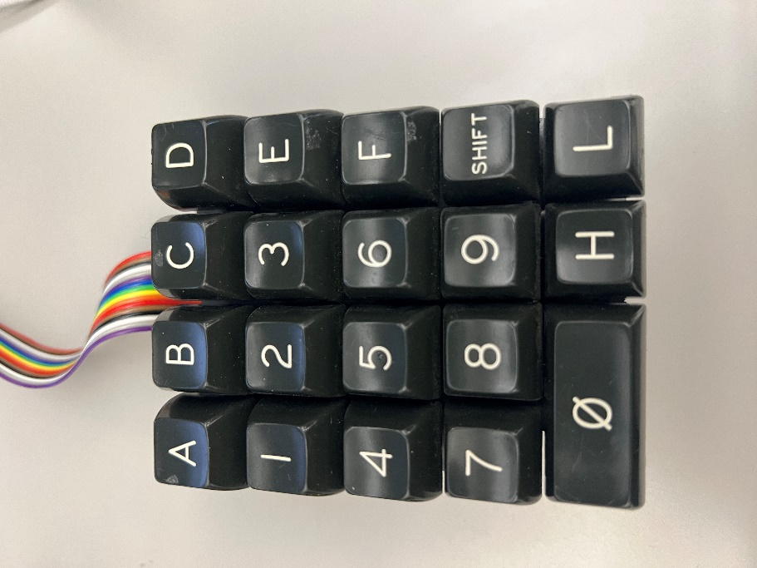
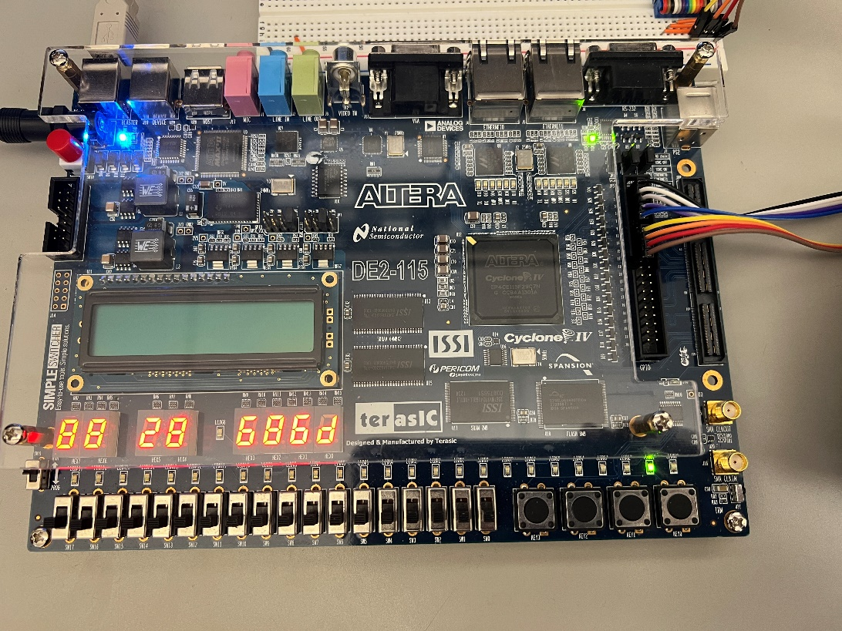
Several assumptions and constraints were addressed in the implementation. First, because the memory is asynchronous and the data bus can go either in or out, but not both at the same time, the design must manage OE_N/WE_N timing and tri-state control to avoid data being changed during reads and writes when it shouldn’t. In this implementation, CE_N is held asserted and both byte mask signals (UB_N and LB_N) are enabled so the full 16-bit word at each address is accessed. Second, keypad inputs must be debounced and converted into a single press event; the design therefore treats each key press as a one-shot pulse and uses internal registers to read 4 bit nibbles into the address and data fields. Finally, the system must use multiple timing enables from the 50 MHz board clock (notably a 1 Hz enable for sequencing and a faster scan enable for keypad servicing), while ensuring SRAM write operations are held long enough to be reliable even though the initiating keypad command is only one pulse wide.

Figure 1 (Left): Altera DE2-115 Board for project
Figure 2 (Right): 19 Key Keypad used for this project.

This design was divided into several functional blocks so that each portion of the system could be implemented, verified, and debugged independently before being integrated into the full project. The specification requires an SRAM-based 256-entry sequence that can be viewed and modified through a keypad-driven interface, so the design separates user-input handling, mode/control logic, memory timing, and display driving into well-defined modules. At a high level, keypad activity is converted into a single-cycle press event and a decoded 5-bit key value. The top-level controller (Top_Level_SM) interprets each press according to the current mode (operational or programming) and updates internal address/data registers, counter controls, and memory read/write intent. The SRAM subsystem (SRAM_TL) then performs the SRAM transaction: it generates the SRAM address, drives or releases the bidirectional data bus, and asserts the correct control strobes. Finally, the display subsystem continuously converts the stored address and data nibbles into seven-segment patterns on HEX5 through HEX0.

C) Problem Decomposition
These are the main functional blocks that made up this project.
1) Clocking and enable generation: All logic is clocked from the 50 MHz DE2-115 system clock. Divider/enable modules generate a 1 Hz enable for operational sequencing and a scan enable for keypad servicing. Short internal enables are used inside the SRAM interface to satisfy asynchronous setup/hold and strobe-width requirements. In Figure 3 you can see that it takes an input clock, and slows it down, in this case from a period of 20ns to a period of 5ms, and there are a couple other clock dividers, like the 1Hz, the 5ms, and the 60ns.
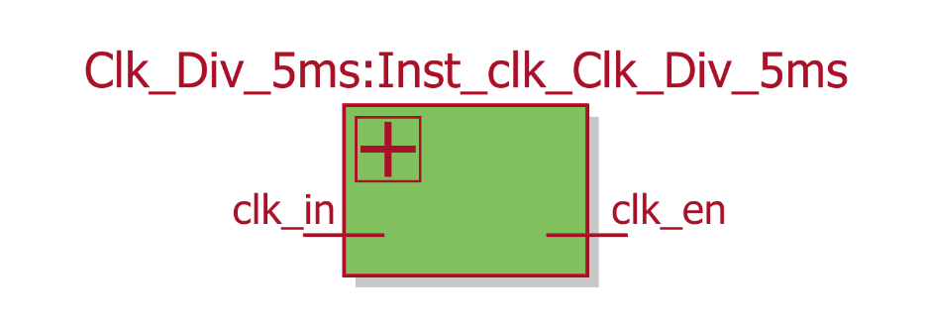

Figure 3: Clock Divider Block Diagram
2) Keypad subsystem (Keypad_SM / Keypad_TL): The keypad is scanned by driving one column at a time and sampling the row lines. The scan state machine produces a stable decoded key value for the 0-9 and A-F keys, along with the special SHIFT, H, and L controls. A pulse-generation stage ensures each physical press is treated as a single event, preventing repeated entries while a key is held. As seen in Figure 4. The keypad top level consists of the keypad rows as inputs, and clock in, while the outputs are the values, and the button pulse. The keypad rotates through the columns to find which value to output, so the columns are generated directly in the Keypad state machine. In Figure 5 we can see that the state machine has an input of the rows, the clock enable (whether we’re probing or not), and the clock in (50mhz clock), and has the outputs of whether the button is pressed, the value, and the columns which are generated by the state machine, and sent to the keypad, so that it can cycle through the columns to catch which row and column is pressed down.
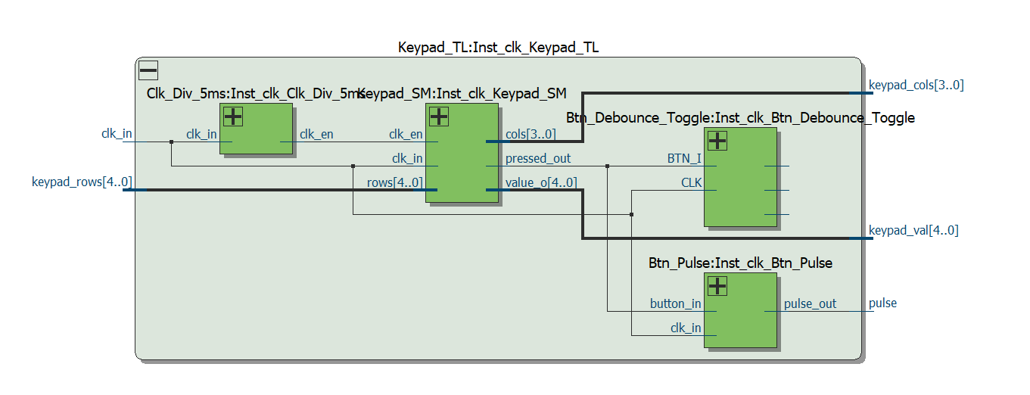
Figure 4: Keypad Top Level
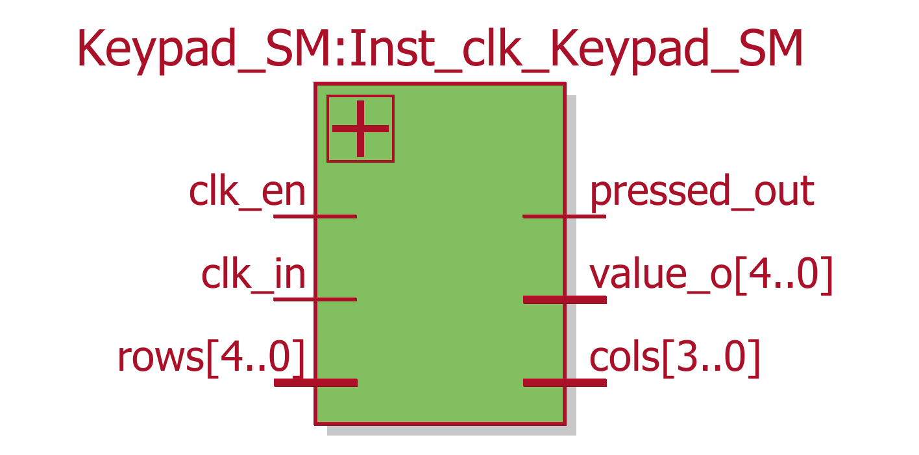
Figure 5: KeyPad State Machine block diagram
3) Mode and control subsystem (Top_Level_SM): The top-level FSM implements the required operational and programming behavior. In operational mode it controls pause/run and forward/backward sequencing, and it updates the displayed address and data from SRAM reads. In programming mode it shifts keypad-entered nibbles into the address field (HEX5-HEX4) and data field (HEX3-HEX0) and issues a write command when L is pressed. A short write-hold window stretches this command into a reliable multi-cycle SRAM write transaction. In Figure 6 you can see the different states, and the methods to get between them. These states go between OP (operation) or PR (program) and use F or B to say forwards or backwards, iterating through the sram. D and A are for programming, and refer to address or data, when programming some data in memory.
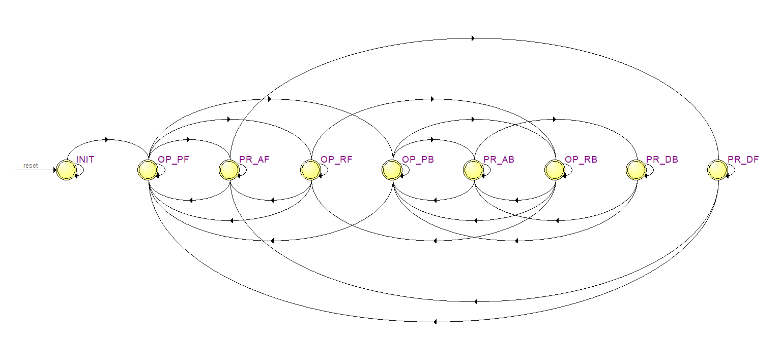
Figure 6: State machine diagram for the top level states
4) SRAM subsystem (SRAM_TL + SRAM_Controller + ROM/init logic): SRAM_TL provides a synchronous interface to the asynchronous SRAM device. During initialization, a ROM generated from sine.mif supplies the default 256x16 sequence, which is written into SRAM across addresses 0x00 to 0xFF. During operation, an 8-bit address counter (forward/backward) selects the current entry, and SRAM_Controller generates OE_N and WE_N pulses and uses direction control (dq_oe) to make sure than data doesn’t interfere with itself. As seen in Figure 7 the SRAM controller which was given to us takes in inputs, and has a data bus that is read from or written to using the address generated by the binary counter seen in Figure 9. Also in Figure 9 you can see the ROM, and another clock delay for the initialization. In Figure 8 you can see the SRAM controller given to us, which outputs the output enable, and write enable, depending on the operating mode, clocks, and address.
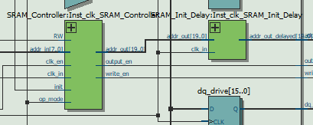
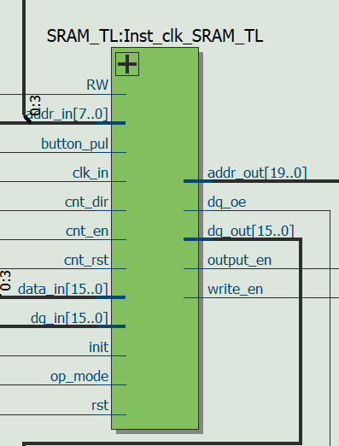
Figure 7: Left: SRAM top level inputs and outputs
Figure 8: Top : SRAM Controller and INIT Delay logic
Figure 9 bottom: ROM, Bin_Counter

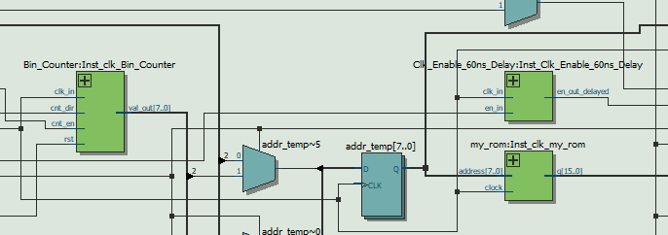
5) Display subsystem (Seven_Segment_TL): The 8-bit address is represented as two nibbles and the SRAM data is represented as four nibbles. Each nibble is converted to a seven-segment encoding and driven onto HEX5 through HEX0, allowing the user to view both the current address and its corresponding 16-bit value. As seen in Figure 10 the seven segment top level controls the hex outputs based on the hex inputs, the hex inputs come from the values give by the SRAM and the address and data inputted by the keypad. In Figure 11 you can see how each one has a separate hex converter, to display the hex information on the hex displays.

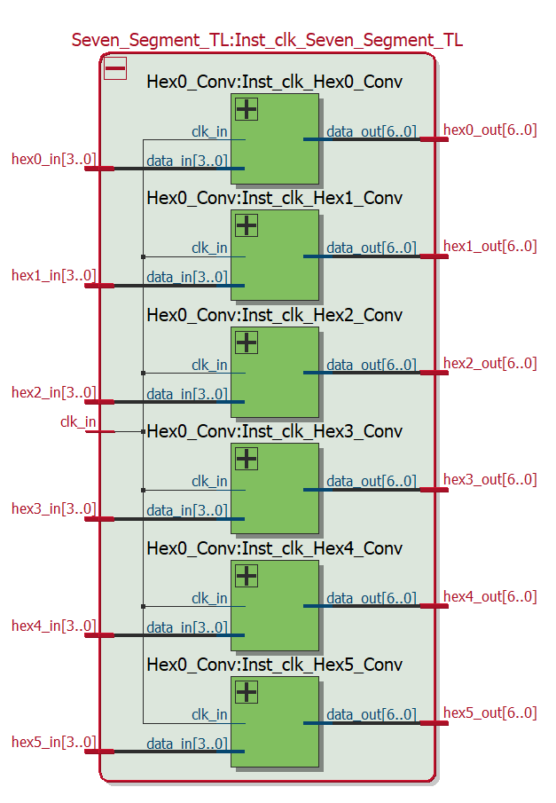
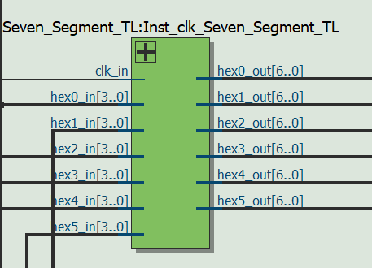
Figure 10 (Left) : Seven Segment TL

Figure 11 (Right) : Hex converters

6) Board wrapper and pin mapping (DE2_115): The top-level board entity connects all internal modules to physical FPGA pins for SRAM, seven-segment displays, keypad I/O, and KEY0 reset, as seen in Figure 12.
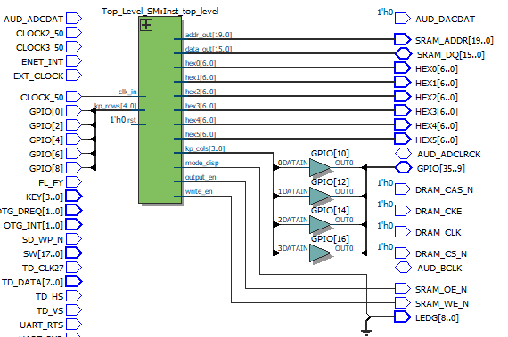
Figure 12: Board wrapper.
D) Detailed design and module testing
KEYPAD:
The keypad subsystem converts physical key presses from the 19-key hexadecimal keypad into two clean digital outputs for the rest of the design: a stable 5-bit key code (kp_val) and a single-cycle keypress pulse (kp_pul). This separation is needed because the rest of the system must treat each press as an event (for state transitions), not as a continuously asserted level that would cause repeated entries while a key is held. A photo of the keypad used in this project is shown in Figure 2.
The keypad is wired as a row/column matrix with five row lines and four column lines. The column signals (kp_cols[3:0]) are actively driven by the FPGA, and the row signals (kp_rows[4:0]) are sampled to determine which switch in the matrix is closed. The scan is performed with active-low signaling, meaning at any given time exactly one column is driven low and the remaining columns are held high. If a key in the active column is pressed, the corresponding row line is pulled low, producing a row pattern different from "11111". The row and column wiring is summarized in the provided keypad documentation and is reflected directly in the decode logic. Keypad_SM scanning state machine: The scan logic is implemented in Keypad_SM using four states (C1–C4), one per column. In C1, kp_cols is driven to "0111" (col[3] low), in C2 it is driven to "1011" (col[2] low), in C3 it is driven to "1101" (col[1] low), and in C4 it is driven to "1110" (col[0] low). The state machine advances to the next column only when no key is pressed (rows = "11111"). If a key is detected (rows != "11111"), the state machine intentionally holds its current state so the key remains associated with a single active column during the press. This prevents value glitches that can occur if the scan advances while the key is still down.
When a press is detected, Keypad_SM decodes the active-low row pattern for the current column into a 5-bit code. Hexadecimal keys are encoded using their natural 4-bit values (0x0–0xF) with a leading zero, and the three control keys are encoded above the hexadecimal range: SHIFT = 0x10 ("10000"), L = 0x11 ("10001"), and H = 0x12 ("10010"). The top-level controller (Top_Level_SM) uses these specific codes to distinguish between run/pause, direction/program-write, and mode switching versus ordinary hexadecimal digit entry. In Figure 13 you can see the decoded messages.
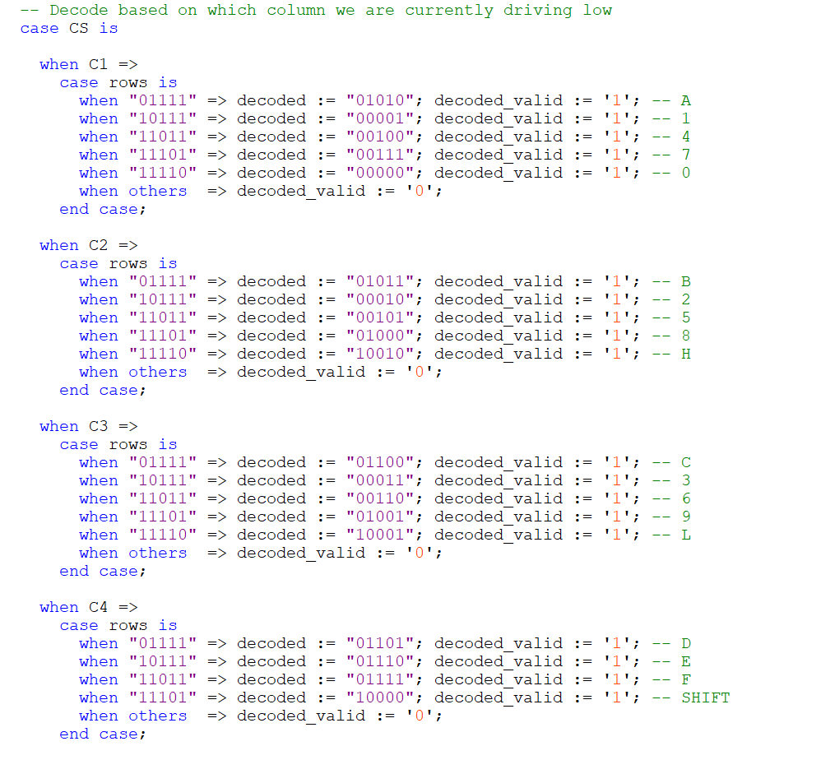
Figure 13. Keypad decoding messages
The keypad is serviced using a clock-enable generated by Clk_Div_5ms. Keypad_SM only updates its registered outputs on clk_en events, which means the row inputs are effectively sampled at a slower rate than the 50 MHz system clock. Combined with registered outputs (pressed_out and value_o) and the fact that the scan state is locked during a press, this provides stable key detection for manual button entry.
The event output kp_pul is generated by the Btn_Pulse module. Btn_Pulse asserts pulse_out high for one 50 MHz clock cycle on the first cycle that button_in is high, and then forces pulse_out low while the button remains held. When the button is released, its internal counter is reset so the next press again generates a single-cycle pulse. In this project, button_in is driven by Keypad_SM pressed_out, so kp_pul represents “one keypress,” while kp_val holds the most recently decoded key code throughout the press. Verification approach: In ModelSim, the keypad subsystem can be verified by forcing representative row patterns while observing the scan state (C1–C4), kp_cols drive patterns, value_o decoding, and pressed_out behavior. A second simulation view should show that kp_pul is a single clock-wide pulse at the start of each press and remains low for the remainder of the press. On hardware, SignalTap can be used to capture kp_pul and kp_val while pressing several keys (hex digits and the SHIFT/H/L controls) to confirm the encoding and the one-shot pulse behavior. Screenshots are provided later in the testing section.

CLOCK ENABLERS
Although the DE2-115 provides a single 50 MHz system clock, this project needs multiple clock dividers simultaneously: a 1Hz readable rate for stepping through SRAM values, a very quick scan rate for the keypad, and an almost at clock rate for initializing SRAM from ROM. Rather than creating multiple derived clocks, the design uses one clock (clk_in) and distributes one-cycle clock-enable pulses to the blocks that need slower or faster activity. In effect, each module remains synchronous to clk_in, but only “does work” when its local enable is asserted. Three divider modules generate the enables used throughout the system. Each divider counts 50 MHz clock cycles and asserts its output clk_en high for exactly one clk_in cycle when its terminal count is reached.
1) 1 Hz enable (Clk_Div_1s): cnt_max = 49,999,999 produces a pulse once per second. This enable is used for operational sequencing so that, when running, the SRAM address increments or decrements at 1 Hz and the seven-segment outputs visibly update at a human-readable pace.
2) 5 ms enable (Clk_Div_5ms): cnt_max = 249,999 produces a 200 Hz pulse (period = 5 ms). This enable is used by the keypad scanning state machine so that columns are advanced at a rate that is fast enough to feel responsive, but slow enough to reduce sensitivity to contact bounce and to avoid racing through columns during a press.
3) 60 ns enable (Clk_Div_60ns): cnt_max = 2 produces one pulse every three 50 MHz cycles, i.e., 50 MHz / 3 ≈ 16.67 MHz, corresponding to a 60 ns period. This fast enable is used during SRAM initialization so that the design can write the full 256×16 ROM pattern into SRAM quickly after reset, but accounts for SRAM delay, as there is a delta between the address coming in, and the data being written, and it can’t all be done in one clock cylcle. \
The SRAM needs to increment addresses at different times depending on mode. SRAM_TL therefore selects its internal clk_en as follows: during initialization it uses a delayed version of the 60 ns enable; during operational run it uses the 1 Hz enable; and in programming mode it uses one enable pulse per keypad press (button_pul). This matches the three behaviors required by the specification: fast ROM loading at startup, slow continuous stepping during run, and single-step updates during user programming.
The SRAM initialization path reads data from a synchronous ROM (my_rom) and writes it into an asynchronous SRAM device. Because the ROM output q updates on a clock edge after its address is registered, the design delays the 60 ns enable by one stage (clk_en_60ns_delayed) so that SRAM address updates and write strobes occur after the corresponding ROM data is valid. Similarly, the SRAM address output is passed through a small register delay (SRAM_Init_Delay) so that the externally driven SRAM address lines remain aligned with the controller’s sequencing and do not change mid-transaction. These delays are small, but they prevent the “off-by-one” behavior that can occur when a registered ROM output is used to drive a write on the same edge that the address counter advances.
In ModelSim, the divider outputs should appear as clean one-cycle pulses with the expected periods (1 s, 5 ms, and 60 ns equivalent cadence). For SRAM_TL, a waveform capture should show clk_en switching between these sources based on mode (init vs operational vs programming), with the delayed enable active during initialization.
On hardware, SignalTap can be used to confirm that addr_out[7:0] updates at 1 Hz in operational run and updates only on keypress events in programming mode, while initialization completes rapidly after reset.

STATE MACHINE
The goal of the top-level state machine was to control the different operating modes, and all combinations of them. They need to interact with 1: the user-interface requirements from the keypad (SHIFT, H, L, and hex digit entry), 2: safe SRAM read/write control (including a reliable write strobe), and 3: mode-dependent display behavior on HEX5 through HEX0. The top-level controller is used above the keypad scanner, seven-segment driver, and SRAM subsystem (SRAM_TL) and decides, on each keypress pulse, what mode the system is in, which address/data registers should be updated, and whether SRAM should be read or written.
The controller is implemented as a synchronous Moore-style FSM with one initialization state and two major operating regions. The state names encode the two high-level toggles required by the specification: pause vs run and forward vs backward. Operational states are OP_PF (operational paused forward), OP_RF (operational running forward), OP_PB (operational paused backward), and OP_RB (operational running backward). Programming states are split into address entry and data entry while preserving the direction suffix: PR_AF / PR_AB for programming address entry and PR_DF / PR_DB for programming data entry. A complete state diagram is shown in Figure 6 above (Top_Level_SM state diagram).
The system reset input rst is mapped to KEY0. On reset or power-up, the FSM enters INIT and asserts init_sig = '1' so that SRAM_TL performs ROM-based initialization (writing the 256×16 ROM pattern into SRAM across addresses 0x00–0xFF). INIT also includes a short counter-based guard delay using clk_cnt up to cnt_max. With the default cnt_max = 23041 and a 50 MHz clock, the delay is approximately (23042/50 MHz) ≈ 0.46 ms. After this delay, the FSM deasserts init_sig and transitions to OP_PF so the user begins in operational mode, paused, at address 0x00.
Operational mode is indicated by op_mode = '1' (passed into SRAM_TL) and mode_disp = '1'. In the paused states (OP_PF and OP_PB), cnt_en is deasserted so the SRAM address does not change. Pressing H toggles into the matching run state (OP_RF or OP_RB). Pressing L toggles direction (OP_PF ↔ OP_PB). Pressing SHIFT enters programming mode and clears the displayed nibble registers so that address/data entry begins from a known, clean state. In the running states (OP_RF and OP_RB), the counter enable is asserted (cnt_en = '1') and direction is selected by cnt_dir (forward when '1', backward when '0'). In these states, the display registers are continuously updated from the SRAM read data and current address: HEX3–HEX0 show data_out(15 downto 0) split into nibbles, and HEX5–HEX4 show the active address (addr_sig(7 downto 0)) split into nibbles. Pressing H returns to the paused state in the same direction. Pressing L reverses direction while continuing to run. Pressing SHIFT enters programming mode.
Programming mode is indicated by op_mode = '0' and mode_disp = '0'. In programming mode, the seven-segment displays act as input registers. Address entry occurs in PR_AF/PR_AB: successive hex digit presses are latched into hex5_val then hex4_val to form an 8-bit address presented to SRAM_TL. Data entry occurs in PR_DF/PR_DB: successive hex digit presses are latched into hex3_val, hex2_val, hex1_val, and hex0_val to form a 16-bit value presented to SRAM_TL. Pressing H toggles between address entry and data entry. Pressing SHIFT exits programming mode and returns to operational pause, while also resetting the address counter to 0x00 using cnt_rst.
In programming mode, the L key is used as the write command. The keypad subsystem produces a one-cycle pulse (kp_pul) for each press, but a single-cycle write pulse is not ideal for asynchronous SRAM because address/data must remain stable while WE_N is active. The top-level FSM uses a write-hold counter (wr_hold). When L is pressed in programming mode, wr_hold is loaded (for about 20 cycles) and counts down each clock. While wr_hold > 0, the design forces rw_sig low (write mode), stretching the write operation across multiple clock cycles even though the keypress pulse is only one cycle.
The rw_sig is forced low during INIT (so initialization writes always occur) and during the write-hold time. Otherwise rw_sig is high, and the SRAM interface operates in read mode. This logic ensures the SRAM controller is never asked to read and write in the same cycle, and it keeps read behavior as the default when no write is intentionally requested. Bidirectional data bus control (tri-state): Because SRAM_DQ is bidirectional, the design controls the direction data is moving. SRAM_TL provides sram_dq_out and a drive-enable sram_dq_oe. When sram_dq_oe is asserted, the top level drives data_out with sram_dq_out; otherwise data_out is placed in high impedance so the SRAM can drive read data.
In ModelSim, correctness of the FSM is verified by applying kp_val and kp_pul sequences and observing state transitions among OP and PR states, correct changing of address and data nibbles into the hex values, and correct activation of the write-hold behavior (wr_hold countdown and rw_sig forced low). A representative timing capture should show WE_N asserted during the write-hold window, OE_N deasserted during writes, and dq_oe asserted only during writes. On hardware, SignalTap captures should show the same relationships between kp_pul, TLS, rw_sig, write_en (WE_N), output_en (OE_N), dq_oe, addr_out(7 downto 0), and the data bus during both operational stepping and programming writes.

SRAM
The SRAM controller and top level is responsible for making the DE2-115 SRAM behave like a clean, synchronous resource for the data and the keypad. The board SRAM uses a 20-bit address bus and an input/output bidirectional16-bit data bus (DQ), controlled by active-low pulses (OE_N and WE_N) and byte enables (UB_N/LB_N). To synchronize this, the design uses a small hierarchy consisting of SRAM_TL, SRAM_Controller, an 8-bit address counter, and a ROM-based initialization path. Together, these blocks generate SRAM addresses at the correct times, assert OE_N/WE_N with safe timing, and explicitly control the direction of the bidirectional data bus so that data issues never occur from trying to read and write at the same time.
The SRAM uses only 256 programmable entries (0x00–0xFF). SRAM_TL uses an internal 8-bit address counter (Bin_Counter) used during operational sequencing and initialization. In operational mode, this counter increments or decrements (cnt_dir) when enabled (cnt_en) and provides addr_count[7:0]. In programming mode, the user-entered address (addr_in[7:0]) is selected instead so any location in 0x00–0xFF can be modified. The external SRAM address port (addr_out[19:0]) is driven such that the upper bits remain zero and only the lower eight bits change; this enforces the intended 256-entry memory map while remaining physically compatible with the SRAM device.
Default sequence initialization (ROM SRAM): On reset/power-up, Top_Level_SM asserts init_sig and forces RW low, placing the SRAM interface into write mode while SRAM_TL selects its “fast” initialization sequence. A synchronous ROM (my_rom) generated from sine.mif supplies the default 16-bit sequence values (data_rom). During initialization, SRAM_TL selects addr_temp <= addr_count so that the ROM and SRAM are both addressed using the same 8-bit counter, and it drives the SRAM data bus with dq_drive <= data_rom. This causes the ROM pattern to be written into successive SRAM addresses. The initialization window is intentionally long enough that the full 0x00–0xFF range is written at least once before init_sig is deasserted, after which the system transitions to operational mode.
SRAM_Controller generates the active-low SRAM control signals from a single intent bit RW. When RW = 1 (read), SRAM_Controller deasserts WE_N (write_en = '1') and asserts OE_N (output_en = '0') so the SRAM drives the data bus. When RW = 0 (write), SRAM_Controller asserts WE_N (write_en = '0') and deasserts OE_N (output_en = '1') so the board can safely drive data into the SRAM. A key design choice is that OE_N and WE_N are updated every clock cycle, while the SRAM address output is only updated when clk_en is asserted. This separation allows the top-level state machine to “hold” a write transaction across multiple clock cycles (write-hold window) without needing to re-issue address updates; WE_N remains asserted for the duration of the hold while the address and data remain stable.
Enable-controlled address updates and mode-dependent timing: SRAM_TL computes a one-cycle enable signal (clk_en) that determines when a new SRAM address should be applied. During initialization, clk_en is a delayed version of the 60 ns enable so that the ROM output has time to update before a write strobe is asserted. During operational run, clk_en is the 1 Hz enable so the SRAM address advances once per second. During programming mode, clk_en is the keypad pulse (button_pul), so the SRAM address only updates in response to user actions. This matches the three required behaviors: fast automatic initialization, a readable sequencing in run mode, and single-step programming writes.
When dq_oe is high, the board drives the SRAM_DQ bus with dq_out, and when dq_oe is low, the board places the bus in high Z and the SRAM drives read data onto DQ. Bus direction is controlled by mode and RW. During initialization, dq_oe is high because the system is writing ROM data into SRAM. During operational mode, dq_oe is low so the SRAM can drive the bus continuously for reads. During programming mode, dq_oe is high only when RW = 0 (write) and is low when RW = 1. The bus value is sampled through dq_in (connected to the physical DQ lines), allowing the top-level controller to display read data on HEX3–HEX0.
ModelSim waveforms for OE_N/WE_N and dq_oe during read and write transactions are shown in Figure , and a hardware SignalTap capture showing the same relationships is shown in Figure . 6) Practical SRAM configuration notes: In this implementation, chip enable and byte enables are held asserted so that the full 16-bit word is always accessible, and only OE_N and WE_N are toggled dynamically by the controller.

SEVEN SEGMNETS
The seven-segment display displays two things depending on the operating mode. In operational mode, the displays show the current SRAM address and the 16-bit SRAM data word stored at that address. In programming mode, the same displays act as input registers that the user fills by entering hexadecimal digits on the keypad.
The project specification says that the SRAM address be displayed on HEX5–HEX4 and the SRAM data be displayed on HEX3–HEX0. The design represents the 8-bit address as two 4-bit nibbles (address[7:4] and address[3:0]) and represents the 16-bit data word as four 4-bit nibbles (data[15:12], data[11:8], data[7:4], data[3:0]). These six nibbles are stored internally as hex5_val through hex0_val. In operational mode, Top_Level_SM continuously updates these 4 bit registers from addr_out(7 downto 0) and the SRAM read data so the user sees the live sequence. In programming mode, the nibble registers are updated only by keypad entry so the user can compose a new address and a new data word before writing to SRAM.
Each letter/number 4 bit nibble is converted to a seven-segment pattern using dedicated converter modules (Hex0_Conv through Hex5_Conv). These modules implement a combinational mapping from a 4-bit hex value (0x0–0xF) to the corresponding seven-segment encoding for the DE2-115 displays. The converter outputs are then registered and driven to the board by the Seven_Segment_TL module, which acts as the display top level. Keeping the conversion in separate modules makes the design easy to verify (each converter can be tested with a 0–F sweep) and keeps the Top_Level_SM focused on control rather than segment encoding details. Mode-dependent behavior and clearing: When the user enters programming mode (SHIFT), Top_Level_SM clears hex0_val through hex5_val to 0 so that address and data entry begins from a known state. In address-entry mode, each hex digit press loads hex5_val first and then hex4_val to form the 8-bit address shown on HEX5–HEX4. In data-entry mode, each hex digit press loads hex3_val, hex2_val, hex1_val, and hex0_val in sequence so the 16-bit value appears to “shift across” HEX3…HEX0. This behavior matches the specification requirement that each new digit appear at the right-most display of the active field and shift left on subsequent presses.
In ModelSim, the display subsystem can be verified by monitoring the nibble registers (hex5_val..hex0_val) and confirming that they update correctly during operational reads and during programming entry sequences. A separate test can check that each input from 0x0 to 0xF matches the expected digit on the DE2-115 display. On hardware, a simple functional check is that during operational run the address increments/decrements and the displayed data updates at 1 Hz, and in programming mode the entered digits appear in the correct locations on HEX5–HEX0 with no unexpected shifting, which worked great.

RoHS compliance:
The equipment used is compliant with the Restriction of Hazardous Substances (RoHS) directive. The hardware used in this design consisted of the DE2-115 FPGA development board, and the external 19-key hexadecimal keypad. The DE2-115 FPGA is in compliance [1]. I couldn’t find a compliance statement or the exact model of the keypad, however it is assumed to be compliant as well.
https://www.terasic.com.tw/attachment/archive/55/RoHS_Terasic.pdf

All of these things were tested at a modular level, and corrections to the state machine when there were issues, and especially corrections to the SRAM, and timing with the binary counter, and clock dividers were made.

E) Alternate designs

While the final implementation follows the project specification by using the DE2-115 asynchronous SRAM as a 256×16 programmable sequence table, there are several reasonable alternative design approaches.
The initialization path used here writes the ROM pattern into SRAM after reset so that the SRAM contents always begin from a known default sequence. An alternative would be to not use SRAM entirely for the default sine wave, and instead read directly from ROM during operational mode, only switching to SRAM when the user programs values. That approach would reduce initialization time and write activity, but it would complicate the behavior because “default” and “programmed” modes would use different storage. The chosen approach (always SRAM after init) keeps behavior uniform.
A better way to have implemented the project would to also have done it with better planning. It has a lot of moving parts, that fit together in a not so perfect way, and so from a top level design perspective, the way we have some instantiated signals going into each other is a bit convoluted, and could be cleaned up.

F) Specification Testing
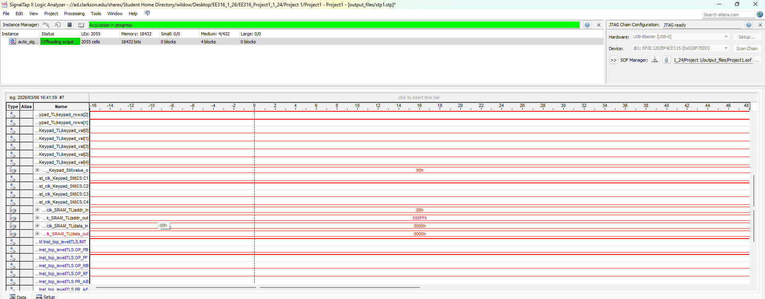
The final design was tested in both simulation and hardware. Verification was done in ModelSim for each component, and then continued on the DE2-115 board using on-board seven-segment display observation and with using signal tap to get board captures of signals. To verify the reset and initialization specification, KEY0 was set high and the internal initialization signals were observed. The test confirmed that the system entered the initialization state, forced the SRAM interface into write mode, and sequenced through the full 0x00 to 0xFF address range while loading the default ROM pattern into SRAM. After initialization completed, the controller transitioned to operational mode in the paused forward state with the address reset to 0x00. This confirmed that the startup behavior matched the design specification. After that, we confirmed that the keypad worked. This was tested only in signal tap and with hardware, and it worked, capturing each signal, and making value out what we wanted it to be based on what we inputted. Signal tap captures show the full working of the project.
Figure 14. signal tap captures for testing
In Figure 14. We can see what values are used. The columns all alternate between being high at a very rapid pace, each probing to see if it will work.
G) Results and Analysis

Overall, the final design met the functional requirements of Design Project 1: the SRAM was initialized with a default 256×16 sequence on reset, the user could step through the sequence at 1 Hz (forward or backward) in operational mode, and the user could program any entry in the range 0x00–0xFF by entering an address and a 16-bit data value on the keypad and issuing a write command. The user interface behavior was consistent and predictable in both simulation and on hardware, and the SRAM bus direction remained safe under both read and write activity.
In operational run, HEX5–HEX4 correctly reflected the current address and HEX3–HEX0 correctly reflected the SRAM word stored at that address. The observed behavior aligned with the expected mapping: the address bits updated at a steady one-per-second cadence when running, remained constant when paused, and reversed direction immediately when L was pressed. The data display updated synchronously with the address, which shows that OE_N was high correctly during reads and that the SRAM address lines were stable long enough for the asynchronous device to present the correct word.
Programming mode worked by inputting your data, and then committng the write with L. One issue is that hex entry by the way that we implemented it, would scroll backwards, so instead of filling right to left like the program described, it filled left to right as that is how it was implemented. This is an easy change with the code, and could be easily corrected.
The H key’s role as a mode toggle (address vs data) worked great. The keypad subsystem produced a single-cycle event (kp_pul), and a one-cycle WE_N pulse told it when to write.
The 1 Hz rate is slow by design (it makes the sequence human readable), and it also makes debugging easy because address changes are obvious even without instrumentation. The keypad scan rate was also extremely quick, as it happened in milliseconds.
The ROM-to-SRAM initialization completed quickly and produced a repeatable starting sequence after each KEY0 reset. It cycled through all 256 addresses automatically and forced the SRAM into write mode. The delayed enable used during init was important to align ROM data validity with SRAM writes, because without that alignment the system risks writing the next value into the current address. The final design avoided that issue by separating the counter’s cadence from the write cadence and ensuring the ROM output had time to update before each write.
A major error corrected was the initialization timing error, that was corrected last minute, for some reason halving the init time from 26k cycles to 13000 clock cycles fixed the values.

References:
[1] https://www.terasic.com.tw/attachment/archive/55/RoHS_Terasic.pdf Terasic Technologies, DE2-115 User Manual, ver. 2.3, Aug. 14, 2017.
[2] DE2_115_User_manual
[3] Terasic Technologies, DE2-115 Main Board Schematic, Oct. 5, 2012.
de2-115_mb
[4] Terasic Technologies, “DE2-115 FPGA Development and Education Kit,” Specifications and Resources pages.
[5] Intel Corporation, Internal Memory (RAM and ROM) User Guide.

